The Natural Step – Sustainability for Business
How Businesses Can Change for the Future
Renee Bryant: 546875832
GEOG 352 – Ecological Economics – Don Alexander

Table of Contents

Introduction 2
History 2
What is Sustainability? 3
Approaches for Implementation - TNS Framework 5
Interface Inc. 7
Conclusion 10
References 11

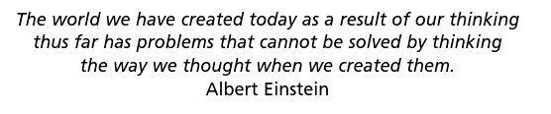
Introduction
The Natural Step could be described as a vehicle to which the concepts of ecological economics are applied. The program offers a systematic approach for businesses, communities, and government alike, to change their current methodologies. The Natural Step has teachings catered to each of these facets, seeking to enhance natural, human, social, and manufactured capital; while pointing out that financial capital can still be maintained. The program is especially beneficial to business leaders that may not understand the concepts of sustainability or how to implement change.

Although the basic principles are simplified, The Natural Step does not offer the empty promise of ‘follow these easy steps and you will succeed’, but rather offers a guided platform to which an organization can create its own vision and goals within the ultimate goal: to have a sustainable society. The framework is openly published on their website with minimal “creative commons” ownership rights. The Natural Step for businesses will be analyzed through a brief history of the program, a definition of their goal of a sustainable society, and their approaches for the implementation of that goal. Interface Inc. will be examined to illustrate the Natural Step approach.

History
The Natural Step is a non-profit organization that was founded by Karl-Henrik Robèrt in the 90s. He was working as a doctor and a cancer researcher in the 80s when he noticed an imbalance in human nature. There was a divide: on the one hand, people seemed to want to get richer and buy nice things, on the other hand he noticed that parents were willing to do anything for their children ailed with cancer (Nattrass & Altomare, 1999. p. xiii). According to Nattrass (1999), this observation led Robèrt to the realization that the fight in us brings us to want to change our environment, not cooperation. Robert, a cell scientist, suggested that the Earth is like a cell considering there must be a balance of all flows into a cell to survive (Nattrass, 1999). These flows can be paralleled to the energy, natural resources, and waste absorption ability that the planet can produce or receive. Before TNS Framework objectives are introduced, the sustainability of these essential flows and social capitals are reviewed (Eaton & Eaton, 2007, p. 16).

What is Sustainability?
Sustainability is not simply defined or understood. It can be difficult to understand with opposing political or corporate views, so The Natural Step defines it simply in four conditions.
James & Lahti (2004, p. 23) list these conditions:
In the sustainable society, nature is not subject to systematically increasing:
- concentrations of substances from the earth’s crust.
- concentrations of substances produced by society
- degradation by physical means
and, in that society,
- human needs are met worldwide.
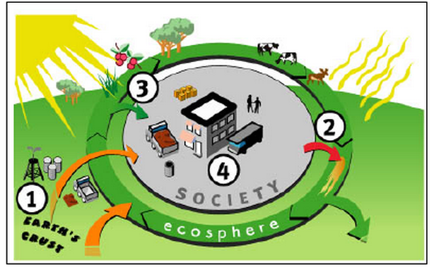
Put simply, sustainability means that the Earth can keep going – having the ability to renew and produce, so it can sustain the people that live here, and can do so indefinitely. Many blame business for negative impacts on the environment. This is true in the sense that pollution caused by large-scale production of large corporations and our consumption of products and services is increasing, hence increasing waste. There is public stigma placed on multinational corporations due to unethical ecological and social behavior (Nattrass, 1999).

Corporations are in a position of power. They have the ability for creation and destruction. Changing the way corporations think and function would be the key to dramatic change. Corporations are run by people. Leaders have the ability to lead positive change for both the economy and the planet. Business leaders think in terms of profit and costs. Dr. Karl-Hendrik Robert uses these terms to connect with business leaders. In a presentation to business owners, he talks about the shift to sustainability by taking a step-by-step approach to assessing their company, and prioritizing their options. He encourages change that will bring revenues fast enough (since CEOs and other business professionals do not want to negatively impact financial capital), but he also points out the costs of continuing without change saying “what will happen to resource costs as we keep losing them… and there will soon be, say nine billion people, not seven, building on the remainders. Do you think prices will go up or down?” (Robert, 2011). If business corporations on a reactive approach, environmental damage may be minimized at most, but not reversed before it happens.

Approaches for Implementation – The Natural Step Framework
The basis for invoking change in corporate structure is simply to help organizations become “learning organizations” (Nattrass, 1999). As the author Herman E. Daly suggests we should use a transdisciplinary approach to cross the boundaries of traditional economics to tackle a single problem (Daly & Farley, 2004). Nattrass similarly suggests that it takes a learning organization to “change the operating norms and assumptions that have guided business in the 20th century”. Most business literature involving accounting, management, finance, and marketing revolve around the economy as a whole, not a subset of the ecosystem. Although some business courses focus on human and social capital, natural capital and the ecosystem as a whole, are essentially ignored. It will take a different way of thinking to change, and the best way to accomplish change is through education; especially of the future businesspeople, governments, and communities who (are all people), have a direct impact on the production and use of natural resources. The simplest approach TNS uses is their four-step method to apply their sustainability framework.

The following is a diagram from The Natural Step website (“Applying the ABCD Method,” 2012):
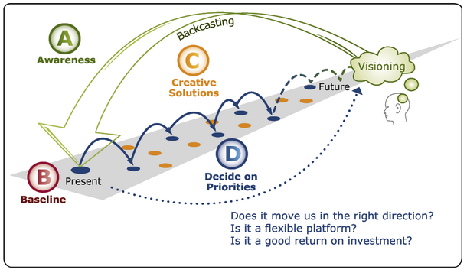

The first step is awareness, where the organization seeks to understand sustainability and to set common ground as to the vision for the future as well as setting a common language to build upon, while at the same time setting new goals that uphold the main goal of sustainability.

The second step, ‘Baseline Mapping’ refers to the four sustainability principles or the care instructions. A ‘gap analysis’ is conducted that sees how the organization’s activities agree with the four principles. The analysis includes an evaluation of all sources of capital including products and services, energy, financing, human resources and the business’ overall organizational culture.

In the Creative Solutions step, organizations are encouraged to brainstorm possible solutions to the sustainability goals outlined in the previous step. With the vision and goals in place, organizations look backwards to develop the strategy – which TNS has coined, ‘backcasting’.

The final step is to Decide on Priorities where the company prioritizes the goals and solutions toward sustainability while “optimizing flexibility as well as maximizing social, ecological, and economic returns” (“Applying the ABCD Method,” 2012).
The decisions and actions are continually reviewed in the ‘backcasting’ step to see if they are achieving their vision. The hopes of this framework are to encourage new ways of thinking and innovation (“Applying the ABCD Method,” 2012). Interface Inc. is an exemplary example of how the vision and goals can be put into action.

Interface Inc.
Interface was founded in 1973 in the United States by Ray Anderson. Today, they are the world’s largest producer of commercial floor coverings, manufacturing and selling of all carpet tiles used in commercial buildings worldwide (Roy, 1997). Interface is a multinational corporation with sales in 110 countries and manufacturing facilities on four continents (Interface, 2008).

Anderson’s mission is similar to The Natural Step’s, in that they both believe that business is an important vehicle in which to spark change. According to Anderson, “business is the largest, wealthiest, most pervasive institution on Earth, and responsible for most of the damage. It must take the lead in directing the Earth away from collapse, and toward sustainability” (Roy, 1997). Ray Anderson decided to take the lead himself. Before he adopted The Natural Step program he had another framework in place called QUEST (Quality Utilizing Employees Suggestions and Teamwork) as well as EcoSense already implemented (Roy, 1997). QUEST focused mainly on eliminating waste. Unlike other corporations that have adopted TNS, Interface was one of the few to have systems already in place.

Anderson is visionary. He gave a speech to his assigned task force for environmental policy, stating “we accept our responsibility as a member of the industrial world to pursue the creation of new products – and processes – that recognize the sustainable limits of our environment. We’re striving to be first in industrial ecology and to set an example for the world” (Nattrass, 1999). So, unlike many politicians, the promise did not stop there. The power of education and shared knowledge is evident in the precursors to this speech.

Ray Anderson received a book from a regional vice president in California by the name of Joyce LaValle. The book, “The Ecology of Commerce”, written by Paul Hawken, was given to LaValle by her daughter Melissa who heard Hawken speak and found his speech inspirational (Nattrass, 1999). She asked her mom to promise to change how much carpet waste went into the landfill (Nattrass, 1999). LaValle read the book and also found value in the vision and wished to keep her promise to her daughter. LaValle gave a copy to her boss and asked that he pass it on to the CEO, Ray Anderson. LaValle felt uncertain about wanting to change the current system of buying yarn for the carpet to recycled yarn. Nonetheless, Anderson loved the book and created the concept of converting his product of carpet tile to a service. It was this book that gave Anderson the motivation for his aforementioned speech.

After Anderson’s epiphany, he decided to put a taskforce together to carry out the vision. Paul Hawken was later hired as an expert in the area of sustainability to join the Dream Team. Paul Hawken, (also chair of TNS US) interested Anderson in the TNS framework (Roy, 1997). Hawken was then hired to train managers of Interface in a 2-day TNS workshop. Karl-Henrik Robert, the founder of The Natural Step helped training managers in this workshop (Roy, 1997). Soon Interface was training all of its employees in The Natural Step framework.

Today, Interface has hundreds of sustainability initiatives. Some of the most notable are their goals to achieve zero emissions, to create carpet from completely organic material, reducing toxic-materials-disposal and increasing awareness through education and communications (Roy, 1997).

For reducing materials disposal, the Urban Retreat, a company developed by Interface boasts natural elements to their modular carpet (“Press Releases”, 2012) The company follows Interface’s “Mission Zero” promise to eliminate any negative impact the organization has on the environment by 2020. The carpet is composed of yarn derived from salvage fishing nets and other recycled material (“Press Releases”, 2012).

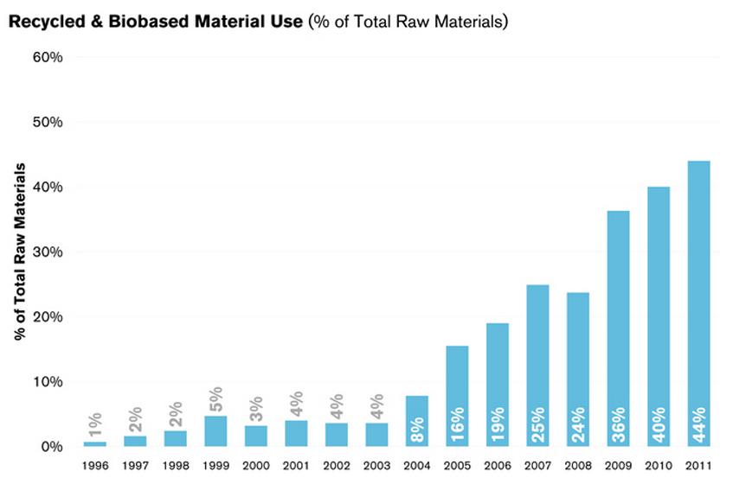
One of Interface’s most innovative goals involves efficient resource use. The specific goal is to “align its practices with cyclical principles of biological systems wherein ‘waste equals food’ and resource use is highly efficient” (Roy, 1997). Their method to achieving this goal involves a shift “from thinking of products as things to understanding products as a means to deliver a service” (Roy, 1997). This goal was achieved by establishing a “perpetual carpet lease” where the customer leases the carpet and Interface is responsible for maintenance and taking the product back at the end of its useful life (Roy, 1997). As a result, the customer does not own the carpet, but pays a monthly fee that includes the installation, maintenance, and disposal (Roy, 1997). This creates a ‘win-win-win’ situation where the customer benefits from a regularly maintained carpet, Interface benefits from the reuse of the material, and the planet benefits from reduced waste.

Conclusion
Making change for sustainability can be a long and somewhat daunting task. The Natural Step is a well-structured, easy way to get corporations to hop on board. There is a lot of information to absorb amongst new economic ideas and business professionals do not always have the time for a new extensive study – that is why there are other professionals! We cannot change classic views overnight, and we cannot convince many business owners to reduce their profits to save the environment. But we can find a systematic way to raise awareness, share a vision of sustainability, and make plans to get there – that respect the current system that we have, as The Natural Step has accomplished.

References

Applying the ABCD Method (2012). Retrieved from: http://www.naturalstep.org/en/abcd-process
Eaton, J. M., Eaton, P.B. (2007). The Natural Step: A Primer for Atlantic Canada: Helping Communities Move Toward Sustainable Development. Retrieved from http://site.ebrary.com/lib/viu/docDetail.action?docID=10197539
Interface Global (2012). Retrieved from: http://www.interfaceglobal.com/Company/History.aspx
James, S & Lahti, Torbjorn. (2004). The Natural Step for Communities: How Cities and Towns can Change to Sustainable Practices. Gabriola Island, Canada: New Society Publishers.
Looking Forward: Interface Asks what’s Next in Design and Sustainability (2012, September 20). Retrieved from: http://www.interfaceglobal.com/Newsroom/Press-Releases.aspx
Nattrass, B. & Altomare, M. (1999). The Natural Step for Business Wealth, Ecology and the Evolutionary Corporation. Retrieved from http://site.ebrary.com/lib/viu/docDetail.action?docID=10313368
Nattrass, B. & Altomare, M. (1999). Einstein Quote
naturalsteponline (2011, November 25). Business Insights – Sustainability is a Lifetime. Opportunity [Video file]. Retrieved from http://www.youtube.com/watch?v=3hIXUT6Snuo&NR=1&feature=endscreen
Roy, J. (1997). A Natural Step Network Case Study – Interface, Atlanta, Georgia, USA. http://www.thenaturalstep.org/en/usa/interface-atlanta-georgia-usa

