The Yasuni-ITT Initiative: A case study
Vancouver Island University
Geography 352
November 22, 2012
Deanna McGillivray

Introduction
Situated in northwest Ecuador, the Ishpingo, Tambococha and Tiputini (ITT) oil fields are found inside the borders of Yasuní National Park, a designated UNESCO Man and Biosphere Reserve. Combined, the ITT oil fields are estimated to hold approximately 846 million barrels of oil, valued at more than $7.2 billion USD (Republic of Ecuador [Ecuador] & United Nations Development Programme [UNDP], n.d.). Although the development of the ITT could give Ecuador's struggling economy a much needed boost, extraction would destroy one of the world's most biologically rich and diverse areas, disrupt the "last refuge" of the Tagaeri and Taromenane peoples, two of Ecuador's Indigenous groups living in voluntary isolation, and cause the release of millions of tonnes of CO₂ into the atmosphere from both deforestation during development, and the subsequent burning of extracted fossil fuels (Ecuador & UNDP, n.d.).ⱱ
In the face of such high costs, Ecuador's government is pursuing the placement of a permanent ban on the development of the ITT reserves, in exchange for half of the $7.2 billion in projected profits resulting from the development of the reserve. Contributions from the world's governments, private corporations, and individuals are being gathered and managed by the United Nations Development Program (UNDP) in a multi-donor trust fund. The Yasuní-ITT Trust Fund offers a new approach to economic development, one which seeks to balance the importance of natural, social, human and financial capital, in opposition to the traditional neoclassical economic model, which focuses solely on financial capital.ⱱ

Ecuador's Oil Industry
Ecuador's economy is heavily dependent upon primary industries, with petroleum, produce, flowers, and foodstuffs comprising approximately 90% of the country's exports (Larrea & Warnars, 2009). The oil industry rose to prominence in the country in the mid20th century, when large reserves of oil were discovered in the region, and the country became an oil exporter in 1972 (Larrea & Warnars, 2009). Half of Ecuador's export revenues today are derived from petroleum products and the country is now ranked 24th in the world for oil exports (CIA World Factbook, 2012).
The ITT oil fields are Ecuador's second largest untapped oil resource (Finer, Vijay, Ponce, Jenkins, & Kahn,, 2009), containing an estimated 846 million barrels of oil (Ecuador & UNDP, n.d.). It is predicted that the development of the ITT reserves could contribute more than $7.2 billion dollars to the struggling Ecuadorean economy (Ecuador & UNDP, n.d.). Ecuador's new constitution, adopted in 2008, prohibits the extraction of oil in protected natural areas; however, this rule can be sidestepped in specific incidences, if the president petitions for a project and it is declared by Congress to be in Ecuador's national interest (Finer, Vijay, Ponce, Jenkins, & Kahn,, 2009). This technicality means that Yasuni National Park remains in jeopardy, despite its established protected status.ⱱ

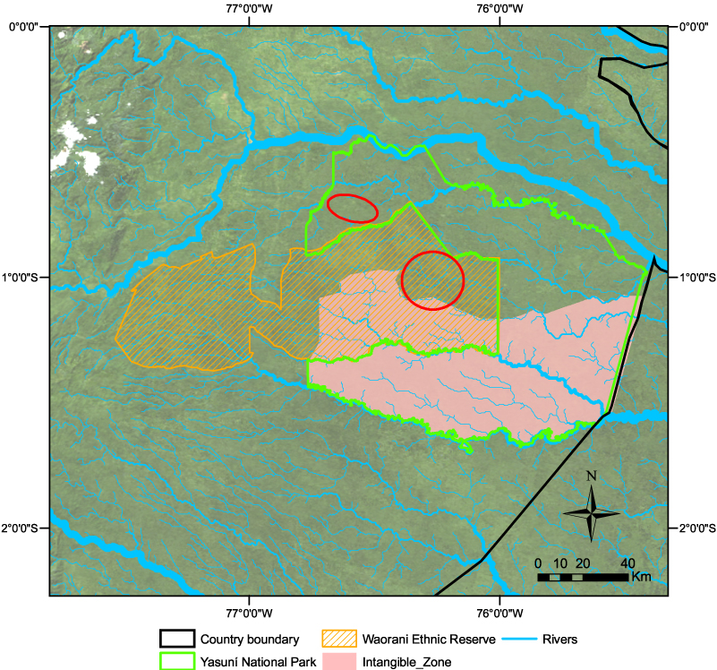
Figure 1: Various geographical boundaries within the Yasuni Region. The red circles indicate areas where there is evidence of Taromenanae or Tagaeri presence outside the Zona Intangible. (Finer, Vijay, Ponce, Jenkins, & Kahn,, 2009) nice map!

Yasuni National Park
The park is a designated UNESCO Man and Biosphere Reserve and covers over 200,000 km² in northeastern Ecuador (Ecuador & UNDP, n.d.). Yasuni is Ecuador's largest park and the only one situated within the Amazonian region of the nation (Finer, Vijay, Ponce, Jenkins, & Kahn,, 2009). Widely reputed to be one of the most bio-diverse regions on earth, the park is home to unprecedented numbers of amphibian, reptile, bird, mammal, and plant species (Baki, 2011; Bass et al., 2010; Finer, Vijay, Ponce, Jenkins, & Kahn,, 2009). In fact, Yasuni holds the record for the largest concentration of tree and shrub species within a hectare, at 655; to put this figure into perspective, it is more species than are found on the entire continent of North America (Bass et al., 2010). In addition, the park and surrounding areas are the ancestral homeland of the Waorani people, a historically highly mobile, hunter-gatherer indigenous population (Finer, Vijay, Ponce, Jenkins, & Kahn, 2009).
Yasuni National Park was established in 1979, though its original footprint differed significantly from the one it has today [bigger? smaller? or just different?] (Finer, Vijay, Ponce, Jenkins, & Kahn, 2009). The ITT oil fields, containing approximately one fifth of the country's oil reserves, are situated in the southeastern region of the park (Ecuador & UNDP, n.d). Yasuni faces a variety of environmental threats, from those related to development, such as pollution, deforestation, and habitat fragmentation, to those that arise from other types of exploitation, including poaching, hunting, and habitat degradation (Albacete, Espinosa & Prado, 2004).

The Waorani, Targeri, and Taromenae
Since contact, traditional Waorani culture has been diluted by the influences of modern society, beginning with contact with the rubber and oil industries, as well as missionary groups in the late1800s to mid-20th century (Finer, Vijay, Ponce, Jenkins, & Kahn, 2009). Since 1983, the Waorani people have been in possession of the legal title for varying proportions of their ancestral lands (Albacete, Espinosa & Prado, 2004 ; Finer, Vijay, Ponce, Jenkins, & Kahn, 2009). Currently, the Waorani Ethnic Reserve covers approximately one third of ancestral Waorani territory, at around 7000 km² (Finer, Vijay, Ponce, Jenkins, & Kahn, 2009). This reserve falls outside of the boundaries of Yasuni National Park, but is surrounded by the park on three sides. It is important to note that although this land was granted to the Waorani people, the Ecuadorian Government still holds the surface rights to the land; therefore, like Yasuni itself, this area is still at risk from government-sponsored oil development (Albacete, Espinosa & Prado, 2004). Though they have their own territory, the land within the Yasuni park boundaries remains part of the ancestral homeland of the Waorani people. As such, the group continues to frequent the area, and has a strong interest in its protection (Finer, Vijay, Ponce, Jenkins, & Kahn, 2009).
In addition to the Waorani, Yasuni National Park and the surrounding areas are home to the Tagaeri and Taromenane, two uncontacted indigenous groups living in voluntary isolation. Little is known about these two groups, which share distant ties with the Waorani, and inhabit an area designated by the government as a "Zona Intangible" or intangible zone. The zone is located in the southern part of the area in question, and overlaps both Yasuni National Park and Waorani Ethnic Reserve boundaries. There is evidence that these groups inhabit areas outside of the zone as well, though in much smaller numbers (Finer, Vijay, Ponce, Jenkins, & Kahn, 2009). It is also possible that other uncontacted groups are present within the region, though no conclusive evidence has been discovered to date.
In order to protect these uncontacted peoples, extractive activities are prohibited within the Zona Intangible. This policy is backed by the new Ecuadorian Constitution, adopted in 2008, which protects the rights of indigenous people residing in isolation, and forbids extractive activities within their territory (Republic of Ecuador, 2008). To further complicate matters, the Zona Intangible overlaps with five oil blocks, including the ITT, and it is estimated that 20-30% of the oil reserves in the ITT block are located within the Zona Intangible (Finer, Vijay, Ponce, Jenkins, & Kahn, 2009).

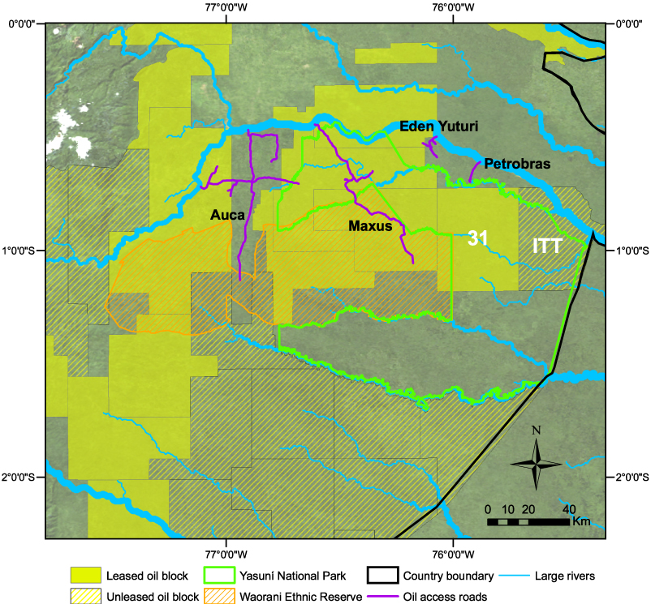
Figure 2: This map shows the locations of both the ITT Oil Block and Block 31in relation to park boundaries, rivers, and access roads. (Finer, Vijay, Ponce, Jenkins, & Kahn, 2009).

Yasuni-ITT Initiative
The Yasuni-ITT Initiative "questions the logic of extractive development" (Acosta qtd. in Hari, 2011 [page no.?]) , and proposes a shift from "an economy based on petroleum exploitation, towards a more sustainable development model" (Yasuni-ITT Initiative, 2009 [ditto]). Thus, it proposes a more holistic approach to economic development, acknowledging the value of natural, cultural, and human capital alongside that of financial capital.ⱱ The main objectives of the initiative are "to protect of biodiversity; to support the livelihood and culture of the indigenous communities living in voluntary isolation; and to ensure net avoided emissions of greenhouse gases" (Ecuador & UNDP, n.d [ditto]).
These objectives highlight three of the four types of capital emphasized by the initiative: natural, human and social. Natural capital is addressed in the value given to the ecosystem services of biodiversity, carbon sequestration, water filtration, food production, etc., that the rainforest within Yasuni provides. Due to the primary focus of the Yasuni-ITT initiative on avoiding carbon emissions and preserving biodiversity, natural capital is of principal importance to the initiative. Human and social capital are addressed in part by the focus on natural capital as well. Firstly, human and cultural capital for indigenous peoples, especially the uncontacted Taromenanae and Targaeri, is closely tied to the ability to maintain a traditional culture. Thus, their ability to perform the other functions of human capital, such as spirituality, skills, or traditional knowledge, are facilitated by the health of their territories and themselves. By forgoing the extraction of oil from the ITT reserves, the neighbouring lands remain unpolluted and productive, and their peoples remain healthy, and thus, their cultures and traditions may remain healthy as well. On a nation-wide, and even world-wide scale, human health is better off for avoiding the emissions, for the effects of climate change are detrimental to the health of large numbers of the human population. Social capital is promoted by the initiative in that it is closely tied with the values expounded within the newly adopted Ecuadorean Constitution, which recognizes not only the importance and value of indigenous heritage and culture, but also of that of the natural world (Republic of Ecuador, 2008). Therefore the initiative fosters cohesion and cooperation among citizens with a relatively new national philosophy and identity by promoting the values of the people, and presenting a common goal for the nation to strive towards.
By leaving the ITT's 846 million barrel reserves in the ground, approximately 1200 million metric tons of carbon dioxide can be kept out of the atmosphere, including 400 million from burning of oil and 800 million from avoided deforestation (Ecuador & UNDP, n.d). Therefore, the initiative proposes a new system, wherein value is accrued to the global ecological benefits of avoiding greenhouse gas emissions by leaving fossil fuel deposits untapped and in the ground, and the involved party is compensated for their sacrifice. For nations with struggling economies, like Ecuador, this remuneration is crucialⱱ, for if no capital can be generated through avoiding emissions, the nation will be forced to pursue "Plan B" (Larrea & Warnars, 2009) and develop the resource. However, Elie Chachoua has pointed out, this arrangement, in effect, offers a positive externality- providing biodiversity and avoiding carbon emissions- for the international community, while providing economic and ecological benefits for the Ecuadorean people, making it both a viable, and decidedly "win-win" situation (2011). Through a multi- donor trust fund, a total of $3.6 billion U.S. dollars is sought from governments, private corporations and individuals in exchange for forgoing the development of the ITT reserves (Ecuador & UNDP, n.d).
The Yasuni-ITT Fund is a joint initiative of the Government of Ecuador, and the United Nations Development Programme. The UNDP contributes by providing management and administration services of the fund, through their Multi-Donor Trust Fund Office (Ecuador & UNDP, 2010a). Ecuador's Ministry of Heritage is designated as the Government Coordinating Entity, and is responsible and accountable for the disbursement of the funds collected. The initiative is governed by a Steering Committee, made up of representatives from the Ecuadorean Government and the UNDP, two individuals from international governments contributing to the fund, and one member from Ecuadorean civil society (Ecuador & UNDP, 2010a). Through the fund, revenue is generated in two ways: through contributions, and through the sale of Yasuni Guarantee Certificates (CGYs). CGYs are exchanged for any contribution over $50,000 USD, and valued based on the quantity? of emissions avoided by a particular donation amount (Ecuador & UNDP, n.d.). The certificates are "national legal obligations" and holders must be reimbursed if the Ecuadorean government decides to extract the ITT reserves (Ecuador & UNDP, n.d.). Revenue raised through the initiative is used to fund sustainable development projects approved by the steering committee, thereby stimulating economic growth, contributing to the nation's social development, and facilitating the transition to a green economy (Ecuador & UNDP, 2010a).
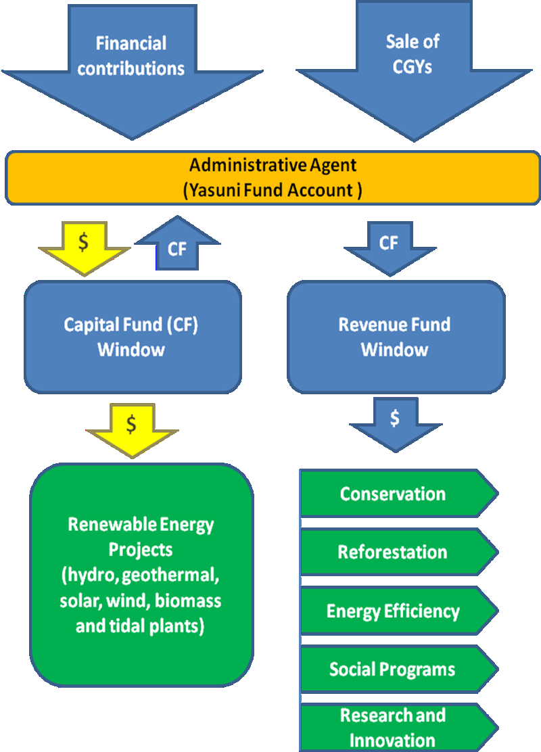
Figure 3: The structure of the Yasuni ITT Trust Fund (Ecuador & UNDP, 2010b) nice!

A New Approach
This new approach to development is reflective of the ecological economic philosophy expounded in Ecuador's new 2008 constitution, discussed above. The document acknowledges the place of society and the economy within the wider natural system and emphasizes the cruciality of natural, human, and social capital to a society's well-being:
We women and men, the sovereign people of Ecuador
Recognizing our age-old roots, wrought by women and men from various peoples,
Celebrating nature, the Pacha Mama (Mother Earth), of which we are a part and which is vital to our existence,
Invoking the name of God and recognizing our diverse forms of religion and spirituality,
Calling upon the wisdom of all the cultures that enrich us as a society,
As heirs to social liberation struggles against all forms of domination and colonialism
And with a profound commitment to the present and to the future,
Hereby decide to build
A new form of public coexistence, in diversity and in harmony with nature, to achieve the good way of living, the Sumak Kawsay.
(Republic of Ecuador, 2008).
In fact, the translation of the Kechwa phrase, "Sumak Kawsay", is well being or good living (Davalos, 2009). Sumak Kawsay refers to the philosophy, held by an array of South American peoples, which stresses the importance of living in harmony within nature, within communities, and within one's own person . Pablo Davalos has described the concept as "a new term of reference to development and economic growth" and" one of the most important and novel alternative proposals to neoliberal globalization" in current times (2009).ⱱ The application of Sumak Kawsay to economic policy creates a view of economic development very different from traditional capitalismⱱ. The resulting policies have a more holistic value system, in which ethics, humanity, and environmentalism are valued over "individualism, the search for profit, the cost-benefit relationship as a social axiom, the use of nature, strategic relations between human beings, the total commodification of all spheres of human life, [and] the inherent violence of consumer selfishness" (Davalos, 2009).
The placement of the philosophy within the Ecuadorean constitution symbolizes a marked shift from neoclassical economics to an ecological economic model. In addition, the principles of Sumak Kawsay are embodied in Ecuador's "National Plan for Good Living 2009-2013" (Gallegos, 2012). Many experts, including Davalos (2009), Gallegos (2012), and Larrea and Warnars (2009), have recognized the Yasuni-ITT initiative as a critical step towards the realization of this constitutional vision, as it places the human, social, and especially natural capital on the same level of priority as financial capital. The influence of Sumak Kawsay can also be seen in the choice to phrase the value of the Yasuni Guarantee Certificates (CGYs) in terms of emissions avoided as opposed to barrels of oil; as the wording is indicative of a shift in thinking away from the notion of resources- especially non-renewables- as the pinnacle of value and towards one which celebrates the importance environmental stewardship and ecosystem services.

Initiative criticisms and successes
The Yasuni-ITT Initiative has prompted critics to accuse the Ecuadorean government of "environmental blackmail", of "ransoming" biodiversity and carbon emissions for financial gain (Finer & Martin, 2010; Walsh 2011). Further criticism has resulted from the inherent complications within the initiative, including the loophole allowing drilling inside the Yasuni Biosphere Reserve with the support of the President and government (Finer & Martin, 2010).
Another criticism is that other blocks within Yasuni National Park boundaries, specifically Block 31, to the west of the ITT block, are threatened with development even as the Ecuadorean government promotes the protection of the ITT (Finer & Martin, 2010; Finer, Vijay, Ponce, Jenkins, & Kahn, 2009). As Block 31 is comprised of the same pricelessly bio-diverse rainforest as the ITT block, the situation and value of both blocks are similar, and the development of either of the blocks could be equally damaging to the region. It remains to be seen whether plans to begin extraction of Block 31 will go ahead; however previous explorations into the possibility have been met with outcry from the public, and from the scientific community (Finer, Vijay, Ponce, Jenkins, & Kahn, 2009).
Despite these criticisms, the Yasuni-ITT initiative has seen success thus far, although it is still too early in the initiative's life to determine what its overall outcomes will be. To date, the fund has successfully reached its first deadline and goal of $100 million dollars by the end of 2011 (Walsh, 2011). It will be some time before a true evaluation of the effects of the initiative on economic development and diversification in Ecuador can be undertaken. However, it is apparent that the initiative has achieved a victory simply through its existence, as it highlights a shift from the capitalist focus on financial capital to a the holistic and sustainable approach of Sumak Kawsay, which recognizes and values the importance of natural, human, and social capital to a sustainable economy, even in the face of a potential financial loss (Finer & Martin, 2010). Though the success of the initiative would be a major boon to both Ecuador, and the environmental movement as a whole, the Yasuni-ITT Initiative is an innovative step away from a capitalist economic model, and towards an ecologically viable economy, whether or not it achieves its final objectives. However, as the meeting of the Yasuni-ITT Initiative 2011 deadline demonstrates, the program is making positive progress towards a successful outcome.ⱱ [This is a highly original paper, Deanna, and very inspiring. Also very well-researched and quite well-written. Perhaps you would be willing to come and talk to my 100s next semester when we do Latin America.] Mark: A

References
Albacete, C., Espinosa, P. & Prado, W. (2004). Rapid Evaluation of the Gran Yasuni Napo. ParksWatch Report. Retrieved from: http://www.parkswatch.org/spec_reports/yasuni_eng.pdf
Baki, Ivonne. (2011). The Yasuní-ITT Initiative. Animal Welfare Institute Quarterly 60.3, 22. Retrieved from www.awionline.org/awi-quarterly/
Bass, M.S., Finer, M., Jenkins, C.N., Kreft, H., Cisneros-Heredia, D.F., McCracken, S.F., Pitman, N.C.A., English, P.H., Swing, K., Villa, G., Di Fiore, A., Voight, C.C., Kunz, T.H. (2010). Global Conservation Significance of Ecuador's Yasuni National Park. PLOS One. Retrieved from http://www.plosone.org/article/info:doi/10.1371/journal.pone.0008767#pone.0008767-United1
Chachoua, Elie. (2011). Turning Externalities into Opportunities: The Case of Ecuador's Yasuní ITT Trust Fund. Getting it Right: Lessons from the South in Managing Hydrocarbon Economies, 193-210.
Davalos, P. & Thompson, B., Trans. (2009, 10, 12) Reflections on Sumak Kawsay (good living) and theories of development. ALAI, América Latine en Movimiento. Retrieved from http://alainet.org/active/33609&lang=es
Ecuador. (2012.). In CIA- The World Factbook. Retrieved from https://www.cia.gov/library/publications/the-world-factbook/geos/ec.html
Finer, M., & Martin, P. (2010, 06, 24). The "Dark Side" of the Yasuni-ITT Initiative (Part II). The Globalist. Retrieved from www.theglobalist.com/StoryId.aspx?StoryId=8534
Finer, M., Vijay, V., Ponce, F., Jenkins, C.N., & Kahn, T. R. (2009). Ecuador's Yasuni Biosphere Reserve: a brief modern history and conservation challenges. Environmental Research Letters, 4.3. Retrieved from http://iopscience.iop.org/1748-9326/4/3/034005/fulltext/
Gallegos, René Ramírez. (2012). A major transition for a great transformation: Reflections from the Yasuní-ITT Initiative. New Society Magazine, 237, 1-15. Retrieved from www.nuso.org
Hari, J. (2011, 05, 26). Johann Hari: A turning-point we miss at our peril. The Independent. Retrieved from http://www.independent.co.uk/voices/commentators/johann-hari/johann-hari-a-turningpoint-we-miss-at-our-peril-2288915.html
Larrea, C., & Warnars, L. (2009).Ecuador's Yasuni-ITT Initiative: Avoiding emissions by keeping petroleum underground. Energy for Sustainable Development,13.3, 219-223. Retrieved from http://www.sciencedirect.com/science/article/pii/S0973082609000581
Repbulic of Ecuador. (2008). Constitution of the Republic of Ecuador. Retrieved from http://pdba.georgetown.edu/Constitutions/Ecuador/english08.html
Republic of Ecuador & United Nations Development Programme. (n.d.).Ecuador Yasuni ITT Initiative Fact Sheet. Retrieved from http://mptf.undp.org/yasuni
Republic of Ecuador & United Nations Development Programme. (2010). Ecuador Yasuni ITT- Memorandum of Agreement. Retrieved from http://mptf.undp.org/yasuni
Republic of Ecuador & United Nations Development Programme. (2010).Ecuador Yasuni ITT- Terms of Reference. Retrieved from http://mptf.undp.org/yasuni
Walsh, B. (2011, 12, 19). Rain Forest for Ransom. Time Magazine. Retrieved from http://www.time.com/time/magazine/article/0,9171,2101884,00.html
Yasuni-ITT Initiative. (2009).Yasuni ITT Documentary 2009. Retrieved from http://mptf.undp.org/yasuni

