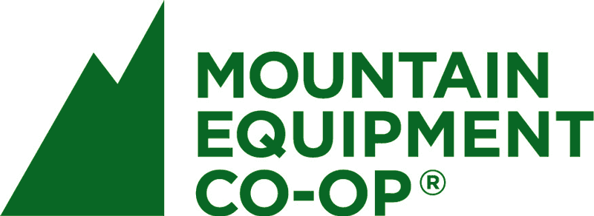

MEC: Case Study and Overview of Cooperative Operations
Jesse Ferguson
Geography 352
Vancouver Island University

Introduction
In the summer of 1970, 4 climbers were snowed in their tent near the base of the Mt. Baker glacier. With nothing to do but talk all weekend, the friends expressed how frustrated they were at how hard it was to get outdoor equipment in BC. They came out of that tent with the determination to start a cooperative retailer of outdoor and climbing gear in Vancouver: Mountain Equipment Co-op. They wanted to create a consumer cooperative, with member shares and quality, inexpensive products. The focus was to be on environmentally friendly and socially responsible operations, not profit. “We want MEC and our members to set examples that inspire other organizations and individuals towards environmental, social, and economic sustainability. In short, we want to leave the world better than we found it.” (MEC, 2012) This as a new kind of company, that focused on getting people out into nature, and keeping that natural environment in pristine condition. It was meant to be much more than just a place to buy gear. The focus they place on natural and social capital is unprecedented. This is reflected in everything they do, from the design of the stores, to the distribution of profit to charities. Sustainability and ethical operation are overarching themes of the co-op, a co-op committed to a new kind of retail.
Co-op Activities
MEC is a successful company that sells millions of dollars a year in outdoor gear. The difference between MEC and other corporations is what happens with the money that remains after all liabilities are paid. Instead of going into the pockets of owners or corporate reserves, it is either given back to members based as a percentage of what they spent, or donated to a number of charitable organizations. Most of these are focused on wilderness preservation. For example, MEC is a member of 1% For the Planet. This organization requires members to annually donate at least 1% of the total amount sold to Canadian Environmental Causes. The MEC website states that since 1987, they have donated over $17 million. (MEC, 2012) 1% a year is the minimum, and they often give two or three times this amount in a year. The organization is composed of over 1300 businesses, and the money goes to about 3000 approved environmental organizations. MEC states that it is the first major retailer in Canada to be part of this movement, and hopes to set an example for others to follow.
Another major project that Mountain Equipment Co-op supports is an organization called the Big Wild, which MEC itself started, in conjunction with the Canadian Parks and Wilderness Society (CPAWS). It is a foundation dedicated to the protection of Canada’s wilderness, and aims to get at least 50% of our natural spaces protected. They believe that this is the minimum amount needed to retain the integrity of our ecosystems. Small isolated parks aren’t good enough, and don’t look at the big picture of ecosystem relationships and movement of wildlife. The Big Wild is committed to keeping very large wild areas intact, hence the name of the organization. MEC itself provides funding, research and staff for the movement, and seeks to educate its customers about the program and how they can help preserve wilderness in Canada. The way that the Big Wild works is by targeting specific areas, and putting pressure on provincial and federal government to create new parks in the region. They urge the public to submit letters to politicians, and on the website they provide templates for letters, as well as petitions to sign. They target everyone from local MP’s all the way up to the Minister of the Environment and Prime Minister, and show them how much citizens of Canada care about our environment and wilderness. Although The Big Wild is primarily about conservation, it is also a community celebrating adventure and our natural environment. According to their webpage, “This site is a community of Canadians celebrating our wilderness – and working together to protect it. It's a place where you can share your wilderness experiences...plan an adventure with friends... and meet people like you who love the outdoors and our wild spaces.” (The Big Wild, 2011) Members can upload stories, photos, and videos of experiences they’ve had in our wilderness. It is a movement to encourage getting outside and experiencing our planet, which is an over-arching theme of MEC as a whole. This improves natural, human and social capital all in one.
Sustainability
Being an outdoor focused business, they put a great deal of emphasis on natural capital and environmentally friendly practices. These values affect everything they do, from the design of stores themselves to the services provided for employees. They make an effort to situate stores in locations near public transit routes, or areas easily accessible by foot or bicycle. Every store has a bike rack, and they provide services to employees such as secure bike storage and solar showers to encourage cycling to work. There is no staff parking at MEC stores, and they claim that “Almost 82% of MEC employees nationwide use alternative transportation (bike, public transit, or foot) to get to work. By comparison, 59% of Metro Vancouver commuters arrive at work in a single-occupancy vehicle.” (MEC, 2012)
Every Mountain Equipment Co-op retail location is constructed to be as efficient and low impact as possible. Everything from the building materials to the design itself takes the environment into account.” Green building is the way we mitigate environmental degradation by designing and operating our structures to use energy, water, and materials efficiently.” (MEC, 2012) Using the Ottawa store as an example, it is evident how extensive their dedication to the environment really is. It was the first retail oriented building in Canada to meet the C2000 Green Building Standard. The store is built in a location that was home to another building for the previous 40 years. That structure was disassembled in a way that enabled them to reuse a large amount of the material. 75% of that building (by weight) was somehow incorporated into the new store. They also built the new store with panels and screws in such a way that it can be easily deconstructed and the materials be used again.
The floor of the new building is a combination of wood from the previous building and reclaimed timber from the St. Lawrence River. Rock for the floor was excavated directly from the site, and the natural floor eliminated the need for wasteful carpeting. 80% of all material used for construction came from within 500km. This cuts down greatly on transportation costs and supports the local economy. Insulation for the building is provided by a combination of 50% recycled Rockwool insulation, and bailed straw. Straw is apparently 50% more efficient at containing heat than standard insulation, and is obviously natural and renewable. Millwork is formaldehyde free, paint is low or zero VOC (volatile organic compound), and the entire air conditioning system is CFC free.

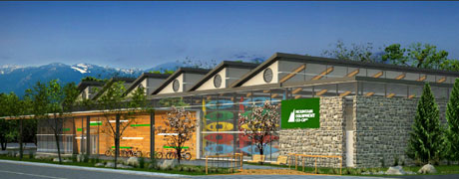
MEC North Vancouver (http://209.205.95.211/joomla/green/index.php?start=48)
An even more recent example is the North Vancouver location, built earlier this year. The entire building was designed around the sun, to utilize as much natural light as possible. The roof was built in a saw tooth style, as shown in the photograph above. The slope is facing north, so that light enters through the flat, south facing windows and is directed down by the reflective sloped ceiling. This provides a substantial amount of sunlight, even in cloudy weather. When there isn’t any natural light available, or for display lighting they use energy efficient fluorescent bulbs, or halide lights. This base lighting is controlled by sensors and timers to turn on or off automatically depending on the amount of natural light being received. The large wall windows are double paned and filled with argon to reduce heat loss or gain from sun. All windows, including the roof slopes use special coatings as well to lessen solar energy penetration. Temperature is controlled by a geo-exchange system utilizing the large concrete floor slab. It acts as a radiant heating or cooling system, depending on the predicted weather. The system looks at 24 hour weather forecasts, and automatic predictive controls are used to pre- heat or cool the large concrete mass. The slab then slowly releases its stored thermal energy to moderate temperature inside the building. This is very energy efficient, and it has much of the same effect of an ocean to control climate. Areas situated near oceans generally have temperature climates without too much variation, because the huge water mass stores thermal energy and moderates temperature change, by heating or cooling far slower than the air surrounding it. This is the principle behind the concrete temperature control system. Another feature is the water system, which uses a well for non-potable water, and collects rainwater, without any connection to the city sewer system. All water is returned to the ground after use and treatment. Along with these measures are things such as multiple bike racks and electric car charging stations to encourage sustainable transportation. The cumulative effects of all of these features create a much smaller environmental footprint than the average building, and enhance the natural capital of the area. The backdoor of the store opens right into Lynnmouth Park, which is full of hiking and biking trails that run in and around Mountain Equipment Co-op’s property.

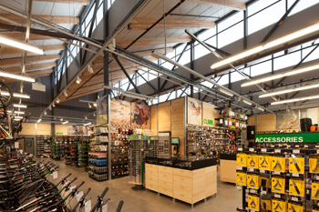
Interior of MEC North Vancouver, displaying the sawtooth roof windows (http://www.proscenium.ca/Pages/Detail_Commercial_MEC_NV_Store-copy.shtml)
Human Rights
These are far from the only ways that Mountain Equipment Co-op seeks to improve the state of capital. In their clothing they try to include a least 50% organically grown cotton or recycled polyester. PVC-Free is a common label on their gear, and they try to responsibly manage emissions and chemical usage in their factories. These same factories must have good quality working conditions and wages for workers, or MEC will not source from them. As a company it is big on ethical production, and they believe that they as a business can advance human rights. “The goal of our Ethical Sourcing Program is to improve the human condition in factories.” (MEC, 2012) The website states that, in principle, they support a living wage for labourers making the products they out on shelves. In practice though, it is not a reality for many reasons. They state 3 of them as:
-No formula for calculating living wage that they agree with
-No support of the factory or industry. As well, workers making MEC products also make many other brands, so payment would be difficult to determine
-Higher prices will be a result of higher cost labour. “We do not know how higher prices would impact our members and ultimately our ability to run the Co-op in a sound financial manner”. (MEC, 2012)
It is true that it is extremely difficult to get Canadian labour without much higher prices, so many of the products come from China. This sometimes generate a lot of criticism from members who state that this goes against core values of the co-op, but realistically there is not a whole lot more they can do. They try to source as much as possible from Canada, but Canadian labour isn’t economically viable for things like textiles that don’t require a high skill level. The company claims that they closely monitor the working conditions of their factories, and deal with infractions quickly. This all sounds very nice in theory, but it is questionable how well it is carried out, and how well workers are actually treated. Certainly though, they do a great deal more than the average clothing company to ensure that the products they sell are as ethical possible. Factories that are found to be in violation of human rights are put on suspension, and if they fail to demonstrate major changes they lose the business of MEC, and the retailer will find a different place to source from. This provides an incentive for suppliers to treat the employees properly, and enhance human capital.
Conclusion
Overall, MEC should be seen as a role model that all other companies should try to emulate. They were named number one in Corporate Knights list of top corporate citizens in Canada for 2010, and consistently rank within the top 3. They are miles ahead of most other retail companies in terms of sustainability, human rights, and member ownership. There are other companies that are good at one or two of these things, but MEC excels at embodying all of them at once. They were also chosen as one of BC’s top employers in 2012, for their treatment of employees (Leung K, Yerema R, 2011). Some of the reasons stated include: excellent financial rewards such as bonuses and profit sharing plans, maternity and parental leave extended benefit coverage and payments, employee development by subsidies for schooling and assorted training/career planning, flexible hours and work arrangement options that balance personal and work life. Employees also enjoy discounts and the testing of almost all gear available, as well as free benefits such as bicycle maintenance and outdoor workshops. In everything from building design to daily operations, this co-op seeks to enhance natural and human capital in each store, and all around the world.

References
Cowling D,. (2010) Mountain Equipment Co-op. New store tests design for recoverability. SAB Mag, Retrieved on November 10, 2012, from http://www.sabmagazine.com/blog/2010/03/11/21-mountain-equipement-co-op/

Heaps T., (2010) Mountain Equipment Co-op Tops Best 50 Corporate Citizens in Canada list for 2010, Corporate Knights, Retrieved on Sept 24, 2012, from http://www.corporateknights.com/in-the-press/72-press-releases/588-best-50-corporate-citizens-2010-press-release.html?page=show
Leung K. , Yerema R., (2011) Mountain Equipment Co-Op, Mediacorp Canada, Retrieved Sept 24, 2012, from http://www.eluta.ca/top-employer-mountain-equipment-co-op
Strashok C., ( 2011) Mountain Equipment Co-op: A cooperative business model, Community Research Connection, Retrieved on Sept 24, 2012, from http://crcresearch.org/community-research-connections/crc-case-studies/mountain-equipment-co-op-co-operative-business-model
(2008) MEC gets award for sustainable business, Vancouver Sun, Retrieved on November 10, 212, from http://www.canada.com/vancouversun/news/business/story.html?id=d7729874-1dde-4785-ba4e-2980e52a714b

