Zoey Ledingham
Portland Public Transit

Over the years Portland Oregon’s public transit has grown immensely, now being one of the leader in the U.S. We’ll be looking at Portland’s current transit and their future plans.
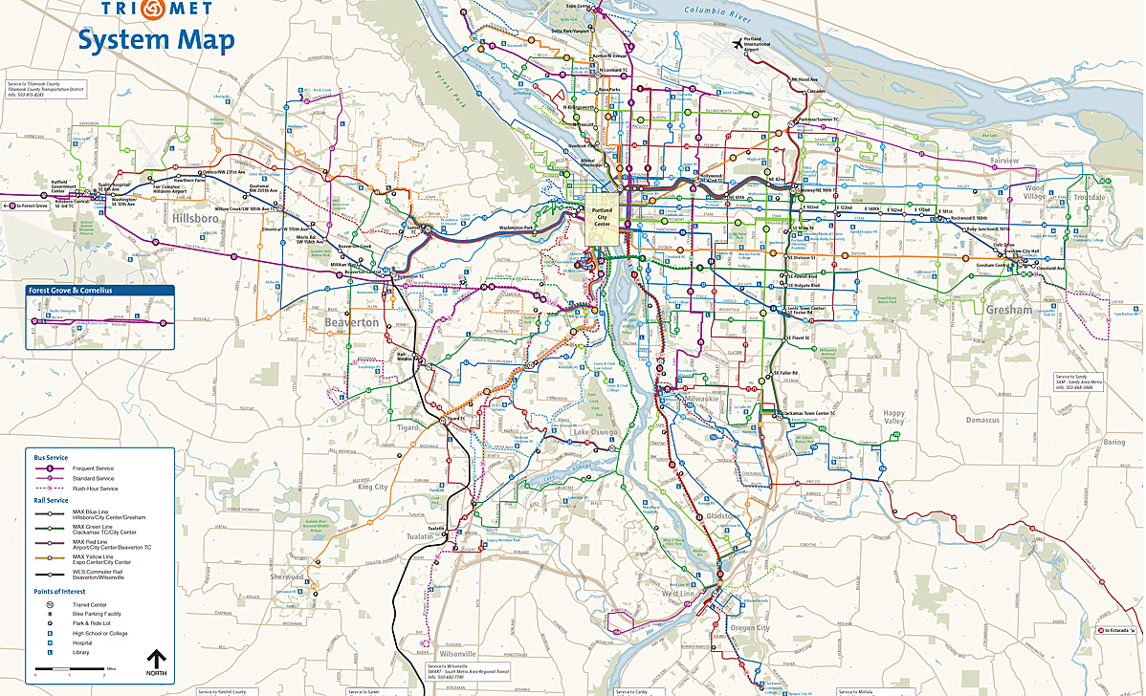
Currently in Portland there are many options for transportation. Aside from private vehicles, there are TriMet Buses, the Max Light Rail, WES Commuter Rail, Portland Streetcars, Aerial Tram, Car2Go, ZipCar, bike trails and rentals, and walking trails. All of which should gladly accommodate for everyone’s need.
There are 625 buses, with 79 routes, and hundreds of stops with the TriMet Bus, but if there isn’t a close enough stop to where you’re going, you can request a stop anywhere along the route between the hours of 8 p.m. and 5 a.m. to help ensure safety of their passengers in getting home. The TriMet Bus operates more frequently during the weekday morning and evening rush hours, running every 15 minutes for many. Upon arrival to stops the bus either has a recording or the bus driver himself or herself will announce their line name and destination over an external speaker as well as within the bus and showing on an illuminated board near the operator. Every bus is equipped with a boarding ramp or power lift and most cal also ‘kneel’ which is when the front of the bus lowers down to the height of the curb. There is priority seating, and securement area for two mobility devices. One of the neatest additions to the buses in Portland has to be the tracking devices. People can observe on a Smartphone App the exact location of the buses, which aids in accuracy with timing and such for their riders. [sources?]
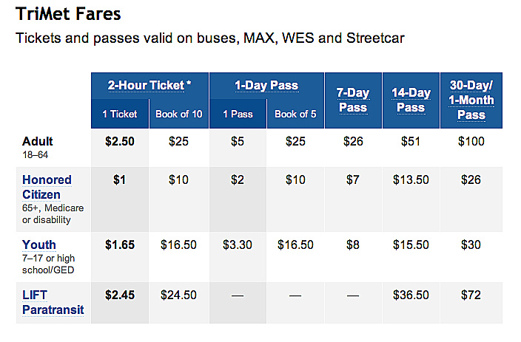
The MAX Light Rail runs everyday with a frequency of 15 minutes or less most of the time. Each station includes or is close by to a free 24-hour parking available for riders and carpoolers. The Rail connects Portland with Beaverton, Clackamas, Gresham, Hillsboro, North/Northeast Portland, and the Portland International Airport. Upon arrival an audio system announces the name of the station both externally and internally along with an illuminated board with the name of the station inside the train. The Rail have ramps that extend onto the sidewalk for easy boarding, along with texture tiles nearing the edge of the platform that can be detected by foot or cane for safety. [ditto]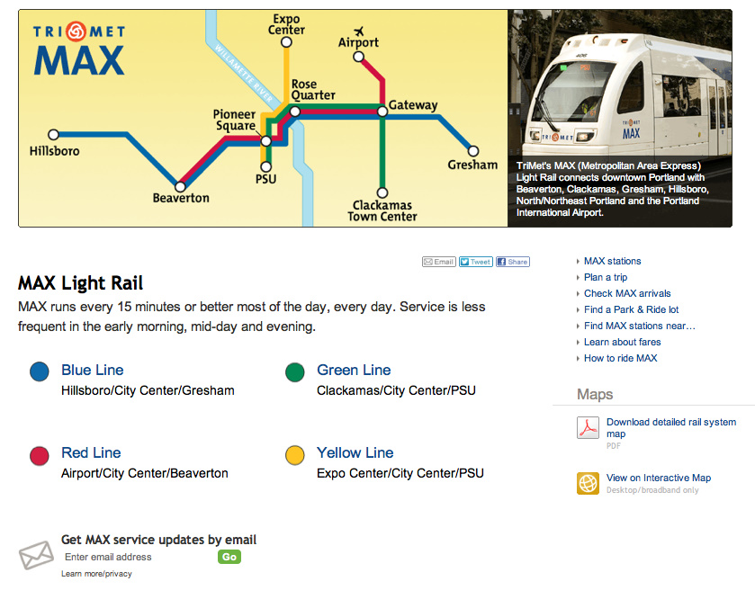
The WES Commuter Rail is an important addition to the Portland Transit. It travels between Wilsonville, Tualatin, Tigard, and Beaverton also connecting with the CAT in Canby, Cherriots in Salem, and SMART in Wilsonville, which are local buses. The Commuter Rail also includes special features such as free wireless internet and ticket machines which accept debit and credit cards, and similarly to the MAX Light Rail, it includes free 24-hour parking for riders and carpoolers at 4 of the WEST stations and offers accessibility features as well.
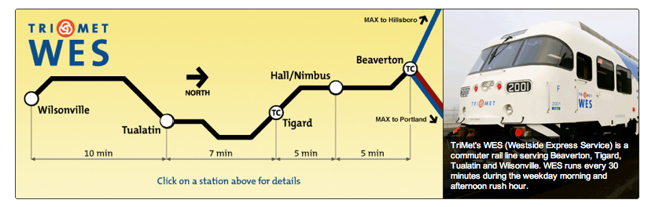
The Portland Streetcar connects Northwest Portland, the Pearl District, Portland City Centre, PSU, RiverPlace, the South Waterfront District, the Rose Quarter, the Lloyd District, the Oregon Convention Center, the Central Eastside Industrial District, and OMSI. It runs every 15 minutes during the day, and less frequently in the evenings and on Sundays. Although the Streetcar is owned and operated by the City of Portland, it is integrated with the TriMet services and scheduled to align with other transit services. Every Car is equipped with bridgeplates in the spacious low floor section of the car, along with reader boards and audio announcements to indicate the next stop, incase of emergency they are equipped with an intercom to talk to the operator, and they are air-conditioned.
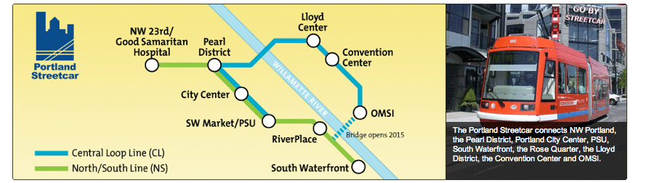 The Ariel Tram travels 3,300 linear feet between the South Waterfront terminal next to OHSU’s Center for Health and Healing and the upper terminal of Kohler Pavilion. It is mostly used by students, only costing $4 for a roundtrip and it’s bike and wheelchair friendly.
All buses and trains within TriMet are equipped to transport people’s bikes; Buses can hold 4 bikes, there are 10 designated areas for bikes on the MAX but the spaces are shared with strollers and luggage, WES can hold up to 6 bikes, and the streetcars have a few designated bike areas which are also shared space.
Or there are also a few other bike parking option. At the Sunset, Beaverton, and Gresham Central transit centers there are secure enclosed parking lockers available with the use of keycards. At the Orenco/231st Ave MAX Station and Tigard TC WES Station there are electronic bike lockers, also known as eLockers, which are first come first serve enclosed lockers with keycards. Nearly all rail stations and transit centers there are reserved bike lockers for rent and at MAX and WES stations there are first come first serve bike racks.
Recently there was a competition for which company would take the initiative to implement shared bikes throughout the city. The winning company is Alta Bicycle Share, which can be found and used all around the world. There are self-serve bike stations throughout Portland where riders with either their membership card or credit/debit card can then rent a bike, and later return back to another bike station. This service is offered 24 hours a day, 365 days a year and only costs $5-$7 a day or $50-$85 a year, with the additional small cost after 30 minutes of using a bike.
In 2008 Portland’s Bureau of Transportation estimated the replacement cost of its then 300-mile bikeway network at approximately sixty million dollars. Although this seems to be a lot of money, the same amount that covers every off-street path, bike lane, and more, would only pay for the construction of approximately one mile of urban freeway.
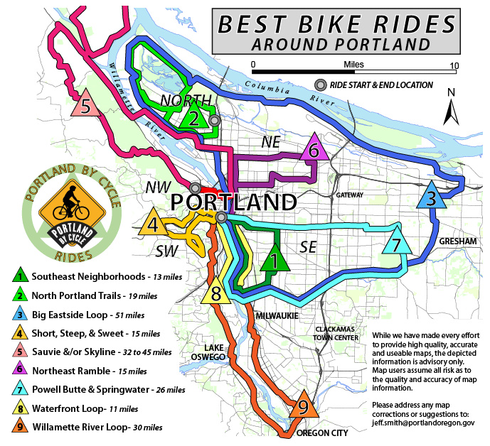
Although walking, biking, and public transit is the ideal green method to get around; Portland also provides other temporary vehicular transportation so less people need to own their own vehicles. Aside from renting a vehicle like in any city, there are two brilliant vehicle ‘rental’ companies, Car2Go and ZipCar. In both situations they are rentals in which you become a member for a small fee then you can rent a vehicle on your Smartphone App, but unlike a normal car rental, these companies rent by the minute and you don’t need to go sign a contract to use one.
Car2Go has over 200 cars in Portland that are ready to go whenever you are. By going on the app you’re able to see where the nearest available smart car is to rent it, then by using your membership card and entering your pin you gain access to the vehicle and only need to push the start button and go at only $.38 a minute, no keys or contracts necessary. Once you’re trip is finished you just leave the vehicle where you want within the boundaries of Portland and someone else will eventually end up needing it. 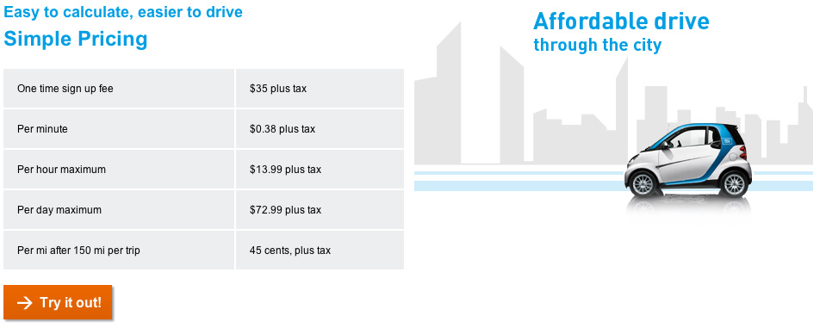
Although the process to begin is similar to Car2Go, Zipcar is more similar to an actual car rental. They have many types of vehicles available, from a MINI to a Prius to a BMW, etc. And they are rented from a rental station, so only for round-trips, but there are many stations located all around Portland, so not to worry about getting it back to one particular location.
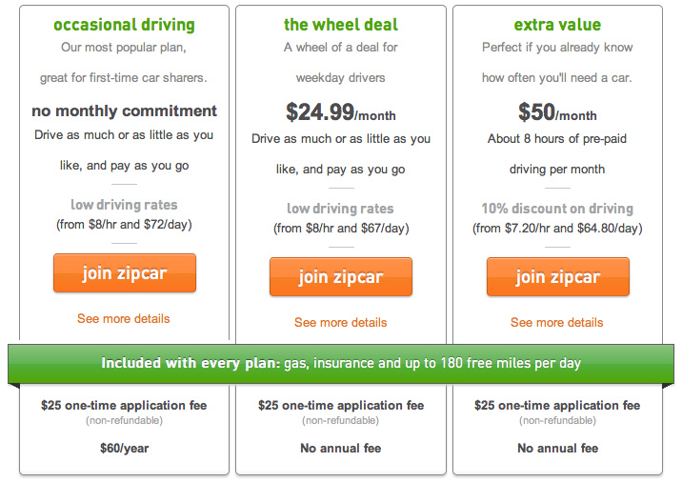
Portland has more options to try to appeal to all groups of people. Portland as a city is ADA compliant and is currently working on ways to further improve their accessibility restrictions.
There are three methods of transportation aside from details within the city such as ramps, sound signaling at crosswalks, service animal allowance, and previously listed features. The three methods are the ‘Neighborhood shuttles’, ‘Medical Transportation’, and ‘LIFT Paratransit services’.
The ‘Neighborhood shuttles’ is a door-to-door service provided through Ride Connection’s transportation network, which is available for seniors and people with disabilities.
‘Medical Transportation’ is coordinated by Trimet and is meant for low-income Oregon Health Plan Plus members who need rides to medical appointments and have no other transportation options available. Although it is not meant for emergency transportation, it is perfect when needing to go to your physician or doctor. This service needs to be booked but can be done on the day of the appointment as long as it’s between 7 am and 6 pm Monday-Friday. Both of these are free services, alternatively ‘LIFT Paratransit Services’ fees are just shy of the cost of a regular transit ticket for an adult.
The ‘LIFT Paratransit Services’ is meant for those who are not able to ride regular buses and trains due to a disability or disabling health condition. It is a shared-ride public transportation service and service hours are generally between 4:30 am and 2:00 am, seven days a week, and the vehicle will travel up to ¾ a mile beyond the outermost portions of TriMet’s bus and MAX line, but it unfortunately doesn’t operate outside the TriMet District.

In 2012/2013/2014 Portland is initiating a few more ways to assist their public transit.
A new pedestrian and public transportation bridge ‘Portland-Milwaukie Light Rail Bridge’. It spans the Willamette River near the Oregon Museum of Science and OMSI on the east bank to the South Waterfront neighborhood on the west bank in fall of 2015. The bridge will be distinctive in the US, only carrying light rail trains, buses, cyclists and pedestrians, and in the future streetcars. The bridge will not be accommodating private vehicles although the structure will allow use by emergency response vehicles when necessary. There will be two 14-foot-wide pedestrian and bike paths on the bridge that will connect planned greenways as part of the city’s Waterfront Loop walking and bicycle trails and the bridge will close important transportation gaps for bike commuters and mass transit riders along the new Portland-Milwaukie Light Rail line which also begins service in 2015.
In 2001, Portland built the first modern-day streetcar which travels through downtown from Portland State University to the Nob Hill neighborhood via the popular shopping and dining neighborhood known as the Pearl District. In the fall of 2012 the project to expand the line to the city’s eastside was completed, adding 3.3 miles and 28 stops to the original line. The line is expecting to start running U.S.-made streetcars this year.
Portland’s mission in 2014 is to “fix what we have and pay what we owe”

Although only 6% of people bike as their method of transportation and only 12% of people use other methods of public transportation, I believe that Portland is definitely on the right track to eventually having a much larger percentage of people using public transit. Surprisingly, most cities are only around 10% if they have good public transportation, which as we know, is not great on the environment. If other cities offered more options and also had tracking devices on their buses that the public could access, I feel their cities would also be on the right path. The largest issue here lies in the eye of the beholder. I spoke to Ethan Seltzer, a Prof at PSU, who said that he uses public transit almost everyday and only have a vehicle at home for long trips or in case of an emergency. He believes that more money has to go into the operation of the transit because a different group pays for the construction, and often they can build but they can’t run them. [more explanation needed…] But after I spoke to Jerry Weller, my boyfriend’s father who’s lived in Portland for the last four years, and he thinks that money has to be put into pot holes and fixing up the roads.
[beautifuly illustrated, Zoey, but more descriptive than analytically; not much discussion of why Portland was able to do what it did and lessons for other jurisdictions. Badly referenced. C-]

Works Cited

http://www.governing.com/topics/transportation-infrastructure/gov-portland-oregon-struggles-to-remain-leader-in-public-transit.html#previous

http://www.trimet.org/howtoride/bus.htm

http://www.trimet.org/howtoride/max.htm

http://www.trimet.org/howtoride/wes.htm

http://www.trimet.org/howtoride/streetcar.htm

http://www.wired.com/autopia/2009/11/portland-trimet-mass-transit/

http://www.pdx.edu/transportation/public-transit

http://gobytram.com/

https://www.car2go.com/en/portland/

http://www.zipcar.com/

http://www.movingtoportland.net/portland-information/buses-and-trains

http://www.altabicycleshare.com/

http://www.portlandoregon.gov/transportation/57983

http://trimet.org/pm/construction/bridge.htm
http://www.oregonlive.com/commuting/index.ssf/2013/04/trimet_begins_building_portlan.html

