Tamera Rogers
GEOG 346
Don Alexander
March 30th, 2012

Interim Brownfield Use: A Case Study of the YPN Community Gardens

Introduction

Travelling through urban areas, it is common to see vacant lots dotting the landscape. These abandoned properties are like missing teeth; one can imagine what was once there, but an empty space is all that remains. Lying vacant, these lots are often capped with cement and surrounded by fencing, further removing them from any benefits to the community. Lots such as these are frequently referred to as brownfields and are defined by the National Round Table on the Environment and the Economy (NRTEE), an independent policy advisory agency for the Government of Canada, as “abandoned, vacant, derelict or underutilized commercial and industrial properties where past actions have resulted in actual or perceived contamination and where there is an active potential for redevelopment" (2003, p. ix).
Brownfields can be eyesores in communities that threaten the health and safety of community members and the surrounding environment. At the same time, they can be benefits to communities if they are remediated, redeveloped or put to temporary use. The purpose of this essay is to describe in greater depth the concerns, challenges and opportunities associated with brownfields, and to consider a strategy for interim use of brownfields as witnessed in a case study in Nanaimo, BC.

Brownfields
While brownfields can be located anywhere, they are most commonly situated in towns and cities. According to the British Columbia Ministry of Environment (2009), BC has more than 9000 brownfields (p. 1). Examples of brownfields are abandoned gas stations, dry cleaning establishments, former industrial sites, and junkyards. These sites often contain heavy metals such as lead, arsenic, cadmium, and mercury (BC Ministry of Environment, n.d. B, para.1). Substances such as these pollute the air, soil, water, and vegetation on sites causing ecological damage as well as mild to severe threats to human health.
While brownfields are stigmatized for their site contamination, not all brownfields are necessarily contaminated. In fact, it is estimated that “up to 30% of brownfield sites, once investigated, are found to be uncontaminated or marginally contaminated” (BC Ministry of Environment, 2007, p. 1). On the other hand, the BC Ministry of Environment (2007) explains that not all contaminated sites are brownfields as the site must have redevelopment potential if it is to be considered as such (p. 1).
The process of identifying potentially contaminated sites is usually triggered when an application is received by a local government for development, rezoning, demolition, or soil relocation on “land that the person knows or reasonably should know is or was used for industrial or commercial activity” (BC Environmental Management Act, 2012, Section 40). The process can also be triggered when a local government is notified of a spill or possible contamination and when an industrial or commercial site is being decommissioned or foreclosed (BC Ministry of Environment, 2009, p.2). When a site comes to the attention of a municipality, the person responsible for the site is required to complete a site profile. Site profiles identify the history of a site and its potential for contamination. If the site’s history indicates potential site contamination, a site investigation is required. When a brownfield is found to be contaminated, the results are compared with environmental quality standards to determine the remediation plan needed for the intended redevelopment use (BC Ministry of Environment, n.d. A, para. 8). Depending on the severity of contamination, those responsible for the brownfield will either be required to remediate the property immediately, or, if there is little immediate risk to human health or the environment, remediation can be postponed [BC Environmental Management Act, 2012, Section 48(9)].
Each brownfield is different as each site has had a unique past and unique location, which can affect its value to developers. In Canada, brownfields are grouped into three categories: top tier, middle tier and bottom tier sites. According to the NRTEE (2003), top tier brownfields account for 15% to 20% of brownfields in Canada and are the most profitable to redevelop (p. 5). Because of their greater potential for profitability, top tier brownfields tend to redevelop quickly. On the other hand, bottom tier brownfields also make up 15% to 20% of brownfields in Canada, and are often cost-prohibitive to remediate and are unlikely to be redeveloped in the near future (NRTEE, 2003, p. 5). Finally, middle tier brownfields make up the majority of brownfields in the country at roughly 60% to 70% of sites (NRTEE, 2003, p.5).
Middle tier brownfields are, at once, a great problem and a great opportunity for developers and communities. These brownfields can be problematic because while they tend to have ideal locations within cities, they are costly to remediate (NRTEE, 2003, p. 6). Because developers do not stand to profit much from redeveloping middle tier brownfields, these sites tend to stay vacant until developers feel the risk is worth taking.

Challenges

Left vacant, brownfields are of disservice to communities as they do not provide social, economic or environmental value. Abandoned brownfields can attract crime, lower property values, provide little tax revenue to cities, leave holes in communities, and contaminate the environment.
Aside from these detractions, brownfields are also difficult to redevelop. A significant reason for this is that there is a liability risk associated with brownfield ownership. According to the BC Environmental Management Act (2012), those responsible for the remediation of contaminated brownfield sites include “a current or previous owner or operator of a site, or the current or previous owner or operator of a site from which the substance has migrated” (Section 45). While there are instances where an owner or operator of a contaminated brownfield is not held responsible for remediation, there remains a great deal of risk involved in owning a brownfield (BC Environmental Management Act, 2012, Section 46). What’s more, liability for brownfields does not disappear after the property passes into other hands. In fact, even after remediation is completed, most provinces do not provide a certificate of completion of remediation. Even when they do, such as in BC, it is still possible that liability can be reopened if environmental standards and procedures change (NRTEE, 2003, p. 6).
In the NRTEE (2003) report, Cleaning Up the Past, Building the Future, the authors explain that the risk of liability passes on a great deal of stigma surrounding brownfields for all stakeholders (p. 7). For example, since there is no transfer of liability when a brownfield is purchased, owners may prefer to keep ownership and leave the property vacant, ensuring that they will not face future charges for remediation due to their previous ownership of the property (NRTEE, 2003, p. 7). Additionally, interested developers are often apprehensive to invest in brownfields as they also become liable for contamination from previous owners. Even financers have concerns as they risk assuming liability for the site if the owner defaults on payments.
The second significant challenge for brownfield redevelopment concerns the capital required for the upfront costs associated with remediation and redevelopment (NRTEE, 2003, p. 7). Because developers of contaminated brownfields must pay to have their sites assessed, investigated and remediated before they can redevelop, they must acquire a considerable amount of capital to complete the project. As was previously mentioned, lenders often consider brownfields as high-risk investments and usually require assurance that their investment is worth the risk—something that developers cannot always provide.
If the risk and lack of capital were not enough to dissuade potential developers from brownfield redevelopment, it is difficult to convince them to do so when it makes much more sense to develop greenfields, which offer greater potential profit for less time spent on the project.

Opportunities

While the challenges related to brownfields are significant, the opportunities for brownfield redevelopment and the associated benefits to the economy, community and environment are considerable. Some of the opportunities of brownfield redevelopment are related to the location of the site. The NRTEE (2003) explains that brownfields are often located in easily accessible transportation corridors in urban areas (p. 3). This can be explained by their pasts as commercial and industrial ventures that were located in areas easily accessed by the workers and clientele that frequented them. Their location within urban areas is a benefit to communities and developers as new developments can take advantage of existing municipal infrastructure, decreasing the cost of the project (NRTEE, 2003, p. 3).
Additionally, by revitalizing abandoned and derelict sites within the city, the reuse of brownfields benefits cities by adding to property tax revenues, promoting infilling (rather than urban sprawl) and creating new jobs, particularly in development and site remediation (NRTEE, 2003, p. 2). Rejuvenating sites can also raise neighbouring land values and revitalize communities, as unsightly and potentially contaminated brownfields are cleaned-up and turned into better places for both citizens and the environment.

Interim Brownfield Usage: The YPN Community Gardens

Despite the benefits to society as a whole, the fact that most middle and bottom tier brownfields remain vacant is indicative of the market failing to effectively allocate the resources needed to make use of these sites. If a price tag is attached to all the benefits of redevelopment including improved health of environments and communities; preservation of greenfields; and increased tax revenue, land value and job creation, it becomes clear that redevelopment has a very favourable cost-benefit ratio (Hara, 2003, p.i-ii). Yet, many of these benefits are externalities to brownfield redevelopment that are not included in assessments of the final value of the redeveloped land. Consequently, the market fails to offer enough incentive to brownfield owners, developers or end-of-project owners to accept the risks and challenges of the site.
Interim uses of brownfields offer a temporary solution to the challenges of sites that are difficult to redevelop. The interim use of a brownfield benefits communities by offering a service and contributing to the economy while remaining provisional. This kind of temporary use can be helpful for middle and bottom tier brownfields, as owners who are waiting for markets to improve can still make use of the site until the time is right for redevelopment. The interim uses that are possible on brownfields vary from site to site due to differing degrees of contamination. Possible interim uses include creating greenspaces, parking lots, brightfields (installations of solar panels), cafes, galleries, potted plant nurseries and community gardens. In Nanaimo, BC, the Young Professionals of Nanaimo (YPN) Community Gardens provide an interesting example of the community benefits granted by the interim use of an abandoned gas station lot.
The YPN is a non-profit organization that facilitates networking and community involvement amongst young professionals in the city. In 2011, the YPN, interested in promoting food security and healthy eating in the city, started a project to establish more community gardens in Nanaimo. Their aim was to use their networking abilities to set up gardens that would eventually be maintained by the communities in which they were located. The organization identified brownfield sites as potential locations for the community gardens, in part to make use of a vacant space but also to beautify the city. The YPN also explained that they liked the choice of abandoned gas station lots because of the positive symbolism of transforming them into gardens (Gorman, 2011, para. 11). Through negotiations with property owners, the YPN were able to establish a five-year lease with Imperial Oil to use its abandoned property on Turner Road in North Nanaimo and also had a brownfield temporarily donated on the corner of Needham and Irwin in South Nanaimo (Barron, 2011, para. 2).
In the summer of 2011, the two gardens were built with volunteer help from the YPN and community members, donations from local businesses and support from the City of Nanaimo. Because of the risk of contamination, all garden plots were raised above ground and new soil was brought in to fill beds. The site is now run by volunteers and plots are available to the public for $30/year. In addition to individual plots, the YPN has also set aside beds that volunteers use to grow produce for the Loaves and Fishes food bank in Nanaimo (YPN Community Gardens, 2011). As of March 2012, all plots are being used in the north end garden.
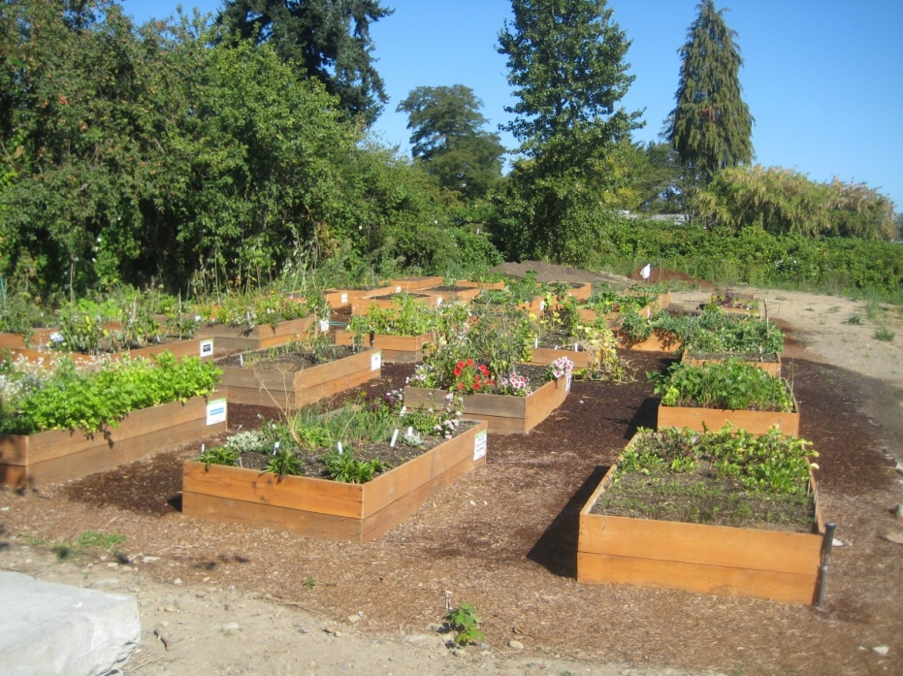
YPN Community Garden in South Nanaimo
(ABC Precast & Ready Mix Ltd., 2011)
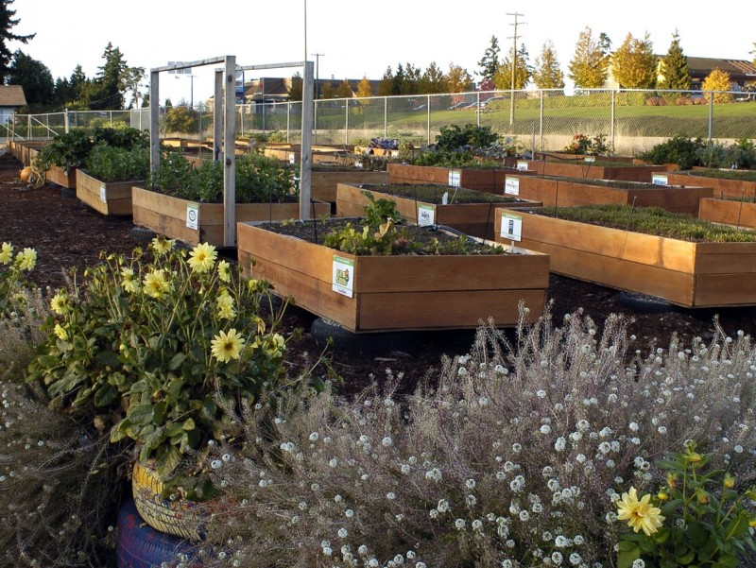
YPN Community Garden in North Nanaimo
(Belbin Household, 2011)

Strengths of the Approach
There are many strengths to the YPN’s approach of implementing community gardens as an interim brownfield use. The primary strength of this interim use is that it converts a community burden into a community asset while still leaving the potential for future redevelopment of the site. The conversion of the vacant lots into gardens creates a space that is both beautiful and beneficial to the surrounding community. Revitalizing vacant lots also has the benefit of decreasing crime in neighbourhoods, as the site is used more often and people tend to take care of things that they value. Seeing positive change in communities through the use of brownfields also helps to mitigate the stigma against brownfields, causing developers to see opportunities in redevelopment and the potential for future redevelopment projects to face less opposition. Beautification of once blighted sites also helps to raise properties values in the immediate area. Finally, a significant strength of this approach is that it has the potential to be replicated in other cities.

Weaknesses of the Approach

A weakness of the interim use of brownfields, including their use as community gardens, is that they are only temporary solutions to the problem of brownfields in cities. There is no requirement for interim users to remediate sites; therefore, successful interim use may prolong the time the brownfield site is left contaminated. Along the same line, community gardens are public spaces that are often well-loved by the surrounding community. Because of this, when the owner of a site decides it is time to redevelop, he or she may be met with opposition from the community that stalls the remediation of the site and its eventual redevelopment.
Another weakness of the approach of community gardens on brownfields is that there is stigma within the community of the dangers of food grown on contaminated sites. The YPN, for example, has had to do a significant amount of advertising in local newspapers of their risk-assessment process as they faced some initial opposition and concern from the community. In the end, despite these efforts, some community members remain unconvinced.
A lack of resources and a lack of willingness from property owners provide further obstacles to this approach. In general, there is a lack of incentive for property owners to allow interim uses such as community gardens. In the case of the YPN Community Gardens, the YPN first had to convince property owners to lease their sites for very little compensation ($1 per year) and then had to fundraise and apply for grants to build the gardens. Unless organizations or private ventures provide the financial resources to start a community garden, there is little financial incentive for brownfield owners to implement one themselves.

Recommendations

While the strengths and weaknesses identified were written specifically for the YPN’s interim approach, the recommendations provided can be applied to other interim uses. The first recommendation is that municipalities should write policies for interim use and make the process as clear as possible. This could also include a searchable database of brownfields available for interim use within the region. The less bureaucracy interested parties must experience, the more likely that interim brownfield use will be considered a viable opportunity.
In order to support interim use of brownfields, municipalities should offer incentives for property owners to convert vacant properties to interim uses. Incentives could take the form of tax breaks or grants. Taking this concept further, municipalities could provide financial disincentives to leaving properties vacant to encourage interim use of sites.
Finally, to mitigate public resistance to redevelopment of interim community spaces, property owners or those leasing the land should communicate with the public about the intent of the interim use. By making clear the intention of the new use (to provide a temporary use for the site), when redevelopment begins, the public may be more likely to support the process.

Conclusion

Brownfields provide a significant challenge to communities. Vacant lots lower the quality of life for citizens and provide hazards to human and environmental health. While there are many opportunities associated with brownfields, markets are currently failing to meet our needs and many brownfields face a future of idleness unless put to temporary use. Interim uses, such as the YPN Community Gardens, may only be short-term solutions to many of the challenges of brownfields; however, they provide benefits that far exceed leaving lots idle. Until markets find a solution to the problem of middle and bottom tier brownfields, interim uses may be the best choices for filling in the holes in communities.

References

ABC Precast and Ready Mix Ltd. (2011). ABC in the community. Retrieved on March 31st, 2012, from http://www.abcprecast.ca/index.php?page=32&did=4170&level=1&type=unique
Barron, R. (2011, May 11). Group moves forward with big plans for community gardens. Retrieved on March 29th, 2012, from http://www2.canada.com/nanaimodailynews/news/story.html?id=a3e04dff-4fed-41f8-8a2f-2a7a1d73d13b
Belbin Household. (2011, November). Canadian Geographic energy diet challenge: Community gardens. Retrieved on March 31st, 2012, from http://energydiet.canadiangeographic.ca/home/update/community-gardening
British Columbia Environmental Management Act. (2012, March 14). Part 4: Contaminated site remediation. Retrieved on March 23rd, 2012, from http://www.bclaws.ca/EPLibraries/bclaws_new/document/LOC/freeside/--%20E%20- -/Environmental%20Management%20Act%20SBC%202003%20c.%2053/00_Act/03053_04.xml#part4
British Columbia Ministry of Environment. (n.d. A). Brownfields and brownfield redevelopment. Retrieved March 22nd, 2012, from http://www.env.gov.bc.ca/epd/remediation/brownfields/index.html
British Columbia Ministry of Environment. (n.d. B). Contaminated sites 101. Retrieved on March 22nd, 2012, from http://www.env.gov.bc.ca/epd/remediation/cs101.htm#1
British Columbia Ministry of Environment. (2007, August). Facts on contaminated sites. Retrieved March 22nd, 2012, from http://www.env.gov.bc.ca/epd/remediation/brownfields/index.htm
British Columbia Ministry of Environment. (2009). An introduction to contaminated sites in British Columbia. Retrieved on March 29th, 2012, from http://www.env.gov.bc.ca/epd/remediation/fact_sheets/pdf/fs01.pdf
Gorman, T. (2011, March 24). YPN considers unused lots for garden project. Retrieved on March 29th, 2012, from http://www.nanaimobulletin.com/news/118257174.html
Government of British Columbia. (2012). A community resource guide for brownfields redevelopment: Case studies. Retrieved March 26th, 2012, from http://www.brownfieldrenewal.gov.bc.ca/Documents/BrownfieldsRedevelopment_CaseStudies_Web.pdf
Hara, D. (2003). Market failures and the optimal use of brownfield redevelopment policy instruments: National brownfields redevelopment strategy. Retrieved March 25th, 2012, from http://economics.ca/2003/papers/0245.pdf
National Round Table on the Environment and the Economy. (2003). Cleaning up the past, building the future: A national brownfield redevelopment strategy for Canada. Retrieved March 22nd, 2012, from http://nrtee-trnee.ca/wp-content/uploads/2011/06/brownfield-redevelopment-strategy-eng.pdf
YPN Community Gardens. (2011). YPN community gardens. Retrieved on March 29th, 2012, from http://www.ypngardens.com

