Ashley Dodsworth
Geography 352 Case study: 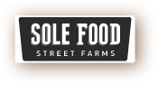

SOLE food farm market started in 2009 as a social enterprise part of United We Can, but owned by Cultivate Canada. Cultivate Canada is a registered charity and oversees the operations and activities of SOLEfood street farm. They have a board of directors consisting of four members- Rob Withers, Michael Ableman, Russel Precious, and Sherry Edmunds Flett. Hey have several donors: Radcliffe Foundations, Vancity Community Foundation, Vancity Capital, and the City of Vancouver; as well as supporters: Central City Foundation, TD FEF Fund, Natures Path, Real Estate Foundation, VEEES, Building Opportunities with Business, and Social Ventures Partners Vancouver; they also have several infrastructure partners: BW Global Structures Inc., Valhalla Inc., and Eco-soil. They grow vegetables and sell them currently to 30 local restaurants and at local farmers markets to the public. Their first growing season in 2009 they grew 10 000 pounds of produce on its first half acre lot. This year (source published in 2012) they grew 100 000 pounds of produce on the five verdant sites.(2)
How do they get land to grow on? Well, the city of Vancouver provides some land in some cases. Some landowners get a 65% property tax break for the project as an incentive to allow them to use the land. Companies like Concord Pacific, who owns land near BC place and home of the markets highest profiting site uses the money they get and put it back into the farm. Some landowners may be reluctant to allow them to use the land. They put in the lease stating that they will leave on short notice as they grow the produce in fork lift moveable containers that are able to move at a moment’s notice.(2)
The people that are employed at SOLE Food farms are recovered addicts, people from the downtown east side. These people are given a second chance to make life right. From BC Living about Ron, manager at downtown east side site:
You couldn’t tell by the way he gingerly handles the plants, but he only recently started working in agriculture. Four months ago, Rob was going through some personal changes and looking for a job. “It’s been a winding road,” he says. “I went to recovery and then started working with an agency that helps people in recovery find employment, and through my research, though I have many interests, I kept coming back to horticultural therapy, which I had zero experience in but it seemed to really pull me.” This was when he heard about SOLEfood. After attending an information session, he was hired on the spot. (3)
From the Globe and Mail: If SOLEfood has changed its employees for the better, it has also changed Mr. Ableman, too. “I have seen a level of courage and determination among our staff that you would be hard-pressed to find anywhere,” he says. “I see these folks rise up against incredible personal challenges. …I’ve seen the dignity of these folks. I think there’s a very thin line that separates any of us from folks who are living on the margins of the Downtown Eastside.” One of the farm’s employees has gone off social assistance for the first time in her life. “I don’t know if we can attribute that to our work,” Mr. Ableman says. “But I think there’s a connection.”(4)
They currently employ 25 people who make $10.50 an hour from outside sourcing…(4)
They currently have four sites located in Vancouver:
Strathcona- The original site where most of the ideas and techniques used at all other farms. This is a half-acre parking lot adjacent to the Astoria Hotel on Hastings and Hawkes.
False Creek- This is their largest farm- 2 acres provided by Concorde Pacific. The farm is located on the corner of Pacific and Carrall, right below BC Place sports stadium. This site makes use of the advantages like warmth, exposure, larger concentrated block to grow on.
East Van- This farm is located beneath the Grandview viaduct in an industrial part of town. They have one acre of high tunnel unheated greenhouses; provides infrastructure to grown warm weather crops and extend growing season through the winter months.
Main St.- Their newest farm is located at the intersection of Main and Terminal. This one acre lot was provided by the City of Vancouver and is the future location of the New City Market but currently hosts their retail sales outlet which provides products from all the farms six days a week.
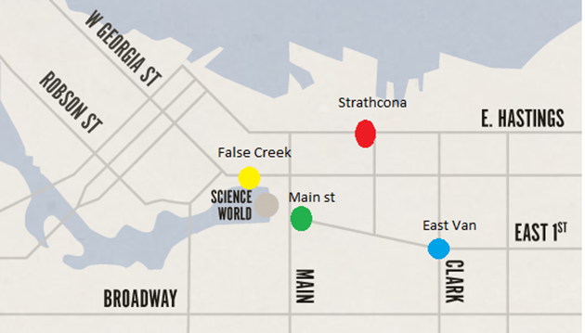
FIG. 1. Map of SOLEFoods four farm sites.

They are currently growing: Arugula, Basil, Beets, Carrots, Cilantro, Collards, Cucumber, Dill, Eggplant, Filet Beans, Green Onions, Hot Peppers, Kale, Lettuces, Melons, Parsley-curly and flat leaf, Peas, Radicchio, Radish, Rainbow Swiss Chard, Spinach, Strawberries, Sweet Peppers, Tomatoes and Cherry Tomatoes.
There are many forms of capital which SOLE food covers…Physical capital, human capital and social capital are ones that come to thought right now. Human capital: They take people from the downtown east side of Vancouver, who are recovering addicts, are unhireable, or have mental illness and they give them a job and they teach them something that is totally new to them. Not very often are people willing to do this, to offer a person a second chance at life to turn life around…
“There are a lot of ups and downs,” Mr. Ableman said. “I have come to realize that addiction is a lifetime experience and, as such, we have allowed for that in our employment model.” (2)
SOLEfood still has many challenges, says Ableman who is also a partner in the project, having been part of the planning process. “Most of the people have never done this, the learning curve is fairly steep but I see this as one piece of a number of sites around the city that we’ll do together,” he says.(3)
"And I think the guys who have stayed with it, there have been little moments when we’re planting or something and I see these guys who had such a tough life in many respects become so soft and so attentive and so sensitive to a tiny little plant and it’s so great.” (3)

Physical Capital: They take barren lots and turn them into farms and make it a beautiful sight to see.
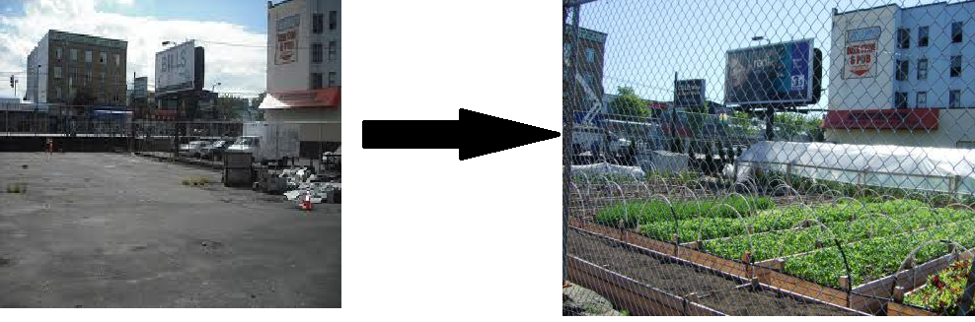
FIG. 2. This is their Strathcona location before the farm and then after.
They are giving an improvement to downtown Vancouver.
But mostly because it has transformed a vacant lot in Vancouver’s Downtown East Side (DTES), a community that unfortunately is more associated with street drugs and social problem than with fresh veggies. Maybe SOLE food is going to change that, even just a little bit. (4)
About two years ago, the idea of starting an urban farm arose and after a year of looking for a suitable and available space, the parking lot adjacent to the Astoria Hotel on Hastings Street and Hawkes Avenue came up late last fall. The problem was, the owners wanted to take advantage of the property tax concessions that the city of Vancouver was offering to land owners who would convert bare lots or unused space into a green space, and the deadline was….tight. “We built in one day, on October 31” says Seann Dory, a soft spoken Edmontonian-turned-Vancouverite/ and social enterprise manager turned farmer, “in order to get the tax assessment done.” It took about 50 volunteers to turn the 17, 000 square-foot space into an urban veggie farm on that day last year. The farm is now in its very first growing season in the summer of 2010. The land that it sits on is courtesy of the owners of the Astoria Hotel, a rooming-house hotel common in the neighbourhood. Dory explains that they got access to the lot because of Vancouver’s new tax incentives for green spaces. It was the parking lot to the hotel next door, but mainly it was a dumping ground and a haven for a lot of the street activity that goes on in the neighbourhood. The hotel owners received a healthy tax break if they converted that unused space to a park or garden; and UWC jumped at the chance because they had been looking for a space for their urban farm for almost a year without any viable prospects. But the deadline for the tax evaluation was November 1 and Dory and about 50 volunteers had to literally build the farm on October 31 in order for the space to qualify. It worked and the enterprise got the space for merely the cost of the property taxes.(4)
Social Capital: The people that they hire are on their way up from an all-time low. This is giving them something to feel good about doing, gives them something worth changing their lives for. They are taking lots used by drug dealers and prostitutes and turning it into a garden growing high quality food. It’s giving people a new lease on life as not very many people are willing to take people from the DTES and have faith in people who are recovering addicts and suffering from mental illness.
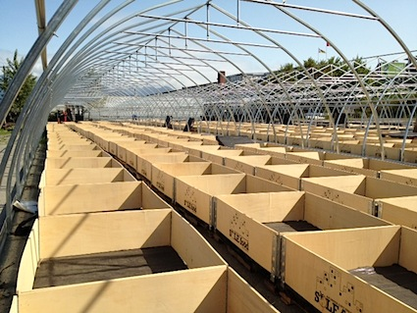
FIG. 3.These are what they plant the crops in.

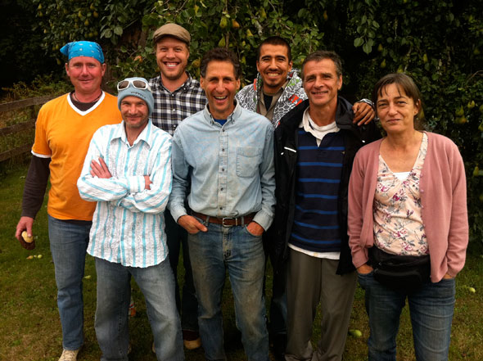
FIG. 4. From Left to Right (hopefully): Rob Holland, Ken Vallee, Seann Dory, Michael Ableman, Michael Jacko, Alain Guy and Donna Gilkes.

References:
1. SOLE Food Street Farms. Online source. Accessed on 21/11/13. http://solefoodfarms.com/
2. Beverley Smith. SOLEFood Farm changes landscapes and lives. The Globe and Mail.
Published 20/11/12. Last Updated: 20/11/12. Online source Accessed on 21/11/13. http://www.theglobeandmail.com/report-on-business/solefood-farm-changes-landscapes-and-lives/article5471486/
3.Colleen Tang. SOLEFood, a community’s farm. BCLiving. (nd) Online source. Accessed on
21/11/13. http://www.bcliving.ca/garden/solefood-a-communitys-farm
4.Jennifer CK. Vancouver Pt. 3: SOLEFood Farms, An Urban Farm Project. Welcome to
foodgirl.ca. 04/09/13 Online Source. Accessed on 21/11/13. http://foodgirl.squarespace.com/book/2010/8/4/vancouver-pt-3-solefood-farms-an-urban-farm-project.html
Image locations:
1. http://solefoodfarms.com/
2. http://www.cityfarmer.info/2012/05/16/another-solefood-urban-farm-being-built-in-vancouver/; http://archive.constantcontact.com/fs045/1102771164343/archive/1105313947030.html
3. http://www.cityfarmer.info/2012/05/16/another-solefood-urban-farm-being-built-in-vancouver/
4. http://vancouverisawesome.com/2011/12/07/vancouver-farmers-markets-vendor-profile-1-solefood/

