Belo Horizonte:

Food Security in Brazil

Vahid Mathiscyk

Geography 352

Don Alexander

November 21, 2013

“Hunger is not caused by a scarcity of food but a scarcity of democracy” (Lappe, 2009) Among the myriad of issues that are pervasive in our global society, hunger and malnutrition are ones which should no longer, or should ever have fallen under the category as a “global issue.” Everyone should be entitled to food just like everyone is entitled to air. Food should not be seen as a material commodity. Belo Horizonte, the fourth largest city in Brazil, is an exemplary case where democracy prevailed and food sovereignty became possible and prominent. Changes made in policies and municipal law became the cornerstone of Belo Horizonte’s community, making it what it is today, with communities around the world seeking to follow in their footsteps. In addition, the collaboration of social, human, economic and physical capital (Roseland, 2013) were the striking forces that allowed for Belo Horizonte’s community to become more sustainable.
Belo Horizonte is located in the southeastern region of Brazil, with Sabara and Betim as neighbouring cities and is the capital and largest city in the state of Minas Gerais. (wiki)
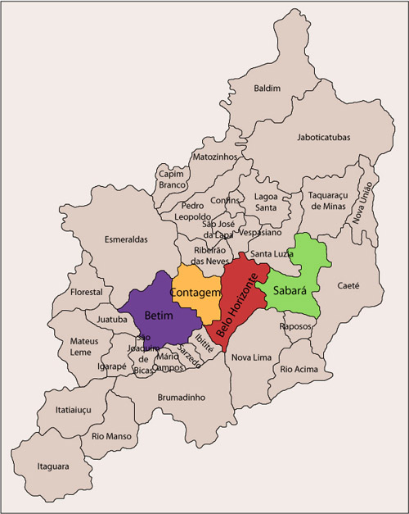
Figure 1: Map of Brazil
“Belo, a city of 2.5 million people, once had 11 percent of its population living in absolute poverty, and almost 20 percent of its children going hungry. Then in 1993, a newly elected administration declared food a right of citizenship.” (Lappe, 2009) Newly elected mayor, Patrus Ananias, was a key actor in revolutionizing Belo Horizonte’s food initiatives by establishing food as a right.
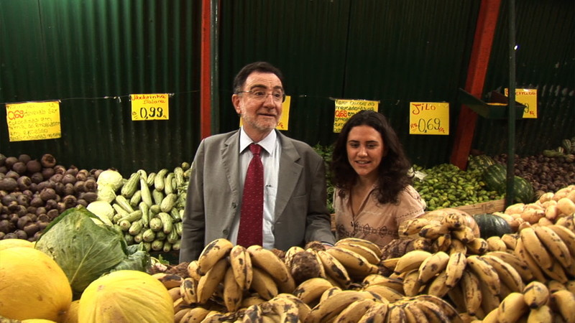
Figure 2: Patrus Ananias (on the left) - Former Mayor of Belo Horizonte

“Its Municipal Law No. 6.352, 15/07/1993 set out a policy framework that is committed to the concept of food sovereignty: the right of peoples to define their own food and agricultural policies, to protect and regulate their production and trade in such a manner as to secure
sustainable development, to determine the degree of their autonomy and to eliminate
dumping on their markets.” (Gopel, 2009) This policy would then become world renowned and would win the 2009 Future Policy Award as “the world’s most comprehensive policy that tackles hunger immediately and secures a healthy food supply for the future.” (Gopel, 2009)
Although citizens have been part of Belo’s “participatory budgeting” (PB) model since the 1970s, it only became prominent in 1993 as the city was seeking to manage the city’s budget in such a way that included both citizen participation and to properly manage the public budget, gearing it towards food sovereignty. “Through the PB, communities discuss and decide on what investments should be carried out by the local administration in its region. Through the meetings and the Comforça, the wishes of the residents turned into reality.” (Pimentel, Fernando - Current Mayor of Belo Horizonte, n.d.)
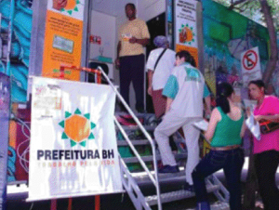
Figure 3: Citizens engaging in Participatory Budgeting voting station

Although the participatory budgeting model is significant and relevant to the transition in Belo Horizonte’s community, the factors that present Belo Horizonte as such an interesting case are encompassed in the unique example of urban governance in creating an alternative food system. “Unlike many areas in North America and Europe where alternative food systems are emerging from private (although certainly not conventional) market initiatives and social movements (such as direct marketing, Community Supported Agriculture, ‘slow food’, ethical labeling, organic products, and ‘fair-trade’), Belo Horizonte’s ‘alterity’ or ‘alternativeness’ is due, in large part, to conscious public policy-making.” (Rocha and Lessa, 2010)
Essentially, Belo Horizonte’s alternative food system is so unique because it was created by government and it reached both the private sector and civil society. Embodied in Belo Horizonte’s public policy-making was the formation of the “Municipal Secretariat of Supplies (Secretaria Municipal de Abastecimento - SMAB) created by the City Government to develop and carry out an integrated policy addressing malnutrition and hunger in the area.” (Rocha, 2001) All of the projects designed by the staff at SMAB are guided by the principle that “all citizens have the right to adequate quantity and quality of food throughout their lives, and that it is the duty of governments to guarantee this right” (Rocha, 2001) The program implemented by SMAB is divided into three main lines of action.
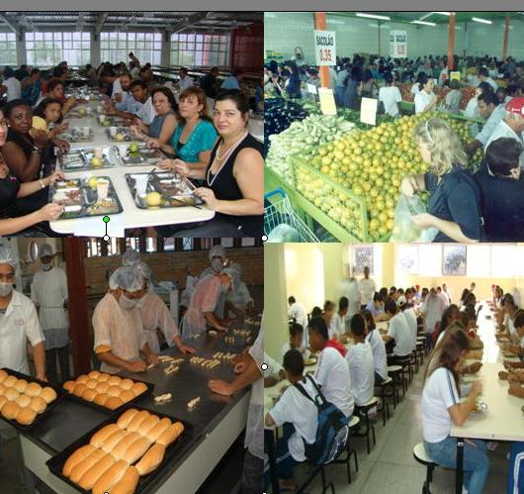
Figure 4: Depictions of the different “lines of action”

The first line of action encompasses policies geared to “assist poor families and individuals at risk to supplement their food consumption needs.” (Rocha, 2001) Rather than simply being emergency programs, these are permanent initiatives where progress is monitored by civil society groups. The second line of action in the SMAB program is directed towards the private sector in the food trade. “Through partnerships with private food suppliers, the SMAB has been able to bring food to areas of the city previously neglected by commercial outlets.” (Rocha, 2001) The last line of action are attempts to increase food production and supply. “Initiatives here include technical and financial incentives to small producers, creation of direct links between rural producers and urban consumers, and promotion of community gardens and other forms of "urban agriculture."” (Rocha, 2001) Among the many projects and programs, the city agency aimed at integrating farmers and consumers by offering local family farmers several public spaces where they can sell to urban consumers, “essentially redistributing retailer mark-ups on produce—which often reached 100 percent—to consumers and the farmers. Farmers’ profits grew, since there was no wholesaler taking a cut. And poor people got access to fresh, healthy food.” (Lappe, 2009)
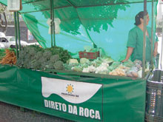
Figure 5: “Direct From the Country” farmer produce stand

Additionally, Belo Horizonte’s food system consist of a number of interconnected programs that foster and complement one another. Public restaurants; school meals; food banks; employment and income generation; the People’s Basket; special program to combat malnutrition; education on healthy nutrition; and urban agriculture are a few, among many other successful programs, that will be further discussed emphasizing the success of Belo Horizonte’s food system.
The defining factor about Belo Horizonte’s public restaurants are that “the restaurants are subsidized by the city and provide healthy and nutritious lunches at a low price.” (WorldFutureCouncil, 2013) This is not only great for citizens, but great for local businesses, allowing them to provide local food for consumers and supporting local food suppliers. School meals in Belo Horizonte represent “free, fresh and high nutritional school meals for all children enrolled in public schools are being provided.” (WorldFutureCouncil, 2013) This takes away added pressure on parents and ensures that not only that their children being fed, but the food carries significant nutritional value. Although food banks are common in North America, food banks in Belo Horizonte not only provide non-perishable food items but “food banks are provided with produce from rural and family agriculture,” (WorldFutureCouncil, 2013) reinforcing the sense of local community.
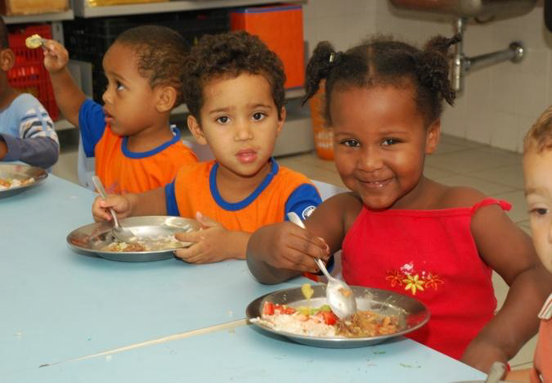
Figure 6: Children in public school eating a nutritious lunch

The “People’s Basket,” is a very unique program intended for the lowest income families which are registered with the authorities. “They are given magnetic cards with which they can buy highly subsidized food and foodstuffs and other products (cleaning products, personal hygiene products, etc.) at supermarkets, abastacers and in special busses.” (WorldFutureCouncil, 2013) Providing citizens that have low incomes with the ability to purchase not only food but certain necessities, removes some of the hardship in their lives.
One of the most effective projects set out by the SMAB was “to distribute “enriched flour” (with vitamins, minerals and ground cassava leaves) to mothers with young children, pregnant and nursing women in low-income areas through health clinics and the school meals program to fight malnutrition in the first years of the system.” (WorldFutureCouncil, 2013) Finally, urban agriculture is extremely prominent in Belo Horizonte and a key component to its successful food system. Urban agriculture in Belo Horizonte is supported through three projects: “community gardens in free space in the city to grow vegetables, fruit and medicinal plants; School gardens which complement the school meal program; Workshops for urban agriculture and plant cultivation on alternative spaces like terraces, roofs and windowsills.” (WorldFutureCouncil, 2013)
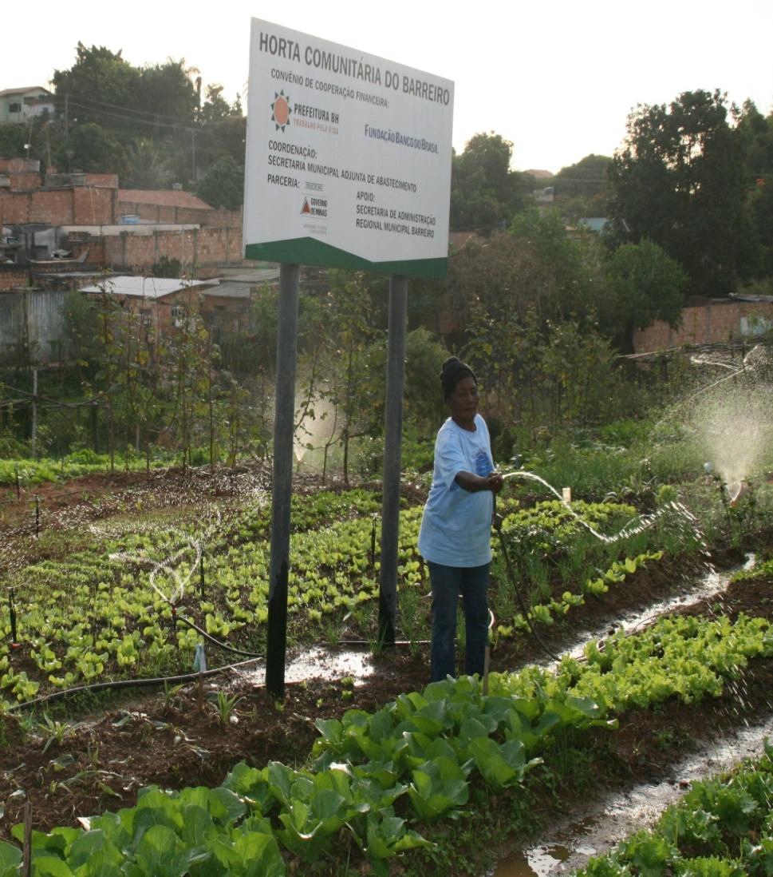
Figure 7: Community Garden

Urban agriculture is a significant factor that emphasizes locality and security and is essential for Belo Horizonte and all other communities in the world.
Measuring Belo Horizonte’s success is an integral aspect when defining their community and when differentiating from others. Their success reflects the attention received from around the globe and for other communities desire to adapt their systems. To bring to light how these programs have affected peoples lives, it would be fundamental to provide some findings. As of 2009, sixty percent fewer children are dying compared to ten years ago; twenty-five percent fewer people live in poverty; seventy-five percent fewer children under five are hospitalized for malnutrition; forty percent of the population benefit directly from the program; forty percent of people in Belo Horizonte report frequent intake of fruit and vegetables (the national average is just thirty-two percent); and two million farmers have access to credit. seven-hundred-thousand for the first time in their lives. (Gopel, 2009)
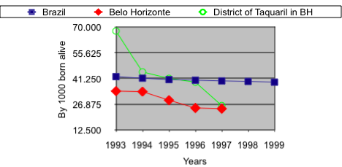
Figure 8: Evolution of Infant Mortality Rate in Children Under One

Belo Horizonte’s success reinforces Mark Roseland’s model on mobilizing communities. It is evident that Belo Horizonte represents specifically four of Roseland’s forms of community capital. The first being physical capital, which consists of “machinery and other infrastructure that can be used to produce goods and a flow of future income.” (Roseland, 2013) Belo Horizonte’s administration allowed for a significant emphasis to be made on supplying infrastructure to support all sorts of food initiatives. (e.g. buses for low-income citizens as a part of the “People’s Basket” program and farmer produce stands.)
Second, is human capital which is the “knowledge, skills, competencies and other attributes embodied in individuals that facilitate the creation of personal, social and economic well- being.” (Roseland, 2013) Citizens of Belo Horizonte work together in such a way that their knowledge and skills allow for an interconnectedness among suppliers, business owners and consumers, allowing for an exceptional flowing system.
Following is social capital, which “constitutes the "glue" that holds communities together. It represents community cohesion, connectedness, reciprocity, tolerance, compassion, patience, forbearance, fellowship and love.” (Rocha, 2009) This exists not only among citizens, but among institutions and social development programs as well. Finally, is economic capital. “Individuals and organizations use financial resources, such as money and access to affordable loans, to achieve well-being and generate wealth through goods and services production.” (Rocha, 2009) When Belo Horizonte’s administration decided to shift towards integration among the private and public sector, locally-owned and operated companies and suppliers were able to generate employment and income within the community.

The case of Belo Horizonte’s food system and the overall changes that were made in municipal law are ones which restore a lot of faith in humanity. In addition, although no place is perfect, Belo Horizonte represents a remarkable example of a city that practices a true democratic system and proves that it can be fully functional and efficient. The ability for citizens to voice their views and opinions, for the community to integrate the various forms of community capital and for the administration to establish food sovereignty, allowed for Belo Horizonte to be known as “the city that ended hunger.” (Lappe, 2009)

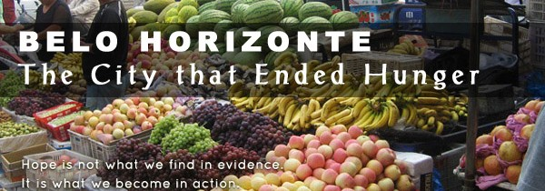
Figure 9: The City that Ended Hunger

Bibliography

(2013) Belo Horizonte. Wiki. Retrieved from: http://en.wikipedia.org/wiki/Belo_Horizonte

Author Unknown (Jan 2013) Sharing the Experience of the Food Security System of Belo Horizonte. WorldFutureCouncil. Retrieved from: http://www.fao.org/fileadmin/
templates/FCIT/Meetings/Africites/presentations/WorldFutureCouncil_experience-Belo-
Horizonte.pdf

Author Unknown (2008) Participatory Budgeting in Belo Horizonte Fifteen Years. Retrieved from: https://www.demworks.org/node/583

Cecilia Rocha & Iara Lessa (2009) Urban Governance for Food Security: The Alternative Food System in Belo Horizonte, Brazil, International Planning Studies, 14:4, 389-400, DOI: 10.1080/13563471003642787

Gopel, Maja (2009). Celebrating the Belo Horizonte Food Security Programme. Hilmer Bee, Hamburg. Retrieved from: http://www.worldfuturecouncil.org/fileadmin/user_upload/ PDF/Future_Policy_Award_brochure.pdf

Lappe, F. M. (Feb 2009). The City that Ended Hunger. Retrieved from: http:// www.yesmagazine.org/issues/food-for-everyone/the-city-that-ended-hunger

Rocha, C (2009). Urban Food Security Policy: The Case of Belo Horizonte. Ryerson University. Retrieved from: http://www.ryerson.ca/foodsecurity/publications/articles/
BeloHorizonte.pdf

Roseland, M (March 2013) The Community Capital Sustainability Framework. Retrieved from: http://www.cnv.org/attach/2013%2003%2018%20item%2013.pdf

Figure 1: http://www.chs.ubc.ca/consortia/beloE.html
Figure 2: http://www.drsfilm.tv/nl/no_fight_no_victory
Figure 3: http://demworks.org/node/583
Figure 5: http://www.yesmagazine.org/issues/food-for-everyone/the-city-that-ended-hunger
Figure 6 and 7: http://www.fao.org/fileadmin/templates/FCIT/Meetings/Africites/presentations/WorldFutureCouncil_experience-Belo-Horizonte.pdf
Figure 8: www.envireform.utoronto.ca/conference/local-food/adriana-aranha.ppt‎
Figure 9: http://delightmakers.com/news-bleat/the-city-that-ended-hunger/

