Belo Horizonte: A Story of Those in Need of Help, Learning as a Communal Whole how to Sustainably Help Themselves Through Food and Nutrition Security.

Alexandra Casey
GEOG 352 – Don Alexander
Due November 24th

INTRODUCTION: ESTABLISHING A NEED FOR CHANGE
The Belo Horizonte Metropolitan Region is Brazil’s third most populated area with 5.7 million people calling it home. With such a large population, it becomes vital for good governance to take a leading role in facilitating the needs of the various communities within its scope. Focusing on the early 1990s, it was estimated that 38% of families within this region lived below the poverty line. Additionally, it was recorded that 18 percent of children less than three years of age suffered from malnutrition, and that “infant mortality was a high 35.3 per thousand live births,” (FAO Belo Horizonte, 2015). These statistics are crippling to a community and emphasize a need for there to be an intervention to reignite health and prosperity.

In 1993, an opportunity presented itself, as it was time for Belo Horizonte to elect a new mayor. Quite desirably, the winning political agenda, “promoted inclusive social and economic development, focusing on ending hunger and poverty, creating jobs and investing in education and health,” (FAO Belo Horizonte, 2015). According to Yes! Magazine, “The new mayor, Patrus Ananias—now leader of the federal anti-hunger effort—began by creating a city agency, which included assembling a 20-member council of citizen, labor, business, and church representatives to advise in the design and implementation of a new food system,” catering to the importance of allowing locals to lead initiatives to strengthen their own community, as opposed to bringing in foreign ‘professionals’ (The City that Ended Hunger, Lappe). As will be presented throughout the following report, this leadership left in the hands of locals is the key reason that that this movement to become food secure is successful. By legitimizing the agenda of food sovereignty on a community based scale via the municipal government, the movement is able to make procurements that work in the best interest of the city.

EARLY INITIATIVES:
One of the first things accomplished by this new government was the creation of SMAB. SMAB was the, “government’s first act to create a municipal food supply agency . . . charged with preventing and reducing malnutrition among vulnerable groups, bringing food to parts of the city that were neglected by commercial outlets, and increasing food production,” (FAO Belo Horizonte, 2015). From here, SMAB divided its program into two key endeavors. “The first encompasses policies geared to assist poor families and individuals at risk to supplement their food consumption needs,” and is not to be mistaken and a reactive and emergency procedure. Instead these initiatives are permanent to strengthen the both the human and social capital (Rocha, 2001). The second initiative of SMAB targets private food trade. “Through partnerships with private food suppliers, the SMAB has been able to bring food to areas of the city previously neglected by commercial outlets. It has also adopted policies to regulate prices and control quality of basic staples, fruit and vegetables supplied under its program,” and its effectiveness is being locally monitored at the close by Minas Gerias Federal University. Furthermore, it recognized the importance of connecting local producers to local customers and creating a network of trust and mutual benefit between the two (Rocha, 2001).

TRANSITONING SMAB INTO SMASAN:
Today, SMAB has grown into the Secretariat for Nutrition and Food Security, with a staff of 180, including 30 nutritionists, a budget of US$27.2 million a year, and programs that benefit more than 300 000 citizens daily,” (FAO Belo Horizonte, 2015). Throughout the expansionist changes however, its mandate still remains the same of providing food and nutrition security to Belo Horizonte, especially those residents with low income. Accomplishing these results is a direct reflection of the well designed procedures and programs put into place. “SMASAN’s programs are guided by a Council for Food Security, representing municipal, state and federal governments, labour unions, food producers and distributors, consumer groups and other NGOs. Strategies and action plans for urban agriculture are developed by a civic forum, the Urban Agricultural Space, which brings together 33 civil society organizations and government agencies,” (FAO Belo Horizonte, 2015). The Council for Food Security is a successful example of how important it is to have a well developed human capital. Giving these knowledgeable individuals a space to discuss and share what they know about food, nutrition, and community outreach is the backbone to the successes and accomplishments of SMASAN. Even more so, having local individuals in charge of their local outcomes drives and raises the standard of what social capital entails. If social capital is the networks of relationships among people who live and work in a particular society, enabling that society to function effectively, the better the social capital is within Belo Horizonte, the more effective they will be at ensuring food and nutrition sovereignty for all.

SMASAN INITIATIVES:
One of the most widely regarded SMASAN initiatives in Belo Horizonte is the subsidized food sales it offers at its ‘Popular Restaurants’. “These cafeteria-style ‘Food and Nutrition Units’ (as the restaurants are called in SMAAB’s technical documents) have been serving a typical lunch meal of rice, beans, meat, vegetables, salad, and fruit (or juice) for the low price of R$1.00 (about US$0.45) since 1994. Breakfast can be bought for R$0.25 (US$0.11), and a bowl of soup at dinner time for R$0.50 (US$0.22),” and between the three Popular Restaurants over 15,000 meals are served a day (Rocha, 2001). Recently, in 2012, 3.3 million meals were served, at an average price discount of 60 percent. (FAO Belo Horizonte, 2015). Consequently, the more meals these restaurants sell, the more produce they need to acquire to meet the client demand. Due to both necessity, and municipal policy these recusants often cook with local produce creating a bond of mutual befit between local farmers, local initiatives, and local customers. In keeping the circle small, these restaurants bring together local social capital and allow for everyone to be working towards a common goal, while still receiving individual benefits. While it is the people who drive these operations forward, none of it would be possible without the proper natural capital suitable for agriculture, or physical capital suitable for safely and effectively preparing, and serving the meals.
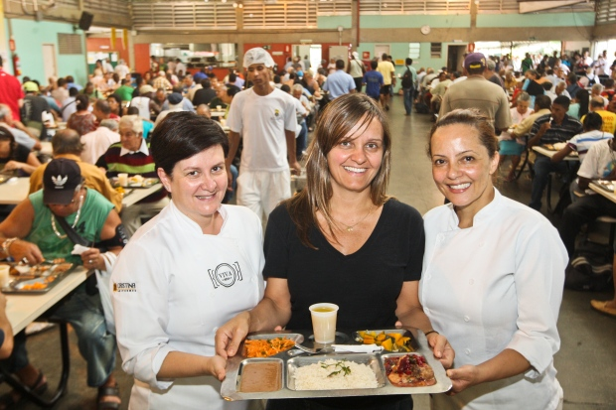

Another initiative that played a vital role in securing food and nutrition sovereignty was that of the Food and Nutrition Assistance Program, which aims to provide food to at risk groups within the city such as children. Consequently, these programs are only made possible through strong social networks and capital, as these programs are spearheaded by various municipal departments and social agencies working together (Rocha, 2001). Because of the nature of the targeted individuals, a great focus is placed on involving the Food and Nutrition Assistance Program within schools. The first way the Program has contributed food and nutrition sovereignty to children is through its School Meal Programs. “By law, federal funding can cover only the cost of food. The program, thus, relies heavily on partnerships with municipal governments to cover all costs with infrastructure (from storage to kitchen utensils) and personnel (from nutritionists to school cooks). Demonstrating the importance, the municipality places on feeding children and youth, in 2008 Belo Horizonte spent just over R$2.3 million (US$1 million) with the program,” (Rocha & Lessa, 2009). As Rocha elaborates, it is the human and social capital that make the other forms of capital functional for the success of the program. The listed examples are, “ Purchasing, storage and distribution of foodstuff throughout the network of schools; Quality control of foodstuff used in the program; Planning and monitoring of construction and renovations of school kitchens; Purchasing of new and replaced kitchen equipment and utensils; Supervision of food preparation in loco in each school: from confirming quantity and quality of foodstuff delivered, to local storage, hygiene standards in food manipulation and preparation, number of meals served, and waste control,” (2001). This program is the largest of its kind, as in just 2007 alone it has served 40 million meals to 155,000 students in 218 public schools (Rocha & Lessa, 2009). However, these children are receiving more benefits than just a belly full of nutrition. Being food sovereign means so much more than just participating in an institution that reliably caters meals. It is the right of peoples to healthy and culturally appropriate food produced through ecologically sound and sustainable methods, and their right to define their own food and agriculture systems. This is why it is so valuable to teach these children about where their food comes from, and the process it takes to get it onto their plates.

This is why the next big initiative for the Food and Nutrition Assistance Program was establishing and promoting school gardens. “Children are invited to attend workshops on micro gardening, and those joining the program receive technical assistance from SMASAN to set up their gardens. Gardens have been established in schools and kindergartens with a total of 96 000 pupils, who spend on average one hour a day caring for the plants. The gardens are used to grow cabbage, lettuce, aromatic plants and herbs, and serve as open-air centers for environmental and food education,” (FAO Belo Horizonte, 2015). The gardens, while illuminating the importance of natural capital, are also uniquely being used as physical capital would be too. These gardens have grown into education centers, and are just as important as a classroom would be.
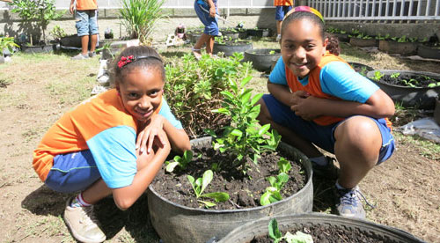

FOME ZONE ZERO POVERTY
While the success thus far can be attributed to powerful municipal policies, when Belo Horizonte aimed to become poverty free it deeply needed the assistance of the federal government. “Under an innovative multidimensional national framework called Fome Zero (Zero Hunger), a new rural agricultural policy was created to strengthen family farming, called . . . the Food Acquisition Program. The function of PAA is to support the commercialization of crops and livestock products grown on family farms through direct state purchases at near market prices. These purchases are then redistributed to government food programs such as schools, day care centers, popular restaurants, and food banks,” (Mendonca, Rocha, 2015). From 2003-2007, the PAA agriculture program was able to help 117, 694 family farmers, which in return gave 14.3 million people access to food via the government programs that these farmers work alongside. And as farming makes up 77%, of rural employment, it is critical to strengthen the market that purchases from these farmers (Mendonca, Rocha, 2015). According to the Borgen Project, “Poverty has reduced drastically in Belo Horizonte, Brazil since the Right to Food law passed in 1993. Benefits include: Reduction of the child mortality rate by 60 percent, Reduction of child malnourishment under the age of 5 by 75 percent, and Fruit and veg eatable intake increase by 25 percent,” (Kureishi, 2015). And WWF Global further goes on to report, “as a result of these policies (which cost the city less than 2% of its budget) Belo Horizonte has almost eliminated hunger, reduced poverty, created price stability, and generated rural sustainability and a thriving urban and local agriculture sector. Within 10 years of the launch of the program . . .child hospitalization for malnutrition [decreased] by 75% and poverty [decreased] by 25%, while 700,000 farmers had access to credit for the first time in their lives, leading Belo Horizonte to become known as "the city that ended hunger,” (Belo Horizonte Food, 2015).

Successes and Reapplication of Belo Horizonte’s Project:
Belo Horizonte’s success only continues to rise. In 2003 the program became the blueprint to eradicate hunger in all of Brazil. Furthermore, the program is constantly revising to meet the growing needs of development. In 2010 the program was revised to incorporate urban agriculture as a non-residential land use, on a par with commerce, services and industry (WWF Global, Belo Horizonte Food, 2015). The success and innovation of this program have truly been admired world wide, with many trying to learn and adapt from such a leading example. “The Right to Food law is an award winning policy and serves as an inspirational example of how food redistribution saves lives. UNESCO named the Right to Food law, Best-Practice in 2003. The Right to Food law also received the Future Policy Award by the World Future Council in 2009. Scholars regard Belo Horizonte as a progressive city in its utilization of existing resources. UN Special Rapporteur, Oliver de Schutter, reports: “I think we should use the example of Belo Horizonte as a lesson taught to us, food is not a commodity. It is a human right and it should be treated as such…” Belo Horizonte did something the U.S. has yet to do, tackle poverty from a bottom-to-top approach. By recruiting the help of local farmers, Belo Horizonte helped the impoverished by teaching them ways to help themselves. Policy makers isolated the detrimental effects of competition in the market and eradicated them, thereby emphasizing the freedom in free markets. The Right to Food serves as an example of the role democracy can play in helping [and empowering] the world’s poor,” (Kureishi, 2015). Without any doubt, Belo Horizonte is a wonderful example in exemplifying how it takes more than just intervention in one area to be enough to spark change. Taking a more holistic approach Belo Horizonte teaches the world how self-empowering, and self-sufficient a community can be when the right forms of capital are invested in. Truly, without the federal governments grants and budgets given to Belo Horizonte, the proper physical structures could not have been created, farmers could not have received credit, and their produce could not have been purchased by the local government and subsidized for its civilians. Without the proper physical capital, there could be no functional popular restaurants, school gardens, or innovative centers for individuals to share knowledge plan out exactly how these programs will be implemented. Next, without strong natural capital there would be no local produce to even sell, and no ways to empower and encourage farmers to keep at it. And finally of course, without strong social capital there would be none of this what so ever. It is truly the people who emphasize the need to succeed in every department and every area of capital. This is why Belo Horizonte serves as such an inspirational story. It is the story of those in need of help learning as a communal entity how to sustainably help themselves.
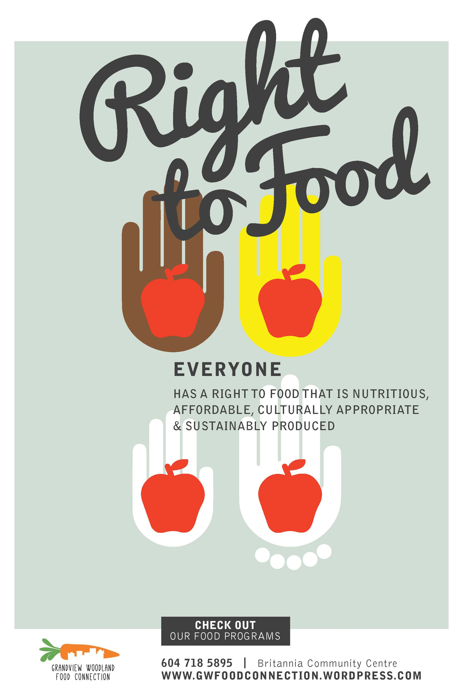

References:
Food and Agriculture Organization. (2015). Belo Horizonte. Retrieved from: http://www.fao.org/ag/agp/greenercities/en/GGCLAC/belo_horizonte.html

Kureishi, T. (2015, 06,15 ). The End of Hunger in Belo Horizonte, Brazil. Retrieved from: http://borgenproject.org/end-hunger-belo-horizonte-brazil/

Lappe, F. M, (2009, 02). The City That Ended Hungar. Yes Magazine. Retrieved from: http://www.yesmagazine.org/issues/food-for-everyone/the-city-that-ended-hunger

Map of belo horizonte - Map Pictures. (n.d.). Retrieved November 24, 2016, from http://www.wpmap.org/tag/map-of-belo-horizonte/

Mendonça, M., & Rocha, C. (2015). Implementing national food policies to promote local family agriculture: Belo horizonte's story. Development in Practice, 25(2), 160. doi:10.1080/09614524.2015.1002454

Pampulha - Sáb, 26/07/2014. (n.d.). Retrieved November 24, 2016, from https://issuu.com/otempo/docs/binder1_27dd876c527c12

Rocha, C., & Lessa, I. (2009). Urban governance for food security: The alternative food system in belo horizonte, brazil. International Planning Studies, 14(4), 389-400. doi:10.1080/13563471003642787
Rocha, C. (2001). Urban Food Security Policy: The Case of Belo Horizonte, Brazil . Journal for the Study of Food and Society , Volume 5 (Issue 1), pp 36-47).
WWF Global. (2015,11,04). Belo Horizonte Food. Retrieved from: http://wwf.panda.org/wwf_news/?255810/Belo-Horizonte-food

