Case Study:
BedZED Project, UK.

Reena Ranger
Vancouver Island University
Geography 346
Professor Alexander

BedZED Project, UK.
Introduction
BedZed is the United Kingdom’s first large scale mixed-use sustainable community, based in Hackbridge, London, UK (Figure 1). The Beddington Zero Energy Development (BedZED for short) was created in partnership between BioRegional, Housing association Peabody Trust and architect Bill Dunster from ZEDfactory. The environmentally friendly housing development was completed in 2002, with a total of 100 homes containing 220 residents, enough office space for 100 workers (BioRegional.co.uk), as well as various community facilities; including 2500m² of commercial space (oneplanetcommunities.org).
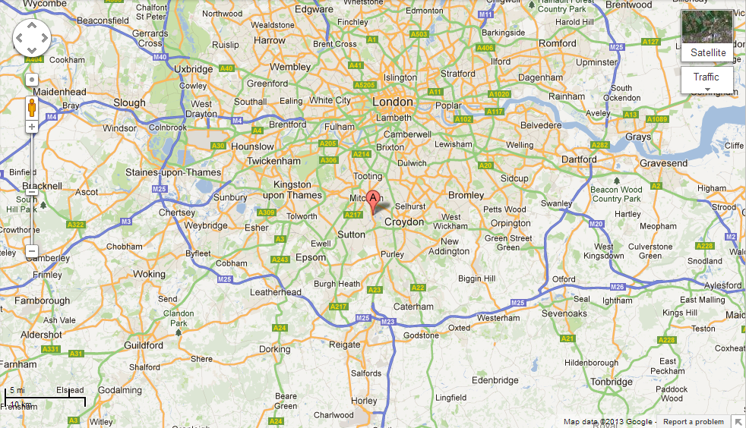

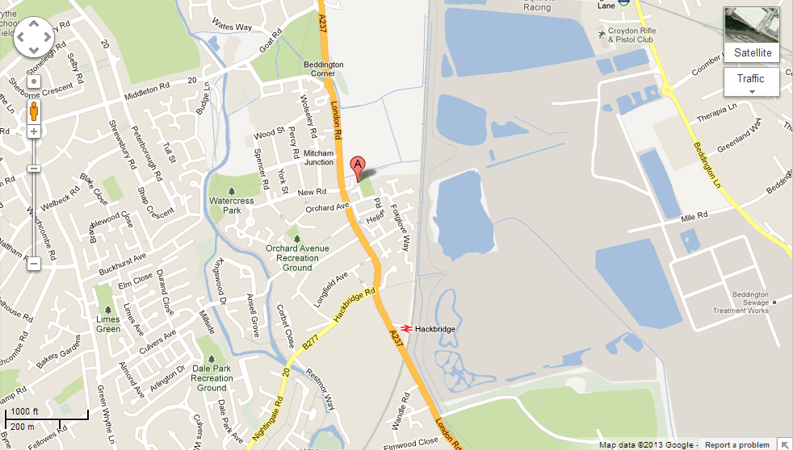

Figure 1. Map showing the location of BedZED within London, highlighting the area in a closer scale in the lower map (maps.google.co.uk).
With the increasingly urbanized population, our resources are being consumed at much faster rates than the planet can regenerate. Because of this, we will eventually have to look at ways to use these resources more efficiently and sustainably, not only for the benefit of the environment but for a better quality of life as well. Although this sounds simple, there are many obstacles to achieving this on a large scale. In the society we live in now, it is not easy to live without a car or to recycle globally. If everyone consumed as much as the average European person does, we would need three planets worth of resources to support us (Pooran Desai, BioRegional.co.uk). BedZED, however, is making ‘the green choice the easy choice’ in order to help people reduce their carbon footprint. The development began in 1997 and was considered unusual; however, today the idea has become more mainstream, with government policies supporting developments and companies looking into green technology, as well as influencing projects all over the world to create places for people to live a one planet lifestyle. The concept of one planet living is a vital lesson for BedZED projects. It consists of 10 guiding principles of sustainability (Figure 2) which have helped create one planet communities globally, including in the Middle East, China and Australia.
Figure 2. Diagram illustrating the 10 principles of one planet living (source: globalecovillage.org).

Architecture and Design Background
ZEDfactory began as Bill Dunster Architects in 1998; the company had a unique track record of delivering Zero Energy Development (ZED) buildings in the UK. Their aim was to create something that was stimulating and practical on a daily basis, yet distinctive, economic, and reliable in the long term. Their holistic approach to design is essential; they think of a building as an organism: it eats, drinks, respires and secretes wastes (Zedfactory.com). Their idea of a ZEDlife is therefore vital, involving nine key themes (Figure 3) to complete this lifestyle:

Figure 3. Diagram showing the components of a Z00EDlife, with the essential elements on the right (source: zedfactory.com).

The ZEDfactory believes that a viable zero carbon/waste society can be created only with a combination of low carbon infrastructure and low carbon lifestyles. The ZEDwheel (Figure 4) shows how to reduce environmental impact and it portrays the proportions of CO² for one’s personal carbon footprint and all the segments needed to reduce this. A third of this personal carbon footprint is derived from agriculture and food miles; therefore they introduced Zero Fossil Energy Farming, which involves home grown foods, partnering up with a local farm, as well as food delivery services.

Figure 4. The ZEDwheel showing the ZED challenge of creating a complete low carbon lifestyle to reduce environmental impact (source: zedfactory.com).

The BedZED site was a former sewage site that was left derelict, with medium contamination. Many developers therefore saw this area as too expensive to build on, but the BedZED developers saw potential as the site is close to schools and modes of transportation. A great deal of thought and consideration went into the process of how to make this project as environmentally sustainable as possible. To ensure this, they sourced building materials locally (especially the heavy ones) in order to reduce transportation costs. In the housing construction they used eco-counters, wind cowls for ventilation which created a control of fresh air, and every unit has a private garden (BioRegional.co.uk). Their concept was to reduce the amount of ‘hard’ materials but maximise vegetation.
The ZEDroof (Figure 5) is a new energy system which lets daylight into a loft to create a conservatory in the south-facing roof space whilst generating electricity. It also forms a fundamental part of the ‘Net Zero Carbon – Net Zero Energy Bills’ solution. The roof panels are self-cleaning and can be installed on any roof with a pitch steeper than 15 degrees that doubles as a micro power producer.

Figure 5. Image showing the ZEDroof
(source: Zedfactory.com).
The ZED heat hub (Figure 6) has a positive carbon footprint device. It delivers a whole house ventilation system with hot water and heating. It is a fraction of the cost of a conventional system without the infrastructure expense of a centralised plant.

Figure 6. Diagram showing the components making the ZED Heat Hub system (source: zedfactory.com).
The windcowl product (Figure 7) is used in buildings that are up to four storeys high to provide around 70% heat recovery ventilation without the use of motors or fans. It uses a combination of wind-driven and thermal flexibility effects allowing fresh air requirements during the heating season.

Figure 7. Image showing the windcowls on the roof of each residential building along with a roof garden (source: zedfactory.com).

There are various vital ingredients which are necessary for Zero Carbon houses (Figure 8) (Zedfactory.com), listed as follows:
- Cool Vault: a self-firing clay brick that can be placed in timber beams to provide low carbon thermal mass to dwellings
- Thermal Mass: Dense materials are used in ceilings and floors to reduce fluctuations in temperature from internal heat gains and losses through open windows
- High Insulation levels: Reduces the need for active heating and cooling to the absolute minimum
- Airtight Construction: Buildings should have as little uncontrolled ventilation as possible to keep valuable heat and cool air

