Dockside Green

Major Project
GEOG 346
April 4th, 2013
Ariel Fabbro

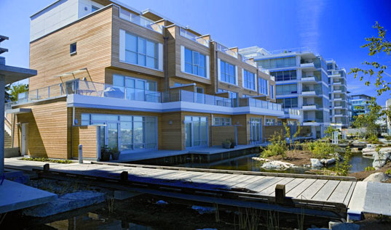

A large percentage of green house gas emissions today result from buildings, particularly those built without efficiency or the environment taken into account. It is, however, possible to greatly mitigate the carbon footprint of buildings. Future constructions of more environmentally sustainable buildings will significantly reduce the impact of the urban environment on the natural environment. For this reason I was interested in researching a case study in which green buildings are being developed. The very local example of Dockside Green has some of the highest standards of environmentally friendly buildings in the world. Dockside Green is a development located in Victoria, B.C. Canada. The project is taking place on 15 acres of former Brownfield land, situated in Victoria's harbour across from the downtown core. The parcel of land had previously been used for industrial uses related to seaport activity, and was further contaminated during its use as a dump. In 1989 the city of Victoria bought the land for one dollar from the province and has wanted to develop it, along with other nearby former industrial sites, which have been transformed into marinas and waterfront walkways (Pirie, 2010). However, the cost to clean up the contaminated land had prevented action from the city. In 2002 the city made a real effort to develop the land. They rezoned it to allow greater density, acquired some public financial support, and held a competition for the best development project design of the land (Pirie, 2010). Joe Van Belleghem, the head of Windmill developments, won the competition and partnered with Vancity Enterprises, who provided 75% of the capital while Windmill productions provided the other 25%. The partnership was called “Dockside Green Limited” (Pirie, 2010). The first major expense for Dockside Green Limited was the de-contamination of the 15 acre parcel of former Brownfield land. The reported cleanup cost for the site was 20 million dollars.
Prior to, as well as during the initial development in 2007, the Dockside Green project gained huge international attention for the ambitious goals it set for itself. The project design was recognized as “one of the most innovative green community developments in North America and a model for community development to follow” (McCormick, 2008). The eventual development plan is for a 26 building, mixed-use community including residential, retail, office, hotel, and light industry uses. These 26 buildings covering 1.3 million square feet will also host 2,500 residents (Benfield, 2011). The developer used the Leadership in Energy and Environmental Design (LEED) program to legitimize their environmental goals and achievements. LEED is a widely recognized and “voluntary, consensus based certification program for developing high-performance, sustainable buildings, through a third-party review process conducted by industry experts” (McCormick, 2008). Using this program allowed Dockside Green to be internationally recognized and was an important factor in gaining financial support from sponsors, which was necessary in order to afford the implementation of such high-end sustainable infrastructure. Dockside's private partners included: Terasen Energy Services, BC Hydro, and Corix. They also received support via their government sponsors: Natural Resources Canada's Technology Early Action Measures (TaEAM) Program, the Province of British Columbia and the City of Victoria (Sparica, 2008, p. 13). The developers of Dockside Green Limited effectively drew further attention to their goals for LEED platinum status by offering to pay up to 1 million dollars as a penalty for each square foot which did not meet the LEED platinum requirements (Dockside Green).
Along with fulfilling the LEED requirements, Dockside Green approached the development with a macro whole-system approach, the emphasis being on integration on multiple levels. This is where the triple bottom line approach to sustainability comes in. The triple bottom line focuses on the social, economic, and environmental consequences of development (Bate, 2009, p. 28). Dockside Green Limited realized that the relations between these factors were important to consider when creating a healthy integrated community. The dense, integrated design of the development which comprises of common spaces and local businesses (such as the onsite bakery and cafe) are important in creating a sense of community. To maintain diversity, they have also planned to have 10% of the suites to be affordable rental units for low income earners with incomes as low as $15,000 (Pirie, 2010).
The environmental and economic aspects of Dockside green are based on efficient and advanced technologies, which reduce the ecological footprint as well as lower utility costs. Two innovations are particularly impactful in dockside's closed loop design and its overall sustainability. These innovations are the onsite waste treatment plant and the biomass heat plant. The waste treatment plant treats all the water used on the development, whether it is grey water or black water. This treated water, in combination with filtered storm water, which is captured from green roofs and open spaces, is then looped back into the buildings and used as grey water for toilets and to irrigate the naturalized greenway which runs through the development as well as other onsite ponds (Bates, 2009, p. 29). These waterways which function as storm-water storage also act as an important visual amenity and public open space for residents, thus enhancing livability. This links to the social aspect of the triple bottom line. The waterways are used as a wildlife habitat, and they provide biophilic benefits. The animals that use this habitat are ducks, crayfish, and stickleback fish, who all contribute to the biophilic aspect of the development (Pirie, 2010). This closed loop water use system is estimated to use 65% less potable water than conventional developments (Dockside Green).
The second major innovation of the Dockside Green development is the biomass gasification plant (Figure 1). It provides heat and hot water for the entire development in a clean and low-cost manner. The plant uses local wood for fuel, and burns it in an incredibly efficient way. The plant takes waste from local logging sites, mills, recycled wood construction debris, and municipal tree trimmings, and uses it as fuel (Sparica, 2008, p. 16). Bio-solids from the water treatment plant are added to the wood fuel as well, maintaining the closed loop philosophy (Morphet, 2009). The fuel is then heated in an oxygen-deprived environment where it does not combust, but is converted into synthesis gas. This synthesis gas then goes through an oxidizer and boiler where it is converted into low-emission heat energy. When the biomass plant is running at full power, it consumes about one truck load of wood fuel every two days (Sparica, 2008, p. 13). This low-emission heat energy source “will avoid approximately 2,500 tonnes of greenhouse gas causing emissions each year” (Sparica, 2008, p. 16). Furthermore, the economic incentives for residents and businesses include lower utility fees, in addition to exclusion from the costs of Victoria's new sewage treatment system when it is eventually implemented (Morphet, 2009).
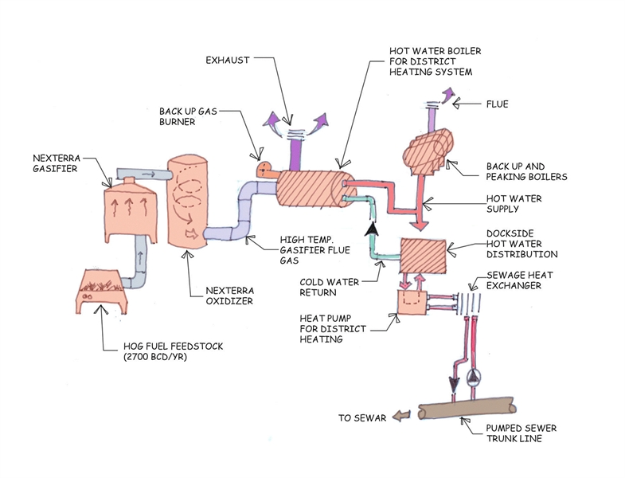
Figure 1. Diagram of Dockside Green’s biomass gasification plant.
Apart from these two significantly impactful innovations, Dockside Green has integrated many other green technologies in its drive for LEED platinum status. Each suite at Dockside Green is or will be equipped with a meter which measures hydro use in real time. This meter can also be adjusted via remote or online at anytime, which allows residents to monitor and have full control their energy consumption (Morphet, 2009). Consciousness of energy consumption reduces both financial costs and environmental impact. The Dockside Green buildings also place an emphasis on air quality. The building materials used indoors include “engineered hardwood floors which produce zero emissions, cabinets are made from compressed bamboo or other wood with no urea formaldehyde, and the paint has low or no volatile organic compounds” (Dockside Green). Along with double-glazed energy efficient windows, the suites have heat recovery ventilations units which filter out impurities from the air outside (Morphet, 2009). In terms of electrical appliances, each suite has high-end, water efficient ENERGY STAR appliances. These include dishwashers, washing machines, and condensing dryers. Low-flow faucets, shower heads, and dual flush toilets are also featured in the suites (Dockside Green; Bate, 2009, p. 28). Lighting efficiency has not been left out either, as the buildings are designed to maximize daylight. Efficient lighting fixtures are also used, including compact fluorescent lighting, solar lighting, and interior occupancy sensors (Dockside Green; Bate, 2009, p. 28). Outside of the buildings, low level and full cut off lighting is used (Bate, 2009, p. 29). The use of vegetation in the form of green roofs and extensive tree planting on the development site has benefits too. This vegetation is effective at absorbing carbon, insulating buildings, and slowing storm water runoff (Dockside Green). Additionally, storm water is able to flow through the (mostly) permeable paved surfaces used on the site (Dockside Green). All of these design features combine to have a significant benefit, and fit the three aspects of the triple bottom line approach.
It is also important to note that the developer did not neglect their environmentally sustainable mindset during construction. They set themselves another lofty goal to “reuse 90% of . . . construction waste on site” (Dockside Green). Thus far, their initiative has consisted of salvaging some wood products, looking to use the most local material possible in order to minimize transport, and using fly ash in concrete. Fly ash is the waste product of cement production; for every tonne of cement production, roughly one tonne of CO₂ is produced as a by-product. This can be reduced by mixing the fly ash (which is usually seen as waste) into the concrete mix (Dockside Green).
In maintaining a holistic approach to sustainability, Dockside Green features many amenities which support its vision of a sustainable community. The location of Dockside Green is rather serendipitous. Not only is it in close proximity to downtown Victoria, but the popular galloping goose trail also runs alongside the site (Benfield, 2011). These innate benefits of the location of the development are further enhanced by Dockside Green, as they encourage environmentally conscious transportation by providing bike racks, secure bike storage, and shower facilities on the Dockside Green site. In terms of water transport, they have a public boat launch which could be utilized for commuting to downtown via kayak, and the harbour ferry makes a stop at dockside green as well (Van Belleghem & Cole, 2005, p. 44). A car share program is being implemented as well to reduce the need for car ownership. Dockside Green has partnered with the Victoria Car Share Co-op and plans to provide 10 vehicles which can be reserved online (Dockside Green). This is a viable option as there no insurance or fuel costs, and user fees are modest.
Beyond transportation, there is an onsite organic bakery that provides fresh baked bread from a wood burning oven, and a fair-trade organic coffee shop. Both have an important role in creating a community feel that coincides with the triple bottom line model. A Tim Hortons or Starbucks, on the other hand would not fit this role (Morphet, 2009). There is still much more to come for the development, as outlined in Dockside Green's master plan (Figure 2). The completed development is planning to have the following: dock facilities, a neighbourhood park, an amphitheatre, shopping facilities, and dining facilities (Pirie, 2010).
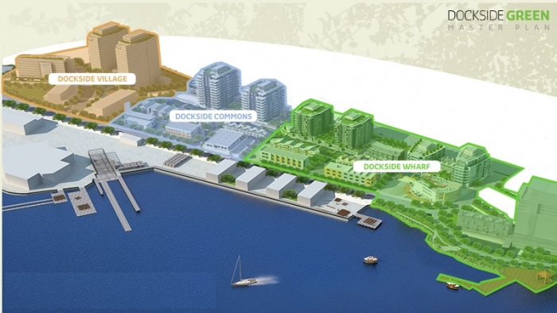
Figure 2. Graphic rendering of Dockside Green’s master plan.
Development completion is the major issue with Dockside Green. Despite Dockside Green's very impressive and innovative design, it is still under development and construction has halted in the last few years. The project is now far behind schedule, having only the first of three planned neighbourhoods complete. Dockside Warf is the first neighbourhood; it currently consists of two residential buildings which are home to 450 residents (Pirie, 2010), as well as two commercial buildings. The residential buildings tied each other for the highest LEED score ever achieved, which was 63 points out of a possible 70. While the commercial buildings also scored well, their scores were not as high (Dockside Green). The project has thus far met its criteria of achieving the LEED platinum rating, and its residential units are sold out according to Dockside Green's website. Despite this success, the project is stagnating and has now lost its place in the spotlight of global development.
In some aspects, this world class development has lost its chance to shine. Many competitors have caught up to or even surpassed Dockside Green's level of sustainability. Nevertheless, the incomplete Dockside Green still has been able to serve as a prototype for developers to follow and learn from. One example of this comes from Quebec City. A project called "Cite Verde" had plans to emulate some aspects of Dockside Green (White, 2010). However, this was in early 2010, before Dockside Green had really stalled. There are a few likely reasons which caused Dockside Green to stall. A major turning point was when Joe Van Belleghem of Windmill Developments pulled out of the project and Vancity took full ownership of the project. The loss of Van Belleghem and Windmill Developments meant the loss of the original designers of Dockside Green, as well as Van Belleghem’s level of experience, as he had been involved in Canada's first LEED Gold rated building (Pirie, 2010). More important than the loss of this experience and leadership is the high cost of infrastructure required for the very high-end project. While Dockside Green was meant to have a “budget that could showcase environmental technologies and act as a center for environmental innovation” (Van Belleghem & Cole, 2005, p. 44), in reality, the financing has become an issue.
The current developer Vancity is likely currently unable to afford further development, or is hesitant because of the risk of large investment in a shaky global economy. It is unfortunate that the developers of Dockside Green could not capitalise on the attention they had gained during the initial phases of development. If they had continued, they would not have lost the spotlight, and this would benefit the marketing of the entire community in terms of selling suites and commercial spaces, and more importantly in promoting the practicality of sustainable communities. If dockside Green was still in the limelight and was a fully functioning community, it would serve to expose developers nationally and internationally to the benefits and potential of green building. Nevertheless, this opportunity has passed, and Vancity is showing a great lack of transparency in regards to the further development of Dockside Green, as they have not provided any public schedule for further developments. Although it does not appear that the final two thirds of the project will fold, the more time that goes by without Dockside Green realizing its potential, the less unique and ground-breaking the project becomes. The result of this could affect current and potential interest in living in a partially completed development.
Overall, Dockside Green provides an excellent example of how to utilize and integrate environmental technologies into a community. They have laid the groundwork and shown a portion of what a world class sustainable community looks like. As well, it has displayed successful innovative technologies that do not rely on particularly unique circumstances. This makes them practical, as developers could relatively easily incorporate them into other developments. At the same time, the case of Dockside Green provides the important lesson: that it is important not to aim for goals that are too high or too expensive without a consistent and reliable plan to meet them.

References
Bate, L. (2009). Dockside Green Synergy. Canadian Architect, 54(5), 28-29.
Benfield K. (2011, August 25). Is This the World's Greenest Neighborhood? The Atlantic. Retrieved from http://www.theatlantic.com/health/archive/2011/08/is-this-the-worlds-greenest-neighborhood/244121/
Dockside Green. Retrieved Jan. 31, 2013, from http://www.docksidegreen.com/Home.aspx
McCormick, K. (2008, Aug 2). Victoria project gets green thumbs up; first-ever LEED rating. Calgary Herald. Retrieved from http://search.proquest.com.ezproxy.viu.ca/docview/243790523?accountid=12246
Morphet, S. (2009, October 16).Waterfront wasteland transformed in Victoria; Dockside Green attracts international visitors. The Vancouver Sun, p. F4.

Pirie, K. (2010). Unsprawl Case Study: Victoria British Colombia. A Journal of the Built & Natural Environments, 25. Retrieved from http://www.terrain.org/unsprawl/25/

Sparica, D. (2008). Biomass Gasification Anchors Dockside Green. Municipal World, 118(1), 13-16.
Van Bellegham, J., & Cole, L. (2005). DOCKSIDE GREEN. Environmental Design & Construction, 8(6), 42-46.

White, M. (2010, January 3). Quebec City project emulates Dockside; Eco-friendly housing development receives $28 million from province. Times Colonist: Victoria B.C., p. A9.

