Stephanie Pike
Geography 352
November 26th, 2015
Farmer Roberts Case Study

Different business types contribute to different types of capital. Before investigating how a company contributes to any type of capital, it is critical to understand the types of capital and how they interact. Farmer Roberts is a great example of how a company works to improve all types of capital within a community and how the types of capital are interrelated.

Farmer Roberts
Located in Whitehorse, Yukon, Farmer Roberts is a locally owned year round farmer’s market/grocery store. After years of planning, Farmer Roberts experienced a “soft” opening in August 2015. Figure 1 shows the store from the outside. The owners of the store are two local farmers; Simone Rudge and Ryan Roberts (seen in Figure 2). The soft opening was focused on the local produce and bulk items. Farmer Roberts is not a typical grocery store; there are multiple aspects to the company. Since opening, Farmer Roberts has opened a bakery, an egg grading station (see Figures 3, 4 and 5), a butcher shop and a café; all of which utilize local goods. The vision of Farmer Roberts “is to directly connect the farmers that produce food to consumers and incorporate the needs of both consumers and producers” (Farmer Roberts About, 2015). Farmer Roberts classifies themselves as a socially responsible business. A socially responsible business is one that is more concerned with the social relationships than maximizing profits (Social Responsibility, 2015).

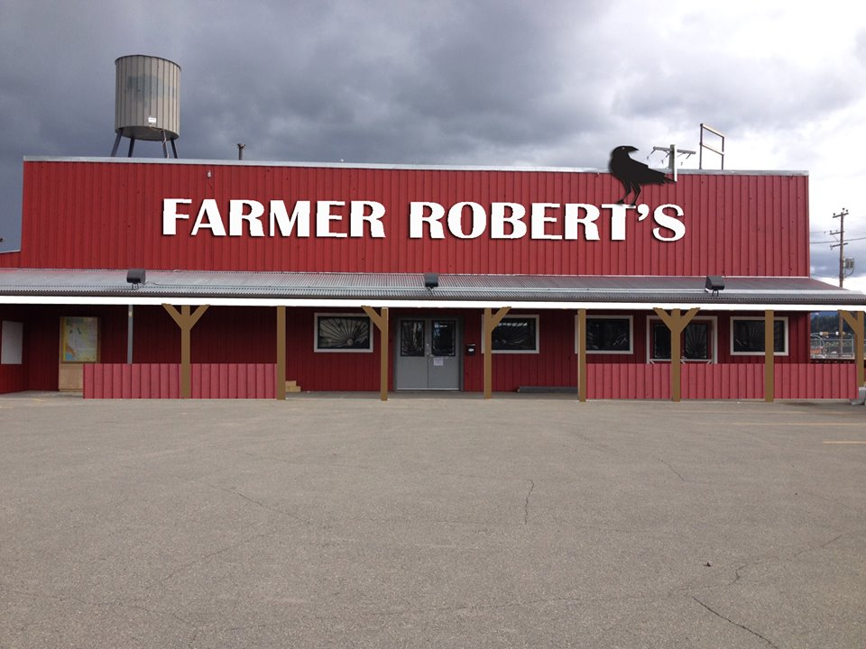
Figure 1. An outside view of Farmer Roberts in Whitehorse, Yukon.
Source: https://www.facebook.com/FarmerRobertStore/photos/pb.1610651602525956.-2207520000.1448307388./1658602241064225/?type=3&theater

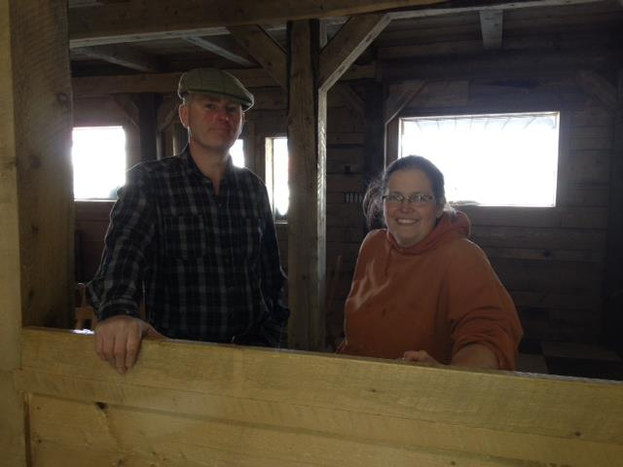
Figure 2: Co-owners of Farmer Roberts, Simone Rudge and Ryan Roberts.
Source: https://www.facebook.com/FarmerRobertStore/photos/pb.1610651602525956.-2207520000.1448307409./1610652975859152/?type=3&theater

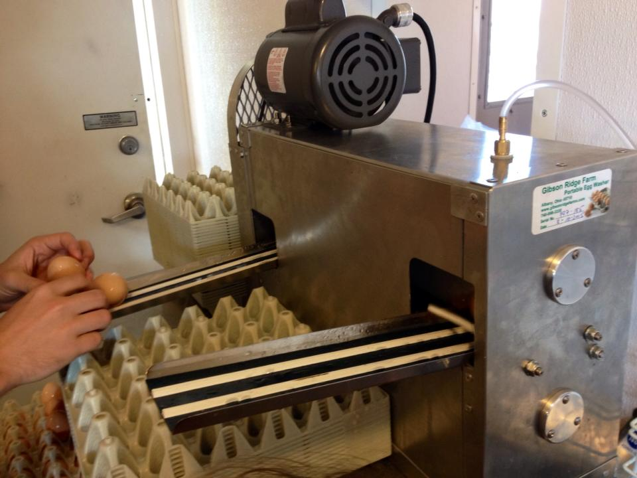
Figure 3: This is the first step in the egg grading process; washing the eggs.
Source: https://www.facebook.com/FarmerRobertStore/photos/pb.1610651602525956.-2207520000.1448307388./1654722844785498/?type=3&theater

Figure 4: The second step in the egg grading process is checking for hole or cracks in the shells.
Source: https://www.facebook.com/FarmerRobertStore/photos/pb.1610651602525956.-2207520000.1448307388./1654722981452151/?type=3&theater

Figure 5: Finally, the eggs are sorted based on their weight.
Source: https://www.facebook.com/FarmerRobertStore/photos/pb.1610651602525956.-2207520000.1448307388./1654723381452111/?type=3&theater

Types of Capital and Farmer Roberts
Farmer Roberts is an establishment that contributes to all 6 types of capital as discussed by Roseland (2012). The 6 types of capital include; natural, social, economic, physical, human and cultural. Table 1 includes the definitions as provided by Roseland (2012).

Table 1. Types of Capital & Definitions
Type of Capital | Definition | Example
Natural | “Natural assets that allow a flow of goods and services into the future”  “Enhancing natural capital means living within its ecological limits” (Roseland, pg 13, 2012) | Renewable resources like food, water, sunlight and nonrenewable resources like fossil fuels and minerals.
Social | “The glue that holds our communities together” (Roseland, pg 14, 2012)  “It is community cohesion, connectedness, reciprocity, tolerance, compassion, patience, forbearance, fellowship, love, honesty, discipline, ethics, rules, laws and information” (Roseland, pg 14, 2012) | Social networks  Institutions  Social Development Programs
Economic | “The ways in which we allocate resources and make decisions about our material lives” (Roseland, pg 14, 2012)  “Can be maintained and strengthened by support economic diversification across sectors and employers” (Roseland, pg 14, 2012) | Money
Physical | “Infrastructure that helps people obtain basic needs” (Roseland, pg 14, 2012)  “Providing stocks of material resources that can be used to make goods and income” (Roseland, pg 14, 2012) | Housing, grocery stores
Human | “Knowledge, skills, competencies and other attributes embodied in individuals that facilitate the creation of personal, social and economic well-being” (Roseland, pg 14, 2012)  “Represents a person’s ability to pursue and achieve individual livelihood objectives” (Roseland, pg 15, 2012). | Formed through training, education and experience.
Cultural | “The product of shared experience through traditions, customs, values, heritage, identity and history” (Roseland, pg 16, 2012)  “Defines community, influences decision-making and shapes how people communicate with one another” (Roseland, pg 16, 2012) | Singing, dancing, stories, food, rituals, spirituality, ceremonies, celebrations, heritage buildings and art.
Source: Roseland, pgs 13-16, 2012

When utilizing these definitions, Farmer Roberts impacts capital in multiple ways. In the case of Farmer Roberts, there are strong relationships between the types of capital. Although Farmer Roberts contributes to all six types of capital to some degree, the three strongest contributions are towards cultural, social and economic capital.

Cultural: In terms of cultural capital, Farmer Roberts focuses on the importance of food within culture. Farmer Roberts aims provides natural, high quality ingredients with the intent that it brings family together and creates more family time through cooking (Rudge, 2015). Within the store itself, there is an area for kids, an area to view the egg grading station, and multiple children’s toys (Rudge, 2015). The design of the store is to make food shopping a more enjoyable family experience (Rudge, 2015). Recently, CBC North reported on the new egg grading station. The report stated that currently Farmer Roberts can grade and sell about 200 eggs (which sell out in two hours), but their goal increase the number of eggs to 500 in the next few months (Kawaja, 2015). For images of this grading station see Figures 3-5. This contributes to the culture of supporting local.

Social: Farmer Roberts has a unique policy on purchasing products. This policy is to say yes (Rudge, 2015). This creates a strong relationship and bond between seller and consumer (Rudge, 2015). With this type of business, that relationship is critical. These relationships and partnerships can allow Farmer Roberts to experience growth in the next stages.

Economic: Farmer Roberts takes on partial responsibility of marketing for Yukon farmers (Rudge, 2015). This allows the farmers to spend more time working with their products. New farmers are attracted to this company due to the fair pay the farmers receive (Rudge, 2015).

Challenges
Past
When opening a business such as Farmer Roberts, the challenges are not only plentiful, but they can be difficult to handle. Farmer Roberts began facing challenges early in the development stages. The biggest challenge was the competition and resistance from the Whitehorse Potluck Food Co-op (WPFC). The food co-op operates in a very similar manner to Farmer Roberts. The WPFC is a business that is owned and operated by the people who use it (About the Co-op, n.d.). In 2013, they opened their online store and in 2015 they opened a physical store. “The food co-op operates as a for-profit business that is community minded, owned and run by the members who use its service. We use a one-member one-vote system that allows members to become active agents in guiding the future of the organization” (About the Co-op, n.d.). The WPFC operates on the same idea of fair wages for farmers and fair prices for consumers (About the Co-op, n.d.). This business created high competition for Farmer Roberts. While the two businesses share similar visions, Farmer Roberts seems to have more stability and strength. The WPFC may struggle with providing local foods to consumers during the winter months, whereas Farmer Roberts has the ability to provide other local goods to consumers such as eggs, meat and bread.
The second challenge with opening this type of business was purely economic. Opening Farmer Roberts was a big risk for an unknown reward. Simone Rudge has indicated that if Farmer Roberts fails, the cost of development will have them bankrupt (Rudge, 2015). This economic challenge will continue throughout the growth of this business and will be an issue at all stages.
Current
Although Farmer Roberts handled the challenges in early development with ease, the challenges are still in the backs of their minds. Currently, the biggest challenge is being able to offer consumers local goods year round (Rudge, 2015). Due to long, cold winters and short cool summers with a short frost-free season, Farmer Roberts is unable to provide local produce year round. In order to handle this and continue to offer consumers local goods, Farmer Roberts has opened other departments that have the ability to operate year round. This would include the café, egg dispensary, bakery and butcher shop; all of which utilize local goods. Farmer Roberts is currently facing the challenge of maintaining economic stability and strength in the slower, winter months (Rudge, 2015). Again, having the other departments operate year round is valuable in maintaining that stability.

Anticipated
Farmer Roberts has shown to be a successful business in the first stages, but that does not mean the challenges are over. There is a delicate relationship between Farmer Roberts and the supplying farmers. A challenge lies in maintaining a strong relationship throughout the winter months. This relationship becomes even more crucial in the spring when the growing season begins. Without the farmers, the store cannot provide the variety of produce to consumers and may lead to fewer sales and less farmers participating. The owners anticipate the challenge of maintaining economic stability and strength in the slower, winter months.

Simone Rudge provided insight to how other businesses could learn from Farmer Roberts.
- Relationships are KEY. Whether the relationship is with the local people or the farmers, it is crucial to maintaining long-term stability (Rudge, 2015).
- Be prepared for the high months and the low months. Especially in the cold climate of the North, having other income when produce can’t be grown is important (Rudge, 2015).

Transferability
Although Farmer Roberts has experienced success in the first months of the opening, this type of business may not be successful in other isolated regions. Two very specific conditions have contributed to the success of Farmer Roberts. The first and most important condition is the agricultural land available in the Whitehorse area. This land is quite fertile and provides great soils for crops, even though the growing season is short. This type of land/soils may not exist in other isolated regions. The second condition is the drive for Yukoners to want to purchase locally and support the farmers. It is difficult to indicate how well a similar business would transfer without knowing the community beforehand.

Conclusion
The owners of Farmer Roberts took a huge step for local producers and consumers by opening a year round store, but due to extremely hard work and perseverance, it will continue to grow. Many businesses have the ability to impact the economy both locally and regionally. Developing a strong local economy is important for communities like Whitehorse because of isolation and Farmer Roberts contributes in multiple ways to the local economy. While Farmer Roberts is a great example of how to encourage supporting the local economy in an isolated northern community, it may not be economically viable in for other isolated northern communities. The strengths and lessons learned from opening this business however, may be useful for the development of similar businesses.

References

About the Co-op. (n.d.). Retrieved November 17, 2015, from http://www.potluckcoop.com/about-1/

Farmer Roberts About (2015). Retrieved October 2, 2015, from http://www.farmerroberts.com/#!aboutfarmer-roberts/cjg9

Kawaja, C. (2015, November 17). Yukon shop gets egg-grader approved, sells out of eggs daily. CBC News North. Retrieved November 17, 2015, from http://www.cbc.ca/news/canada/north/yukon-shop-gets-egg-grader-approved-sells-out-of-eggs-daily-1.3322047

Lewis, M., & Conaty, P. (2012). The Resilience Imperative: Cooperative Transitions to a Steady-State Economy. Gabriola Island, BC: New Society.

Roseland, Mark (2007). “Strengthening Local Communities.” Chapter 9 in State of the World 2007: Our Urban Future. Ed. by Linda Starke (New York: Norton and Co.).

Rudge, S. (2015, October 9). Farmer Roberts [E-mail interview].

Social Responsibility. (2015). Retrieved November 22, 2015, from http://www.investopedia.com/terms/s/socialresponsibility.asp

