The Local Food Project
Major Case Study
Caitlyn Allbury
GEOG 346
Don Alexander
April 4, 2017

Introduction and Background

Every day humans are embracing the vast amounts of diverse food they are able to consume from around the globe. However, too few people understand and are aware of the impacts of their food choices (Food Literacy Center, 2015). Someone who is food literate understands the impact of their food choices on the environment, their individual health, and the economy (Food Literacy Center, 2015). Food choices can lead to negative issues regarding food security, climate change, environmental impacts, and unhealthy diets (Food Literacy Center, 2015). When consumers are not food literate, they may not understand the course their food took to arrive on their plate, the impact fuels and labor had on that journey, or what the “certified organic” label means on produce.
Defined by the United States Department of Agriculture (USDA), food labeled as organic comes from farmers who use renewable resources to produce crops. Theses farmers focus on the preservation of soil and water to maintain a healthy ecosystem for future generations (Gold, 2007). If not organic, food will likely go through the conventional farming process. Conventional farming uses synthetic fertilizers, pesticides, and herbicides made with synthetic ingredients (i.e. petroleum) or sewage sludge, and bioengineering (genetically modified organisms) (Gold, 2007). Even with the large quantities of food produced by these major conventional and organic farming industries, the numbers of individuals who go hungry exceed one billion worldwide (VICRA & OCBR, 2011). In March 2010, there was a 9% increase from the previous year of people needing assistance from food banks within Canada – at 867,948 people, these were the highest numbers on record (VICRA & OCBR, 2011). Although the current food system is feeding most of the world’s population, the sustainability is questionable. With continued conventional farming, there are increases in greenhouse gas emissions as a result of fossil fuel use from fertilizers (VICRA & OCBR, 2011). Agrochemical runoff, lands pollutants, GMO contaminants, and depleted biodiversity are all impacts on the environment from conventional farming practices (VICRA & OCBR, 2011). The impacts from conventional farming and even large-scale organic farming can be difficult to see when they are happening hours away in a different province or country.
According to the David Suzuki Foundation, an average meal travels 1200 km to get from the farm to the plate (2014). Simply put, the closer food is grown to its destination, the less emission from transportation there will be. In 2004, at least 85% of the food needed on Vancouver Island was imported (VICRA & OCBR, 2011). The shift to imported foods on Vancouver Island began around 50 years ago and has been increasing since (VICRA & OCBR, 2011). British Columbia receives 70% of its fruits and vegetables from California; however, over the years, California has slowly been suffering with the effects of climate change (VICRA & OCBR, 2011). With higher temperatures, reduced rainfall, and flash flooding, California may continue to face these problems – if not more severe ones (VICRA & OCBR, 2011). Currently, Vancouver Island could not live off the food it produces and therefore needs to continue importing from places like California. But as major import areas that Vancouver Island relies on also suffer from these same effects, so may the quality of the food it receives. Vancouver Island needs to transition to a self-sustaining region for the benefit of current and future residents.
Vancouver Island is privileged to have a foundation for agriculture production – including a temperate climate and fertile land (VICRA & OCBR, 2011). Unfortunately, the economy on Vancouver Island does not promote farming as a result of: increasing land, labor, and input costs; decreasing population of farmers; and, a decline in industrial processing and distribution centers (VICRA & OCBR, 2011). With a decrease in large rural agricultural land development, urbanization has led to a growing popularity for small ideas such as community gardens and vegetable gardens in yards (VICRA & OCBR, 2011). Figure 1 shows a five year difference that revealed the decrease in rural farms and an increase in urban farm population throughout Canada. Overall, Vancouver Island has seen a decrease in large agriculture production, but an increase in small scale agriculture - this has come from the reactions of residents wanting more local and sustainable food productions (VICRA & OCBR, 2011). Food security is a quality where an individual can acquire food that is safe, nutritious, and in quantities needed to maintain a healthy life (VICRA & OCBR, 2011) and this is what Vancouver Island could accommodate in their food system.
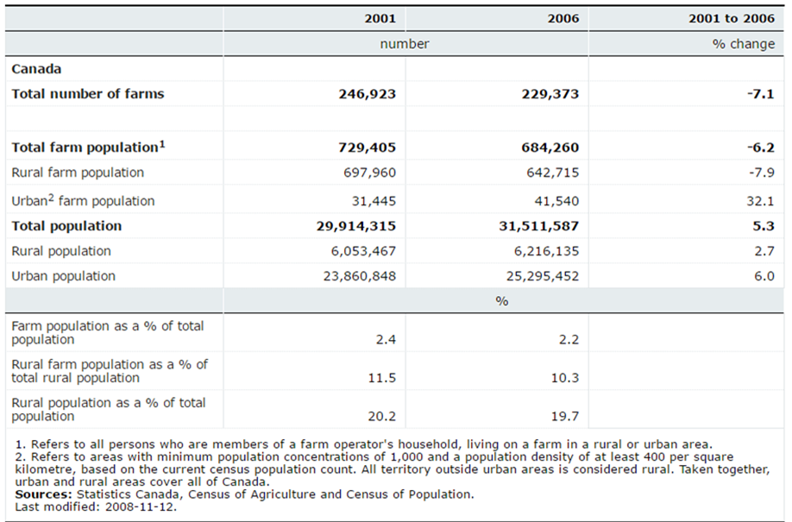
Food systems comprise the life of the food humans eat - from growing, processing, distributing, consuming, and recycling or composting (VICRA & OCBR, 2011). The goals for creating a regional food system are to create: food self-reliance; quality standards for food provisions for residents of the region; and, a system to maintain and rely on its resources (VICRA & OCBR, 2011). By increasing the productivity of agriculture through sustainable, economic, and social practices on Vancouver Island, it will help to identify food sovereignty (the right to create its own policies and strategies for food produced, distributed, and consumed) (VICRA & OCBR, 2011). As temperatures increase, Vancouver Island reliance on imported food could diminish and threaten the food security. It is important to take action at municipal levels across the Island and to build awareness and transition from consumers to producers, resulting in an increase to food security.
Figure 1. Farm population and total population by rural and urban population - 2001 and 2006 census of Agriculture and Census of Population (Statistics Canada, 2008).
About the Case

Vancouver Island imports a large percent of its food and the numbers are increasing while there are decreasing numbers of farms on the Island for residents to buy local and sustainable food. Food security is questionable when the island is supplied with food from states like California who are running into problems as a result of climate change. With a change in lifestyle for many, from rural to urban, there is also a shift to new local food movements. These include developments of community gardens and farmers’ markets – a step in the right direction for food security.
The issues mentioned above are in relation to a local food report completed in 2011 by the Vancouver Island Community Research Alliance’s (VICRA) and Office of Community Based Research (OCBR). The project is called “The Local Food Project: Strategies for Increasing Food Security on Vancouver Island”, which examines steps that could be taken on Vancouver Island to increase food security (VICRA & OCBR, 2011). Since 2009, the VICRA has been researching topics and issues facing Vancouver Island by collaborating with five of the Island’s Post-Secondary Institutions (VICRA, n.d.). These five institutions include Camosun College, North Island College, Royal Roads University, University of Victoria, and Vancouver Island University (VICRA, n.d.).
VICRA is focused on collecting a wide range of research to provide knowledge and skills for creating awareness and change towards local food (VICRA, n.d.). The project had the goal of identifying relevant and current information that could be used as a foundation for future movements to increase food security on Vancouver Island (VICRA & OCBR, 2011). Information was gathered from peer-reviewed research and community experts related to the research topic (VICRA & OCBR, 2011). This project identified what has been done and what still can be done to increase Vancouver Island’s food security (VICRA & OCBR, 2011). It includes opportunities for action with regards to food security and climate change, urban agriculture, indigenous food systems, and institutional practices (VICRA & OCBR, 2011). Each of these topics will be explained and examined in the following sections, along with current initiatives and future directions to increase the food security on Vancouver Island.
Climate Change and Food Security

Climate change is an outcome of greenhouse gas emission into the earth’s atmosphere caused both by natural processes (i.e. forest fires) and human activities (i.e. transportation) (VICRA & OCBR, 2011). It can cause disruptions in the temperature and precipitation patterns which may negatively affect the food industry (VICRA & OCBR, 2011). However, industrial agriculture also contributes to climate change. As of 2007, 3.5% of British Columbia’s greenhouse gas emissions came from agricultural processes; however, this calculation neither included on-farm energy consumption nor food processing and transportation (VICRA & OCBR, 2011). Even though emissions will increase within the province as Vancouver Island’s food security increases, the province will be rely on fewer imports which have high greenhouse gas emissions (VICRA & OCBR, 2011).
Physical impacts of climate change are associated with temperature rise, snowpack, flooding, and sea level rise (VICRA & OCBR, 2011). By 2055, it is estimated that summer and winters will be at least 2 degrees Celsius warmer, and temperature rise also creates wetter winters on Vancouver Island (VICRA & OCBR, 2011). Changing and unpredictable climates could have direct impacts of food security and agriculture. These impacts can be associated with water, land, production, isolation, and poverty (VICRA & OCBR, 2011). With increasing temperatures, there are fewer water resources and therefore less water storage for the dry months and planting season (VICRA & OCBR, 2011). Climate change not only affects water resources but also land resources (VICRA & OCBR, 2011). Over the last twenty years, there are increasing pressures put on the Agricultural Land Reserve (VICRA & OCBR, 2011). Climate change has brought and will continue to bring uncertain weather patterns that could increase the survival of pests and diseases that threatened agriculture. With these challenges, Vancouver Island would benefit greatly from increase local food supply.
In order to combat climate change and increase food security on Vancouver Island, opportunities for action must be taken with the main themes: build awareness, build capacity, and build strategy (VICRA & OCBR, 2011). With regards to building awareness, Vancouver Island residents need to contribute to local food organizations and demand local, seasonal, and nutritious foods (VICRA & OCBR, 2011). Producers need to label food that is grown local and/or organic, as well as offer resources for individuals to become educated in on-farm climate change strategies like water cisterns for irrigation (VICRA & OCBR, 2011). Institutions also have a role in building awareness. If academic institutions increase the quality and quantity of information available to others about the food system and climate change, then there will be a larger basis of knowledge available to individuals (VICRA & OCBR, 2011).
The second theme for opportunities for action to combat climate change and food security is building capacity within policies, the consumer, and the producer (VICRA & OCBR, 2011). Firstly, policies can help farms sustain large diversity of agricultural production and create processing facilities (VICRA & OCBR, 2011). For example, the provincial government could enforce a policy that ensures that food grown on the island must be processed on the island. Secondly, consumers need to buy items from farmers markets or other resources that have reduced greenhouse gas emissions from productions and transportation (VICRA & OCBR, 2011). As a producer it is important to begin reducing on-farm CO2 emission and to come up with strategies to continue the decrease (VICRA & OCBR, 2011). Finally, Vancouver Island needs to build strategies with policies and community planning. Policies could include a carbon credit that helps out farm land, while the community can work together to produce strategies the combat climate change and agriculture (VICRA & OCBR, 2011).
Urban Agriculture

With a shift away from large farming operations, there is a trend occurring for residents as they move from rural to urban areas. This trend shows an increase in community gardens, backyard vegetable plots, and urban farms (VICRA & OCBR, 2011). Some examples include: residents sharing their land so that others around the community can plant their own fruits and vegetables; boulevards that are converted to garden space; and furthermore, groups are advocating for more agricultural areas within cities (VICRA & OCBR, 2011). Urban areas will continue to grow which means food security also needs to grow. On Vancouver Island, schools, parks, and vacant lands that are currently underused can be transformed into food producing green space (example in “Current Initiatives”) (VICRA & OCBR, 2011).
A land inventory is when land is identified, assessed, and categorized for potential urban agriculture (VICRA & OCBR, 2011). There are many benefits of creating a land inventory, some of which include: providing information to aid in decision making and creating by-laws, while also developing connections between land and communities (VICRA & OCBR, 2011). Vancouver Island communities have the opportunity to gain knowledge from cities like Vancouver, Seattle, and Portland who have developed land inventories to help guide their urban agriculture design (VICRA & OCBR, 2011). For example, Portland and Vancouver used the geographic information system to divide their land into four groups based on size: large scale urban farm, small scale urban farm, community gardens, and growing on poor soil (VICRA & OCBR, 2011). These sites are then prioritized in order to determine which lands would be the most beneficial to add urban agriculture.
In order to start the process for developing a land inventory, cities need to start an opportunity for action plan by building awareness, capacity, and strategy-related to opportunities for climate change (VICRA & OCBR, 2011). By building awareness within local communities, residents will gain understanding on urban agriculture. To build capacity, local initiatives and organizations must be supported. (VICRA & OCBR, 2011) Finally, in building strategies, communities need to bring partners together to create a common goal of increase urban agriculture (VICRA & OCBR, 2011).
Indigenous Food Systems

Vancouver Island has a large history of First Nation food including salmon, octopus, herring, shellfish, ducks, seal, cod, seer, root vegetables, green, and berries (VICRA & OCBR, 2011). Before the arrival of Europeans to Vancouver Island, there was a lot of local food trade between communities, coastal and inland trade, there was a sharing and exchange of knowledge and skills, and sharing resources was also very common (VICRA & OCBR, 2011). The First Nation’s practices of food were either decreased or lost due to the new settler populations, but there has been a recent shift towards reviving these practices (VICRA & OCBR, 2011). The First Nation’s populations have used a number of techniques to harvest, prepare, and cultivate food resources on the island which reflected a significant relationship with the environment and stewardship rather than the ownership of land (VICRA & OCBR, 2011). Food is a big part of First Nation’s history, and the history of food has been passed down through generations. Today, First Nations People have combined traditional and new techniques from the settlers in their food practices (VICRA & OCBR, 2011).
British Columbia is at the front of a cultural movement towards reviving traditional First Nations food harvesting, culture, and history. Vancouver Island has begun initiatives to increase food sovereignty such as Vancouver Island and Coastal Communities Indigenous Food Network (VICCIFN), the Vancouver Island Traditional Food Conference, and the Feasting for Change project (VICRA & OCBR, 2011). The VICCIFN has a quarterly meeting on Vancouver Island to discuss how they can make their vision become reality (VICRA & OCBR, 2011). The vision is that “Indigenous food systems on Vancouver Island and in the surrounding coastal communities are recognized, maintained, enhanced and celebrated in a holistic way that honors cultural knowledge and values, nurtures the people, communities and environments they are Indigenous to, and sustains future generations” (Vancouver Island and Coastal Communities Indigenous Food Network (VICCIFN), 2011). The second initiative is the Vancouver Island Traditional Food Conference that gives individuals the opportunity to share their knowledge about traditional foods (VICRA & OCBR, 2011). Lastly, the project “Feasting for Change”, was established to connect youth and elders with the harvesting, preparing, and feasting of meals (VICRA & OCBR, 2011). All three of the initiatives to bring traditional First Nations teaching back all have the potential to increase the food security on Vancouver Island.
Initiatives have begun to use First Nations traditions to increase food security; however, there are more opportunities for actions. It is recommended Vancouver Island residents study the history and techniques used to provide food security to First Nation people, to help those currently living on the Island (VICRA & OCBR, 2011). This information can be found in schools, museums, and events. This is one way to take action on Vancouver Island but it is also recommended that Vancouver Island protects the traditional territory for hunting and fishing, and to protect and establish medicinal plants that can be used for health treatments (VICRA & OCBR, 2011).
Institutional Practices

When institutions purchase their food locally it benefits farmers, the public, institutions, economies, the environment, and food security (VICRA & OCBR, 2011). For farmers, when they have set and reliable buyers it increases the stability of a farm, where the farm can then plan for future infrastructures and advancements (VICRA & OCBR, 2011).
Victoria’s three main post-secondary institutions – Royal Roads University, Camosun College, and University of Victoria – are expanding their food purchases to local food businesses (VICRA & OCBR, 2011). At the Habitat Café at Royal Roads University, the managers and chef try to buy local food whenever possible (VICRA & OCBR, 2011). Unfortunately, the café must make sure their food requests follow the Purchasing Department’s contract, which inhibits the purchase of local food (VICRA & OCBR, 2011). At Camosun College (Interurban campus), the Culinary Arts Program head has shifted away from contracts in order to provide flexibility with food purchasing – therefore increasing the business with local food establishments (VICRA & OCBR, 2011). Gilbert Noussious, who is the head of the program, also insists that Vancouver Island have a distribution and production system that helps to increase purchasing of local food at an Institutional level throughout the Island (VICRA & OCBR, 2011). Finally, with regards to the University of Victoria (UVIC), its Gradates Student Society has transitioned to sourcing local food distributors (VICRA & OCBR, 2011). For example, Ambrosio and Islands West are two local distributors the society is currently supporting; however, the two distributors, UVIC’s society is still finding sourcing local food to be difficult based on lack of availability and higher prices (VICRA & OCBR, 2011).
Challenges that face institutions that want to transition to local food distributors are regulations, policies, cost, seasonality, consistency, dependability, and quality (VICRA & OCBR, 2011). Furthermore, these are just problems facing the institutions when local farmers are also facing food regulations, requirements of Food Safe, and delivery demands (VICRA & OCBR, 2011). In order to combat these challenges and increase food security on the Island, all farmers and institutions need to collaborate to change the working system and create opportunities for action. Actions can include promoting and advertising local foods. (VICRA & OCBR, 2011) This will increase business for farmers and help them establish infrastructures to keep regulations and requirements up to date. Another opportunity for institutions to buy locally is by altering food system policies. For example, institutions could lower contract size and increase the number of distributors they associate with so that they can reduce some of the challenges mentioned above (VICRA & OCBR, 2011).
Current Initiatives

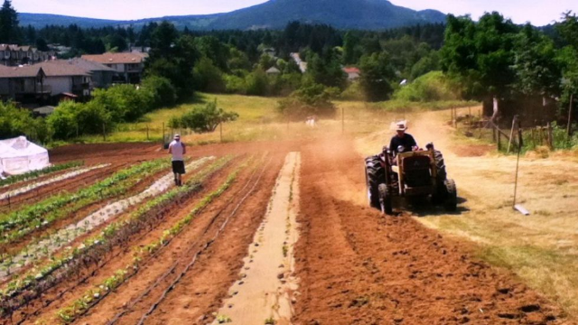
Within Nanaimo, Foodshare Nanaimo is taking a lead at increasing food security for its residences, as well as creating multiple resources in the education sector. The initiative of Foodshare is to bring sustainable food systems into town, and work with a variety of individuals that help in making food sustainability a realistic goal (Nanaimo Foodshare, n.d.). Nanaimo Foodshare is currently using a five acre farmland (figure 2) by Park Avenue and Eight Street in South Nanaimo; however the owners of the land are looking to sell their property for over $1 million and Nanaimo Foodshare is trying to buy the land (Sterritt, 2017). Currently the land is used to teach farming and agriculture to youth and students (Sterritt, 2017). By owning the land, Nanaimo Foodshare is hoping to also educate Nanaimo residents on urban farming and increase the want for local farming around the city (Sterritt, 2017). The project Nanaimo Foodshare has taken on to buy this land is massive, and at the same time they have been contributing to Nanaimo’s food security in a variety of ways. The “Kids Get Cooking” and “Farm to School” initiatives are two of their initiatives. In “Kids Get Cooking” children get the chance to work in the kitchen and the garden (Nanaimo Foodshare, n.d.). Children learn cooking skills and learn to prepare meals in the kitchen, and learn to plant and harvest vegetables in the garden (Nanaimo Foodshare, n.d.). The second initiative “Farm to School” is a healthy lunch program for students in School District #68 (Nanaimo Foodshare, n.d.). Its focus is to improve health of children by giving them access to nutritious, safe, and locally grown food (Nanaimo Foodshare, n.d.).
Figure 2. The 5-acre property by Park Avenue and Eight Street (Sterritt, 2017).
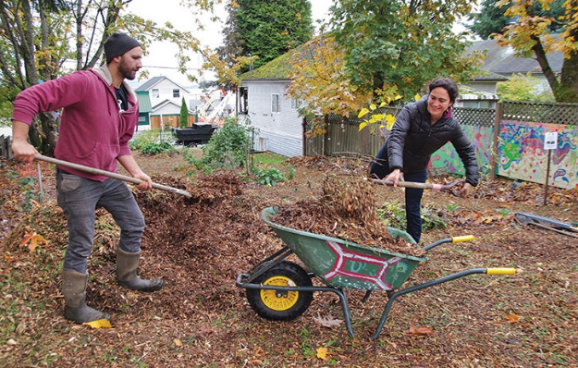
The second plan to increase food security is with regards to urban agriculture. The residents of Nanaimo have recently made new strides in urban agriculture in their city. In South Nanaimo, 364 Haliburton Street is now the new home to Nanaimo’s first “edible landscape” or “food forest” that opened to the public on October 21, 2016 (Bush, 2016). The idea for this landscape came out at a South End Community Association meeting (Bush, 2016). The previously undeveloped lot is located behind the Samaritan House (a women’s shelter) (Bush, 2016). The women’s shelter is run by the Island Crisis Care Society which had asked that the lot’s appearance be improved to increase safety and appearance and decrease the drug use in the area (Bush, 2016). Therefore the Mid-Island Community Development Co-op members took on the project along with the support from other community members and transformed the derelict space into a public garden meant to me maintained easily by residents in the community (Bush, 2016). The space is now home to a variety of fruit trees (apple, fig and plum) and berry bushes (Bush, 2016). The species selected were chosen due to their edibility and capability of fixing nitrogen in the soil to replicate the natural processes that occur in forests (Bush, 2016).
Figure 3. Members of the Mid-Island Community Development Co-op working on Nanaimo's food forest (Bush, 2016).
Future Direction
Vancouver Island has made positive steps in increasing food security; however, there are many opportunities for actions that were mentioned in previous sections that still need to be implemented at a higher degree. The biggest action that needs to be taken is increasing the knowledge of residents on Vancouver Island. Many people to not understand what they can do to increase security and others do not have any initiative because they do not have the prior knowledge to understand why increasing food security is important. Opportunities like developing land surveys, learning traditional food techniques, and changing policies are all ways to create action; however, if residents do not have an interest in food security then there is a decreased chance they will take part in opportunities given to them. Figure 4 represents a survey of 229 stakeholders from 5 farmers’ markets in British Columbia (BC Association of Farmers’ Markets & Vancity Community Foundation, 2013). The figure shows that the majority of individuals that shop at farmers markets are over the age of 36. This is important because it shows that younger generations are not as interested in going to farmers markets and contributing to food security, when these generations will be in power making decision in a few decades. Moreover, younger generations may not be as educated in local and sustainable foods to understand why supporting local businesses is important. Figure 5 shows the percent of customers at farmers markets in British Columbia based on their annual income – based on the same survey as figure 4 (BC Association of Farmers’ Markets & Vancity Community Foundation, 2013). These numbers show that most people shopping at farmers markets make between $25,000 and $99,000 annually. This could be due to the prices at farmers markets, but that does not explain why percentages drop once people have and annual income over $100,000. Local foods need to become more accessible for all ages and incomes in order to increase food security on Vancouver Island.
Figure 5. Percent of customers at farmers markets in B.C. based on their annual income (BCAFM & VCF, 2013).
Figure 4. Age range of Customers at Farmers Markets within B.C. (BCAFM & VCF, 2013).
Conclusion
In 2006, Vancouver Island’s estimated expenditures on food were $5,369 billion. Of the expenditures, only 3-percent ($163.7 million) came from Vancouver Island farms (VICRA & OCBR, 2011). Vancouver Island is threatened by the loss of processing and storage facilities. Facilities to store farmers’ foods will allow food to be bought and eaten instead of the surplus amounts of food in certain growing summers either wasted or exported. Within the Cowichan Valley, fewer farmers are raising livestock, and for the farmers that still raise livestock, increased numbers of the livestock are being processed off the Island due to lack of resources on Vancouver Island and provincial regulation (VICRA & OCBR, 2011). The environmental effects of the current food system include increased greenhouse gases from fossil fuel use, land and water pollution from agrochemical runoff, genetically modified organisms, decreased biodiversity, and business and marketing challenges (VICRA & OCBR, 2011). In order to increase sustainability and manage the impacts of climate change, Vancouver Island needs to look towards migrating food production back to the Island.
The Vancouver Island Community Research Alliance has provided a great deal of information and opportunities with the Local Food Project: Strategies for Increasing Food Security on Vancouver Island. Vancouver Island’s regional food system has three goals: to capitalize on the potential for food self-reliance, to provide residents with a high standard for food quality, and to develop and maintain resources for which the system relies on (VICRA & OCBR, 2011). A study conducted in 2009 concluded that on Vancouver Island, there is a growing interest in: small scale agriculture, reviving traditional First Nation’s food practices, and education of food processing and consumption (VICRA & OCBR, 2011). There is a want by residents on Vancouver Island to increase food security, but there is still a lot that can be done to address Vancouver Island’s food security and: climate change, urban agriculture, indigenous food systems, and institutional practices.

References

BC Association of Farmers’ Markets (BCAFM) & Vancity Community Foundation (VCF). (2013). The
value of farmers’ markets in british Columbia: insights from the farmers’ market toolkit pilot. Retrieved March 25, 2017, from http://www.demonstratingvalue.org/sites/default/files/basic-page-attachments/The%20Value%20of%20Farmers%20Markets%20Report%20Aug%2030.pdf

Bush, C. (2016, October 20). Nanaimo’s first food forest opens in south end. Nanaimo News
Bulletin. Retrieved March 28, 2017, from http://www.nanaimobulletin.com/news/nanaimos-first-food-forest-opens-in-south-end/

David Suzuki Foundation. (2014). Food and climate change. Retrieved March 25, 2017, from
http://www.davidsuzuki.org/what-you-can-do/food-and-our-planet/food-and-climate-change/

Food Literacy Center. (2015). What is food literacy?. Retrieved March 24, 2017, from
http://www.foodliteracycenter.org/what-food-literacy

Gold, M. (2007). Organic production/organic food: information access tools. National Agricultural
Library: United States Department of Agriculture. Retrieved March 24, 2017, from https://www.nal.usda.gov/afsic/organic-productionorganic-food-information-access-tools

Nanaimo Foodshare. (n.d.). Retrieved March 27, 2017, from https://nanaimofoodshare.ca/contact/

Statistics Canada. (2008). Farm population and total population by rural and urban population, by
province, (2001 and 2006 census of agriculture and census or population). Government of Canada. Retrieved March 26, 2017, from http://www.statcan.gc.ca/tables-tableaux/sum-som/l01/cst01/agrc42a-eng.htm

Sterritt, S. (2017, January 31). $1 mil needed for urban community farm in south nanaimo. Nanaimo
News Now. Retrieved February 3, 2017, from http://nanaimonewsnow.com/article/523856/1-mil-needed-urban-community-farm

Vancouver Island and Coastal Communities Indigenous Food Network (VICCIFN). (2011). Retrieved April
3, 2017, from http://www.indigenousfoodsvi.ca/viccifn-vision/

Vancouver Island Community Research Alliance (VICRA). (n.d.). Retrieved March 25, 2017, from
http://vicra.ca/

Vancouver Island Community Research Alliance (VICRA), & Office of Community Based Research
(OCBR). (2011). Local food project: strategies for increasing food security on vancouver island. Office of Community Based Research, University of Victoria. Retrieved March 23, from, https://www.uvic.ca/assets/media-releases/VICRA-summary-report.pdf

