Case study:
SOLE Food Street Farms

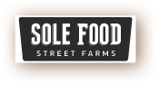

Ashley Dodsworth
Vancouver Island University
Geography 352
Professor Alexander
December 10, 2013

SOLE Food farm started in 2009 as a social enterprise part of United We Can, but is now owned by Cultivate Canada. SOLE is an acronym that stands for Save Our Living Environment (Cockrall-King, 2010, para. 1). Cultivate Canada is a registered charity and oversees the operations and activities of SOLEfood street farm. They have a board of directors consisting of four members: Rob Withers, Michael Ableman, Russel Precious, and Sherry Edmunds Flett. They have several donors: Radcliffe Foundations, Vancity Community Foundation, Vancity Capital, and the City of Vancouver; as well as the following supporters: Central City Foundation, TD FEF Fund, Natures Path, Real Estate Foundation, VEEES, Building Opportunities with Business, and Social Ventures Partners Vancouver. They also have several infrastructure partners: BW Global Structures Inc., Valhalla Inc., and Eco-soil. They grow vegetables and sell them to 30 local restaurants (as of 2012) and to the public at local farmers markets. In their first growing season, in 2009, they grew 10,000 pounds of produce on their first half-acre lot. By 2012 they were growing 100,000 pounds of produce on their five verdant sites (Smith, 2012).
How do they get land to grow on? Well, the city of Vancouver provides land in some cases. Some landowners get a 65% property tax break from the project as an incentive to allow SOLE Food to use the land. Companies such as Concord Pacific, who owns land near BC place and home of the markets highest profiting site uses the money they get and put it back into the farm. Some landowners may be reluctant to allow them to use the land. They include in the lease a statement of agreement that they will leave on short notice, as they grow the produce in forklift-moveable containers (Figure 1) that are able to move at a moment’s notice (Smith, 2012).
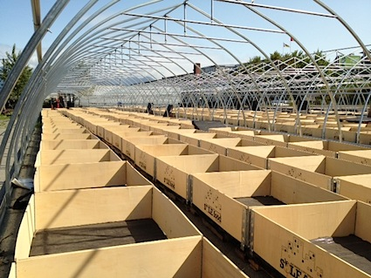
Figure 1. Picture displaying the containers that they plant the crops in at the SOLE Food Farms.

The people that are employed at SOLE Food farms are recovering addicts from the downtown east side. These people are given a second chance through the opportunity of working on the farm to make their life right. Rob, who is the farm organizer at the downtown east side farm site, notes that getting involved in agriculture was a fairly recent but pleasant turn of events in his life:
‘It’s been a winding road,’ . . . . ‘I went to recovery and then started working with an agency that helps people in recovery find employment, and through my research, though I have many interests, I kept coming back to horticultural therapy, which I had zero experience in but it seemed to really pull me’”. (Tang, 2010, paras. 2-3)
Tang (2010) notes that this was when Rob first heard about SOLEfood, and that after he attended an information session, he was hired on the spot (para. 4).
Smith (2012) explains that while SOLEfood has changed its employees for the better, it has also changed Michael Ableman, co-founder and director of the farm in a positive way as well: “‘I have seen a level of courage and determination among our staff that you would be hard-pressed to find anywhere . . . . I see these folks rise up against incredible personal challenges. . . . I’ve seen the dignity of these folks. I think there’s a very thin line that separates any of us from folks who are living on the margins of the Downtown Eastside’” (para. 24). Ableman also pointed out that one of the SOLE Food farm employees has been able to go off of social assistance for the first time in their life since being, about which he remarked: “‘I don’t know if we can attribute that to our work,’. . . . ‘But I think there’s a connection’” (Smith, 2012, para. 25). SOLE Food currently employs twenty-five people who earn a wage of $10.50 an hour (Smith, 2012). In addition to its revenue from produce sales, SOLE Foods is able to continue its work through being owned entirely by registered charity Cultivate Canada, which “raises financing through private foundations” (Smith, 2012, para. 20).
SOLE Food currently has four sites located throughout Vancouver (Figure 2), listed as follows:
1) Strathcona: This is the original farm site and is where most of the ideas and techniques used at all other farms were developed. This location consists of a half-acre parking lot adjacent to the Astoria Hotel on Hastings and Hawkes.
2) False Creek: This is their largest farm, at two acres, and was provided by Concorde Pacific. The farm is located on the corner of Pacific and Carrall, right below the BC Place sports stadium. This site makes use of its advantages such as warmth, exposure, and a larger concentrated block to grow on.
3) East Van: This farm is located beneath the Grandview viaduct in an industrial part of the city. They have one acre of high tunnel unheated greenhouses, which provides the infrastructure to grown warm weather crops and extends their growing season through the winter months.
4) Main St.: Their newest farm site is located at the intersection of Main and Terminal. This one acre lot was provided by the City of Vancouver and is the future location of the New City Market, but currently hosts SOLE Food’s retail sales outlet that provides products from all the farms six days a week. (SOLE Food, n.d., “Our Farms”).
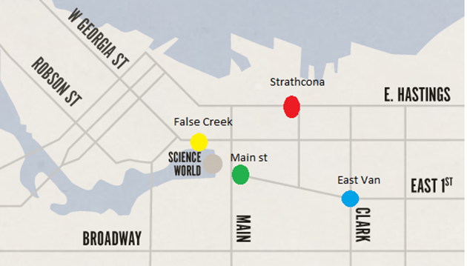
Fig 2. Map of SOLE Foods’ four farm sites in Vancouver.

They are currently growing the following crops at the SOLE Food Street Farms locations: Arugula, Basil, Beets, Carrots, Cilantro, Collards, Cucumber, Dill, Eggplant, Filet Beans, Green Onions, Hot Peppers, Kale, Lettuces, Melons, Parsley-curly and flat leaf, Peas, Radicchio, Radish, Rainbow Swiss Chard, Spinach, Strawberries, Sweet Peppers, Tomatoes and Cherry Tomatoes (SOLE Food, n.d., “Our Food—Produce”).
There are many forms of capital that SOLE Food’s operations encompass. The most obvious alternative forms of capital that SOLE Foods enhance are physical capital, human capital, and social capital. Human capital is enhanced by SOLE Foods in that they connect with recovering addicts from the downtown east side of Vancouver (who are likely considered unhireable by many), or who otherwise struggle with mental illness, and they give them a job teach them skills that are new to them. Not very often are people willing to take a risk such as this, but it is incredibly important that SOLE Foods offers people a chance to turn their lives around. Smith (2012) notes that on the hiring and employment of recovering addicts and people with mental illnesses, Ableman reflects that “‘There are a lot of ups and downs, . . . I have come to realize that addiction is a lifetime experience and, as such, we have allowed for that in our employment model’” (para. 19). Ableman also reflects on the rewards of training people in farm work:
‘And I think the guys who have stayed with it, there have been little moments when we’re planting or something and I see these guys who had such a tough life in many respects become so soft and so attentive and so sensitive to a tiny little plant and it’s so great.’ (Tang, 2010, para. 25)
In terms of physical capital, SOLE Foods benefits the communities that they are located in because they take barren, vacant lots and turn them into farms and make it a beautiful sight to see (Figure 3). They are making an improvement to downtown Vancouver. Perhaps the greatest impact of SOLE Foods is in its transformation of its East Vancouver site.
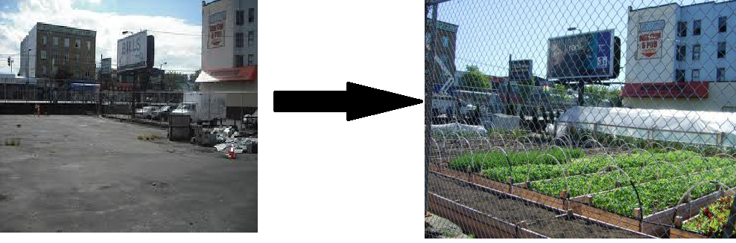
Figure 3. SOLE Food’s Strathcona location before (left) and after (right) the farm was put in place.
Vancouver’s Downtown East Side (DTES) is a community that unfortunately that is more often associated with street drugs and social problems than with fresh veggies. Maybe SOLE food is going to change that, even just a little bit (Cockrall-King, 2010). About two years ago, the idea of starting an urban farm in East Vancouver arose, and after a year of looking for a suitable and available space, the parking lot adjacent to the Astoria Hotel on Hastings Street and Hawkes Avenue came up in late 2012.
The owners of the lot wanted to take advantage of the property tax concessions that the city of Vancouver was offering to land owners who would convert bare lots or unused space into a green space, but the deadline to accomplish this was quickly approaching by the time that the plan to erect a farm there was put in place. Farmer Seann Dory explains that “‘We built [the East Vancouver farm location] in one day, on October 31. . . . in order to get the tax assessment done’” (Cockrall-King, 2010, para. 3). As far as how they were able to establish an entire farm in one day, Cockrall-King (2010) explains that “It took about 50 volunteers to turn the 17,000 square-foot space into an urban veggie farm on that day last year [and that] [t]he farm is now in its very first growing season in the summer of 2010” (para. 3). Cockrall-King (2010) explains the establishment of the East Vancouver farm in more detail as follows:
The land that it sits on is courtesy of the owners of the Astoria Hotel, a rooming-house hotel common in the neighbourhood. . . . [T]hey got access to the lot because of Vancouver’s new tax incentives for green spaces. It was the parking lot to the hotel next door, but mainly it was a dumping ground and a haven for a lot of the street activity that goes on in the neighbourhood. The hotel owners received a healthy tax break if they converted that unused space to a park or garden; and [United We Can] jumped at the chance because they had been looking for a space for their urban farm for almost a year without any viable prospects. But the deadline for the tax evaluation was November 1 and Dory and about 50 volunteers had to literally build the farm on October 31 in order for the space to qualify. (para. 4)

Social capital is enhanced through the SOLE Food Street Farms because the people that they hire are on their way up from an all-time low in their lives. This is giving them something to feel good about doing, and gives them something worth changing their lives for. They are also enhancing social capital through transforming lots that were once used by drug dealers and prostitutes into gardens that grow high-quality food, which fosters collective action towards the creation of a healthy and desirable product for society to consume, in addition to creating more green space for people to enjoy. It is giving people a new lease on life, as not very many people are willing to hire people from the DTES and have faith in people who are recovering addicts and suffering from mental illness (Figure 4). The impact that SOLE Foods is having on improving people’s lives and the communities in which they operate their farms must not be underestimated.
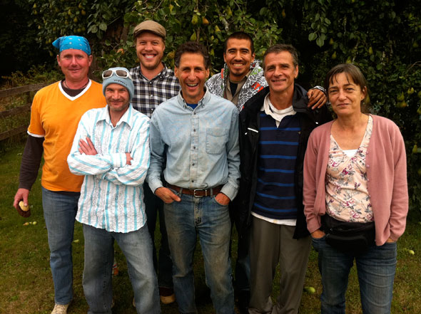
Figure 4. Group photograph of SOLE Food Street Farms workers. From Left to Right: Rob Holland, Ken Vallee, Seann Dory, Michael Ableman, Michael Jacko, Alain Guy, and Donna Gilkes.

References
SOLE Food. (n.d.). SOLE Food Street Farms. Retrieved from http://solefoodfarms.com/
Smith, B. (2012, November 20). SOLEFood Farm changes landscapes and lives. The Globe and Mail.
Retrieved from http://www.theglobeandmail.com/report-on-business/solefood-farm-changes-landscapes-and-lives/article5471486/
Tang, C. (2010, June 18). SOLEFood, a community’s farm. BCLiving. Retrieved from http://www.bcliving.ca/garden/solefood-a-communitys-farm
Cockrall-King, J. (2010, August 4). Vancouver Pt. 3: SOLEFood Farms, An Urban Farm Project. Retrieved from http://foodgirl.squarespace.com/book/2010/8/4/vancouver-pt-3-solefood-farms-an-urban-farm-project.html
Image References
Figure 1. Retrieved from http://www.cityfarmer.info/2012/05/16/another-solefood-urban-farm-being-built-in-vancouver/
Figure 2. Retrieved from http://solefoodfarms.com/
Figure 3. Retrieved from http://www.cityfarmer.info/2012/05/16/another-solefood-urban-farm-being-built-in-vancouver/; http://archive.constantcontact.com/fs045/1102771164343/archive/1105313947030.html
Figure 4. Retrieved from http://vancouverisawesome.com/2011/12/07/vancouver-farmers-markets-vendor-profile-1-solefood/

