Soil and Sustainable Farming
Geography 101, Section 4, Vancouver Island University
By: Casey Grow
For: Don Alexander
March 31, 2017

I come from two large farming families in western Saskatchewan and have made my way out to the west coast of Canada. I came to Vancouver Island for the beauty, climate, and wide arrange of recreational activities and entertainment. While earning an education, I came to understand that a lot of what I was taught by my parents did not always make scientific or ethical sense. Much of what my father and his farmer friends believe is based upon a combination of tradition, television, farm reports, word-of-mouth and “feelings.” It is because of their bias toward every topic imaginable, I have wondered if the way they farm is sustainable or not. This curiosity turned into an obsession after having three children of my own in this troublesome world that we live in. I worry about their future and would find great relief in coming to realize that my father is correct when it comes to food production. For this media analysis research paper, I wanted to compare the views of Canadian conventional farmers and their critics.
The information source I will use for the pro-conventional agriculture will be taken from the government of Canada website at: Agriculture and Agri-Food Canada. (Canada, 2016). I figure the government website would have the closest information to how current farming practices are being handled.
When I did a Google search for articles to include in this paper, I was surprised by the number of articles regarding sustainable agriculture. Most of the articles were about how Canada is near sustainability or making strides towards sustainable agriculture. They are very positively focused on the things they do well. I find it very interesting that even when I was searching for articles that would challenge Canadian agriculture by typing “unsustainable;” articles with “sustainable” in their title would show up. I thought it might be that most authors and editors choose to write in the positive vernacular or maybe the funders for the research are predominately in favour of current agricultural practices due to economics.
The other website I will use has been an advocate for the environment and ecology for many years. The World Wildlife Federation has listed the environmental impacts of farming on their web page. (WWF, Environmental Impacts, 2017). The subheading in the article reads “Unsustainable agricultural and aquaculture practices present the greatest immediate threat to species and ecosystems around the world.” The key here is unsustainable practices. The main negative environmental impacts from farming include: land conversion & habitat loss, soil erosion and degradation, wasteful water consumption, pollution, climate change and genetic erosion.
Land Conversion & Habitat Loss
WWF states that agricultural ecosystems provide habitat for plants and animals in traditional farming areas that cultivate diverse species. Recently, demand for food and other agricultural products has caused the removal of natural habitats to make room for intensive monocultures. It cites palm oil as an example as well as soybean and cattle farms in the Brazilian rainforest. On top of habitat loss, the earth is seeing 12 million hectares of land lost to desertification. (WWF, Habitat Loss, 2017).
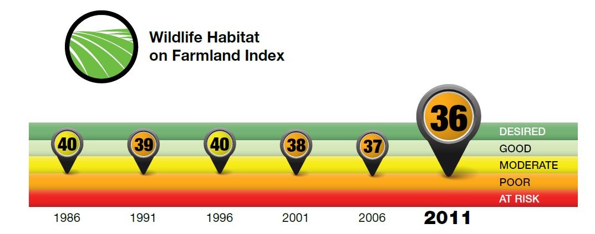
This graphic was taken from the Government website. It shows a concerning statistic and trend of declining wildlife. This decline correlates to the loss of natural and semi-natural land [sq. km. in Canada?] and the increase of farming. Within some regions, the loss of perennial hay and pasture habitat was a major contributor to the decline in wildlife habitat capacity. They emphasized that a "Desired" or even "Good" state is unlikely for this indicator, as annual cropland is generally quite low in its ability to provide habitat. As demand for food grows, more land may be brought into production, causing further habitat loss. (Canada, Wildlife Habitat, 2016).
Flying over the prairies reveals a variety of crops which ranges from Wheat, Corn, Canola, flax, peas, hemp, barley, etc. There are also a wide variety of each of said species. There is brush and riparian habitat to support a small amount of species such as deer, moose, fox, coyotes etc. The original species that have lived in the space, still reside to this day but in far fewer numbers and the plains bison are an exception as they have not been able to survive the European invasion without human assistance.
Because farming is a business driven by markets and commodity prices, it can be challenging to balance high productivity, which is what every farmer wants, with the long-term health of the agro-ecosystem. Wildlife habitat on farmland can be degraded through the conversion of natural and semi-natural areas to annual cropland, increased use of chemical sprays, drainage of wetlands, removal of riparian shelterbelts and natural field barriers to accommodate larger machinery, and sometimes through an increase in livestock density. These changes can lead to habitat fragmentation and the loss of landscape heterogeneity.
Agriculture benefits from the important ecosystem services provided by wildlife, including crop pollination and natural pest control. The provision of wildlife habitat in agricultural regions, through the creation or maintenance of buffers, woodlots or wetlands, can provide benefits such as improved soil and water quality, efficient nutrient cycling and carbon sequestration.
Agriculture has the potential to mitigate the loss of suitable habitat or to create new habitat by implementing beneficial management practices such as reducing summerfallow and tillage intensity and by converting annual crops to perennial cropping systems. The government implies that producers can learn about the benefits of wildlife and ways of conserving it by attending farm planning activities. (Canada, Wildlife Habitat, 2016).

The problem with habitat and wildlife loss seems to be of a minor concern to farmers and consumers because they are getting their needs met through food production, not critter rescue. Most of the farmers I know are also hunters, trappers and riflemen who grew shooting gophers, coyotes, magpies, beavers and anything else they could find. I have found that amongst farmers, the widely held belief tends to be anthropocentric with regards to life outside of the human realm. Until more disastrous consequences are caused due to a decline of species, we may not see a drastic improvement in wildlife. A slow improvement could be attained with the intervention of incentive laden programs.

Soil Erosion and Degradation
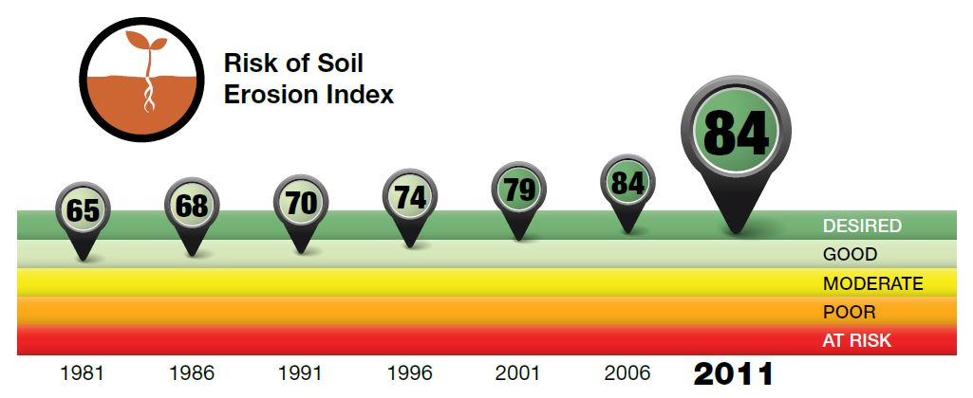
This is another encouraging graphic from the government site regarding risk of soil erosion. This nation-wide improvement came about primarily as a result of widespread adoption of reduced tillage and no-till, as well as decreases in the use of summerfallow in the Prairies. (Canada, Soil Erosion, 2016).
The WWF states that soil erosion is a much bigger problem in other areas of the globe and blame the practice of ploughing and tilling land because it breaks apart the plant life and allows wind and rain to erode nutrient rich soil.

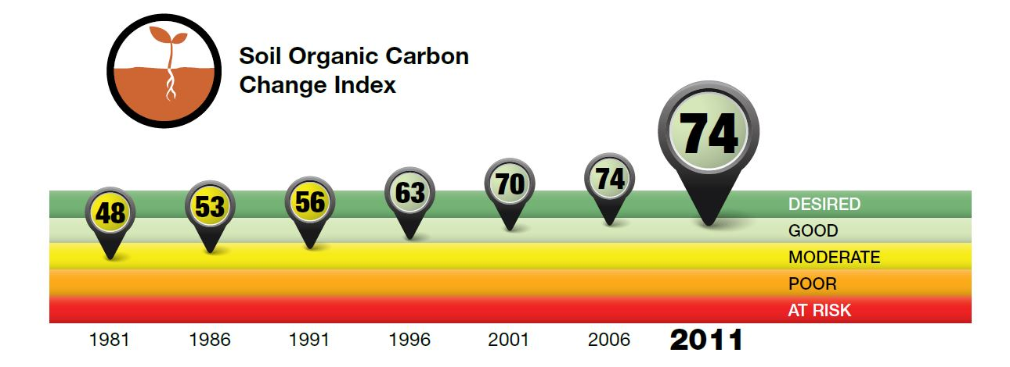
The same no-till conservation and reduced summerfallow in the prairies is thought to be the reason on the improvement of organic carbon in soil. (Canada, Soil Organic Carbon, 2016).

Proper soil nutrition is essential for satisfactory crop growth and production. The use of soil tests can help to determine the status of plant available nutrients to develop fertilizer recommendations to achieve optimum crop production. (McKenzie, 1998).

I was encouraged by the notion of soil testing each year as a way to maintain a healthy homeostasis in soil nutrient levels. I contacted a soil testing company called SGS from Guelph Ontario to get an idea of what a farmer must go through to have his soil tested.

The company offers high quality, reliable services providing Measurements for Management to all sectors of the agricultural industry, including analysis of feeds & forages, soils, fertilizers, plant tissue and greenhouse media and solutions. (SGS, 2017).

Jack Legg replied with the following e-mail:
Hello Casey,
Your request came to me, about an example of our soil report. I’ll attach one, that also has comments to help interpret results. We would also gladly go over results with you after the testing is complete, and help with nutrient recommendations.
I’ll also attach a pricelist of our tests and packages.
Jack Legg, CCA-ON, 4R NMS
SGS Agriculture and Food
Branch Manager, Agronomist

See Appendix A to view an example soil report. If I were a farmer, I may not be able to make sense of the chart but I would have the option of talking to a sales person from SGS or an unaffiliated Agronomist to help me choose the custom fertilizers best suited to the land.

The David Suzuki Foundation has many articles that provide alternatives to chemical fertilizers and pesticides. One such article explains a promising development called “Dark Earth” as a way to sustain soil fertility, reverse climate change and reduce world hunger (Suzuki, D. 2016).
The idea with Dark Earth is to add biochar to the soil which has shown to increase root growth and trap high levels of CO2 inside the soil. Biochar is a form of charcoal made via pyrolysis (heating organic wastes in a low-oxygen environment.) If you pyrolyze organic wastes it gets converted into highly stable carbon, which can persist in soils for thousands of years. As well as carbon, biochar retains nutrients like nitrogen and phosphorous, and because it's porous, adding it to soils and compost helps them store nutrients and water. Dark earth won't solve all our climate problems, but combined with reducing fossil fuel use, it could make a huge difference while addressing many agriculture, food security and hunger issues. (Suzuki, D. 2016).

Wasteful Water Consumption
The WWF websites lists wasteful water practices as a major problem. Leaky irrigation systems, wasteful field application methods and cultivation of thirsty crops which are not well suited to an environment are culpable. The use of underground water and streams for agriculture dries up many naturally occurring water systems which leads to a wide range of interconnected problems. (WWF, 2016).
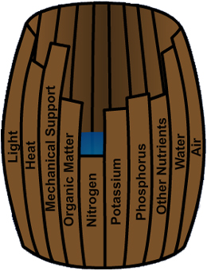
“Drawing of barrel with staves of varying lengths to represent the different requirements of growth; the 10 staves are all labeled as follows: light, heat, mechanical support, organic matter, nitrogen, potassium, phosphorus, other nutrients, water and air. Plant growth is limited by the shortest stave- in this example Nitrogen. The barrel can only hold water to the height of the shortest stave.” (Canada, Watershed Protection, 2016). Nitrogen and phosphorous are two of the biggest deficiencies in Canadian soil, which is why they are the most widely applied fertilizers to maximize yields. The addition of these and other nutrients can be harmful to a water body and the life that dwells in it. (Canada, Watershed Protection, 2016).

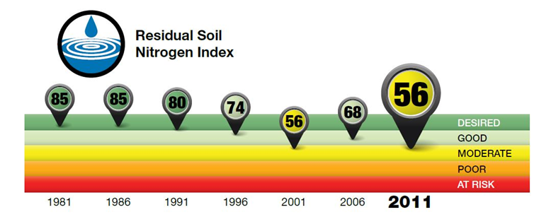
The use of fertilizers has led to an decreasing trend over time due to increases in nitrogen inputs such as fertilizer, particularly since the mid-1990s. (Canada, Nitrogen, 2016). At this rate, something needs to happen with regards to fertilizer spray, otherwise the score could go to poor and at risk in another twenty years.
Modern agriculture relies heavily on the use of pesticides to maintain yields. It has been estimated that without pest management, pre-harvest crop losses would average 40 per cent. “Unfortunately, free lunches are hard to come by and there are a number of environmental risks posed by pesticide use.” (Canada, Watershed Protection, 2016). I included this quote because it seems out-of-place in a scientific informational website. It is similar to the language I hear when talking to farmers who “gotta do what they gotta do.”
“The greatest risk of pesticide use is to non-target organisms. These include species that we consider beneficial or desirable, including ourselves.” Through the development of pesticide resistance and the elimination of predators due to broad-spectrum compounds, we may aid the emergence of new pest species. Notice how they followed up the farmer-talk language by adding “including ourselves” and a warning for doing more harm than good, which more than makes up for the earlier comment.

Pollution
The WWF lists farming pollution as a leading source of pollution in many countries. The use of pesticides, fertilizers and other agrochemicals has increased hugely since the 1950s. The chemicals do not just stay on the fields they are applied to. Some application methods lead to pollution of adjacent land, rivers or wetlands. Due to inappropriate water management and irrigation technology, fertilizers and pesticides also commonly run-off from fields to adjacent rivers and lakes and contaminate groundwater sources. These chemicals eventually end up in the marine environment too. (WWF, Pollution, 2017).
Pesticides often don't just kill the target pest. Beneficial insects in and around the fields can be poisoned or killed, as can other animals eating poisoned insects. Pesticides can also kill soil microorganisms. Pesticide pollution of rivers, lakes and wetlands also directly poisons freshwater species, as well as people. Some pesticides are suspected of disrupting the hormone messaging systems of wildlife and people, and many can remain in the environment for generations. (WWF, Pollution, 2017).
Unlike pesticides, fertilizers are not directly toxic. However, their presence in freshwater and marine areas alters the nutrient system, and in consequence the species composition of specific ecosystems. Their most dramatic effect is eutrophication - resulting in an explosive growth of algae due to excess nutrients. This depletes water of dissolved oxygen, which in turn can kill fish and other aquatic life. (WWF, Polluton, 2017).
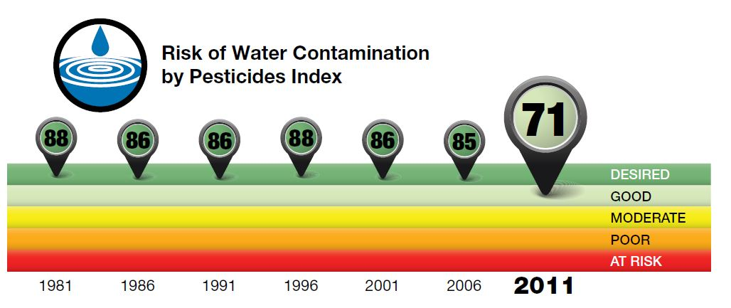
The government notes a downward shift in contaminated water. Much of this increase took place between 2006 and 2011, owing to a shift to cropping systems requiring greater use of pesticides, such as reduced tillage systems and, to a lesser extent, to wet weather in the Prairies and the Maritimes in 2010. (Canada, Pesticides, 2016).

Climate Change and Genetic Erosion
The government website includes a Greenhouse gas indicator and shares an encouraging image, seen here:
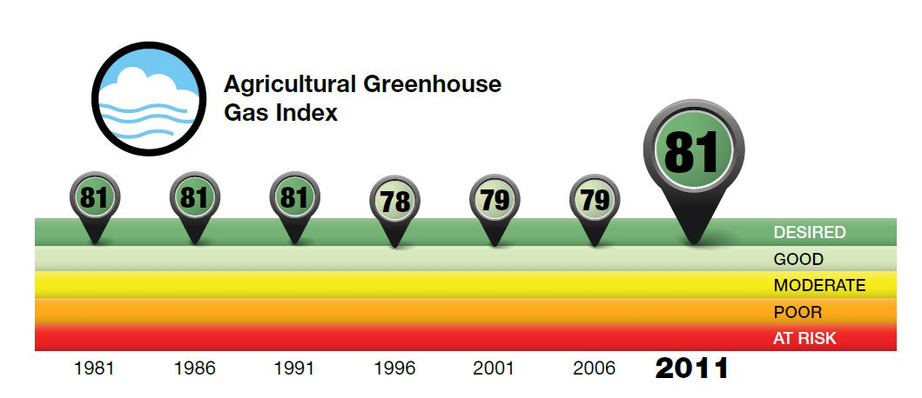
This graphic is based on land that is the most undesirable scoring a zero, and the most desirable scoring 100. It is intended to keep track of aggregate and trends in agricultural environment. They credit the rise in quality from 1991 to 2011 to no-till practices and a reduction in cattle due to poor prices, resulting in less methane. (Canada, Agricultural Greenhouse Gas, 2016).
Another hopeful chart shows that the land we use for agriculture is a “sink” for CO2.
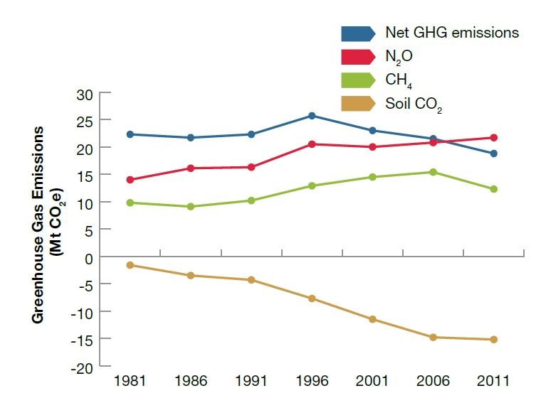
A “sink” means that the agriculture soil now traps CO2 in it like a forest might which has a reverse effect on greenhouse gas emission and climate change. (Canada, Agricultural Greenhouse Gas, 2016). If Dark Earth is found to be a worthwhile option, agriculture land will be able to store even more CO2.
If we stop here at climate change, it almost appears that agriculture will beat out climate change, but with it comes extreme weather such as tornadoes, floods, droughts. These weather events can have a negative impact on the yields of crops and change political climates around the globe.
The Government website reads:
Greenhouse gas emissions have been conclusively linked to climate change, and continued emissions may worsen this problem for future generations.
Agriculture has the potential to mitigate by:
- Implementing BMPs (Best Methods of Practice) that either reduce emissions or encourage the capture and storage of carbon in agricultural soils, and
- Reducing the intensity of emissions on a per-unit production basis, whereby technological and management solutions are used to lower the amount of emissions it takes to produce a unit of product, such as meat or milk.
(Canada, Agricultural Greenhouse Gas, 2016)

Conclusion

Most of the warnings, and negative statistics were found on the government of Canada’s web page. Canada’s various agricultural regions have graphical “Future Outlooks” where anyone can see potential changes to moisture deficits, effective growing days, and length of growing seasons. (Canada, Future Outlooks, 2016).
I think that Canada has done a fair job in communicating to farmers current best practices methods but in a perfect world we would have a quicker response. It does not appear as though Canada is hiding any glaring statistics or trying to cover up any potential harmful practices in the topics it listed. I think that by displaying the negative statistics on the charts that were included in this research paper and listing areas that need correction, signifies a respect for science and an understanding that a sustainable agriculture sector is in every citizen’s best interests. However, I have grown more concerned about the issues found in pollution due to pesticides and fertilizers and feel that changes must be made immediately. Additionally, steps must be taken to save Canada’s wildlife and habitat.
My research helped me to understand how conventional knowledge might seem correct, credible and backed by science, but then suddenly the science is proven to be incorrect and adjustments must be made. To think that the current mode of production in agriculture is sustainable is dangerous and citizens need to be very vigilant about what we do to the environment. This is why statements that my father makes when he answers questions of whether conventional agriculture is sustainable are demonstrative of the reason for slow response time with best practice methods. Adults like to think they are good at what they do, no matter what profession; just look at how long it took for the education system to change. In order to forgo this characteristic, government need to step in with laws, incentives, programs and communication with every farmer. Consumers should be well informed to so that they can make informed purchases.
Over the passage of time, humans have progressed in every field and sector and ingenuity and technology improves. History has shown us that even though the agricultural knowledge and technology improved vastly in the areas of the Middle East known as the Fertile Crescent, the fundamental mistakes were too great and too harmful on the environment. What was once fertile land has become a dry desert caused by thousands of years of damming, over farming and climate change. It also demonstrates a failure to act after sufficient warning (Mark, 2009).

While there’s a lot of uncertainty surrounding the future of Canada’s agriculture industry, one thing is clear: we are likely to see more extreme weather events, soil erosion and higher average temperatures. Farmers must look at environmentally-friendly farming practices to adapt to the effects of climate change and pollution to stay in business. (Canada, Future Outlook, 2016). My worries for my children and the future of humanity may not have been put to rest, but I do feel some relief in knowing that we are at least aware of many of the problems. It is also comforting to know that food will always be of the upmost importance and if there was ever a serious threat to it, our government and the citizens are likely to meet the challenge. Maybe my children will have a part in solving some of the problems and the ones to follow.

References

Arnason, R. (2012, December 05). David Suzuki takes swipe at conventional agriculture. Retrieved March 29, 2017, from http://www.producer.com/daily/david-suzuki-takes-swipe-at-conventional-agriculture/

Canada, Government of. (2017). Retrieved from: http://www.agr.gc.ca/eng/science-and-innovation/agricultural-practices/?id=1360876327795
- http://www.agr.gc.ca/eng/science-and-innovation/agricultural-practices/soil-and-land/wildlife-habitat-capacity-on-farmland-indicator/?id=1462916293297
- http://www.agr.gc.ca/eng/science-and-innovation/agricultural-practices/soil-and-land/soil-erosion-indicator/?id=1462893337151
- http://www.agr.gc.ca/eng/science-and-innovation/agricultural-practices/soil-and-land/soil-organic-matter-indicator/?id=1462905651688
- http://www.agr.gc.ca/eng/science-and-innovation/agricultural-practices/water/watershed-protection/agriculture-and-water-quality/?id=1371491033072
- http://www.agr.gc.ca/eng/science-and-innovation/agricultural-practices/water/pesticides-indicator/?id=1462401144426
- http://www.agr.gc.ca/eng/science-and-innovation/agricultural-practices/water/nitrogen-indicator/?id=1461713461325
- http://www.agr.gc.ca/eng/science-and-innovation/agricultural-practices/agriculture-and-climate/agricultural-greenhouse-gas-indicator/?id=1461014704763
- http://www.agr.gc.ca/eng/science-and-innovation/agricultural-practices/agriculture-and-climate/future-outlook/climate-change-scenarios/?id=1362684401064

Clark, W. (2014, November 06). The End of the Big Oil and Gas Game Has Come. Retrieved March 29, 2017, from http://www.huffingtonpost.com/woodrow-clark/oil-and-ga-game-ends_b_6061194.html

Jaeger, J. (2017, January 09). China is Leaving the US Behind in Clean Energy Investment. Retreived March 27, from: http://www.renewableenergyworld.com/articles/2017/01/china-is-leaving-the-us-behind-on-clean-energy-investment.html

Mark, J. (2009, September 02). Fertile Crescent. Retrieved March 31, from: http://www.ancient.eu/Fertile_Crescent/

McKenzie, R. (1998). Crop Nutrition and Fertilizer Requirments. Retrieved March 15, from: http://www1.agric.gov.ab.ca/$department/deptdocs.nsf/all/agdex3791/$file/540-1.pdf?OpenElement

SGS. (2017). Website. Retrieved March 25, 2017, from http://www.agtest.com/. E-mail from Jack Legg retrieved March 23, 2017.

Suzuki, D. (2016, July 07). Dark earth could herald a bright future for agriculture and climate. Retrieved March 13, from: http://www.davidsuzuki.org/blogs/science-matters/2016/07/dark-earth-could-herald-a-bright-future-for-agriculture-and-climate/

WWF (2017). World Wildlife Federation. Retrieved March 17-31 from: http://wwf.panda.org/
- http://wwf.panda.org/what_we_do/footprint/agriculture/impacts/
- http://wwf.panda.org/about_our_earth/species/problems/habitat_loss_degradation/
- http://wwf.panda.org/what_we_do/footprint/agriculture/impacts/soil_erosion/
- http://wwf.panda.org/what_we_do/footprint/agriculture/impacts/water_use/
- http://wwf.panda.org/what_we_do/footprint/agriculture/impacts/pollution/
- http://wwf.panda.org/what_we_do/footprint/agriculture/impacts/genetic_erosion/

