The Edible Garden Project Case Study

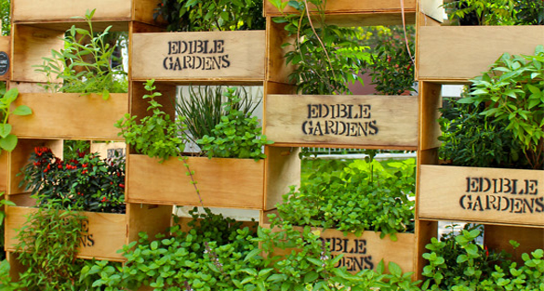

Kala Mackintosh  
Geography 352  
 Professor Don Alexander  
 November 26, 2015

The global food system is not only centralized, energy-intensive and unsustainable, but it tends to prioritize corporate profits over satisfying basic human needs. As nearly half of the global population moves away from the rural countryside and migrates to cities, it remains a challenge to stay connected to our food system. The North Shore in Vancouver, British Columbia leads the way in the transition toward a sustainable future, where citizens are interconnected to their traditional food systems. The Edible Garden Project is an environmentally-sustainable grassroots initiative designed to address food insecurity and satisfy the needs of vulnerable residents by integrating community members to reconnect with their local food system.

The Edible Garden Project (EGP) facilitates community ownership over resources in North Vancouver to repurpose underutilized urban land and grow food to distribute it throughout the community (MacArthur, 2014). This project increases local food security and builds community resilience. The urgency for change grew after the results of a Vancouver Coastal Health scan in 2005 indicated a gap in access to fresh local produce in the North Shore. A passionate group of local volunteers, community agencies, the Vancouver Coastal Health, the District of North Vancouver, the North Shore Recycling Program and the North Shore Neighbourhood House formed a coalition called the Edible Garden Project in 2005. The City of North Vancouver plays an ongoing and instrumental role in securing funding for the project through the Union of BC Municipalities (Edible Garden Project, 2015). The North Shore Neighbourhood House (NSNH) is a registered charitable organization and shares the interests of the EGP to create an inclusive, safe, supportive and healthy community for residents of all ages. The aim of the EGP is to meet the needs of local citizens and to ensure sufficient fresh, locally grown food is available in a dignified manner to the vulnerable residents in the North Shore community, increasing access and affordability.

With a starting budget of $30,000 and a few square feet, the EGP’s first sharing garden began in 2006. The concept of a sharing garden is to grow food and supply the harvest as donations to social services in the community, such as the local food banks, the NSNH, the Harvest Project, Sage Women’s Safe House, local social housing, and various other community partners. Nearly a decade later, over nine sharing gardens exist throughout the community: the Bridgeman, Sailview, Queen Mary, Booth, Mary Anne’s, Keating, Lillooet, Orchard, and West Vancouver. These locations include boulevards, residential properties, roof tops, community gardens and public school yards. Sharing gardens were established in five child care centres, encouraging young children and toddlers to get an early start in learning about growing food by getting their hands in the soil. The EGP uses an online map called, Sharing Backyards, to connect people who have the land to grow food with those who don’t, offering garden space in residential areas and creating convenient opportunities for people to maximize efficiency in growing food across the city. In partnership with the North Shore Recycling Program and the Lynn Canyon Ecology Center, in 2007, the EGP began offering educational workshops to the community at a low cost. The $8.25 fee of Gardensmart workshops supports the efforts of these organizations to build a strong community. Gardensmart workshops cover a variety of topics including: seed saving, pruning, food preservation techniques, bee keeping and pollination, harvesting rain water, chickens, aquaponics, composting, and general gardening tips. These joint ventures and workshops educate people about the interconnectedness of the environment.   
Loutet Park, proposed Urban Farm location, Photo Received from: www.**urbanagriculture**pilot.sala.ubc.ca

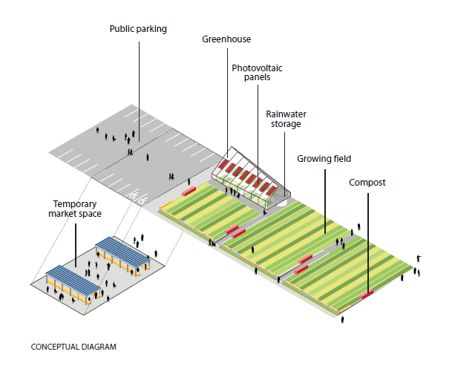  
 Photo Received from: www.**urbanagriculture**pilot.sala.ubc.ca

The EGP’s cooperative business model led to a valuable partnership with UBC’s School of Architecture and Landscape Architecture’s Greenskin’s Lab. In 2009, a proposal for an urban farm park model in the Loutet Public Park was approved. This proposed half acre land was determined to be financially sustainable by operating under photovoltaic technology to generate energy, harvesting rainwater, composting and organic waste management. The proposed land was previously occupied by weeds and gravel. The City of North Vancouver along with the Mayor, the Council and other community organizations collaborated to work through zoning and by-law issues to develop the proposed model: the first urban farm in a residential neighbourhood. (Edible Garden Project, 2015). This concept of urban farming in a high-density residential area is the first of its kind in Canada. The objective of this pilot was to prove the social, environmental, and economic benefits to the community. The Loutet Farm is founded in partnership with the NSNH, the City of North Vancouver and the University of British Columbia.   
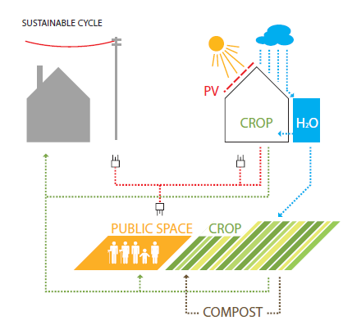  
Sustainable Cycle of Loutet Farm, Photo Received from: www.**urbanagriculture**pilot.sala.ubc.ca

The NSNH determined the EGP to be best suited for managing the farm. Other programs offered by the EGP are sponsored by grants and donations, while the Loutet Farm is a social enterprise. The farm has demonstrated huge growth since conception five years ago. It has transformed from a community project to a social enterprise, using the revenue it generates to sustain it. The farm generates revenue through on site bi-weekly farm gate sales. Revenues reached over $50,000 in 2015, enabling the EGP to break even and redirect funds back into the community. Loutet urban farm is widely recognized as an innovative, sustainable food project. In 2012, it received the Sustainable City Award. The following year it was granted the Social Enterprise Heroes Award, and later it received the Vancity Envirofund, supporting sustainable local food systems. The success of the Loutet Farm led to a partnership between the EGP and the local school district. This led to a second farm site, the Sutherland Schoolyard Market Garden. The school market garden collaboration is designed to enhance the education of students, establishing an outdoor education setting. The repurposing of public school grounds to create diverse food production systems adds value to the property as well as to surrounding properties.

Introducing gardens in schools is a great way to involve and engage the younger generations to become more connected to the food they eat, to acknowledge where it comes from and to understand exactly how it is grown. The transformation of land brightens the area by increasing food security, adding to the aesthetic and the safety for surrounding neighbourhoods. Safety is ensured by having more eyes in the streets at various times throughout the day. “Broader benefits of community gardens include improved social networks, enhanced community capital, better neighbourhood aesthetics and reduced crime” (Blake and Cloutier-Fisher 2009: 798). Citizen engagement with the gardens increases opportunities to meet new people, associates, families, networking connections and life-long friendships. It is common for people to connect with their neighbours who they may have lived beside for years and never met. Strengthening ties and building trust between neighbours helps create stronger communities.

Engaging citizen participation is a key objective for the EGP. This engagement helps build social capital by creating and strengthening relationships between community members. The EGP promotes growing, sharing and teaching people of all ages about food. Working together to achieve food security for everyone helps build trust in the community, building social capital. To remain productive and efficient, farms and gardens require a lot of hands on work throughout the year. At work bees, volunteers participate in various tasks to add to the success of the gardens and farms. Some of these tasks include building fences and raised garden beds, filling the beds with soil, painting, planting, picking, composting, weeding and mulching. Work bees, or volunteer events can be customized to the individual based on concerns about time or commitment. There is no age or skill requirements as each volunteer can contribute something valuable. Corporate volunteer parties are also welcome to commit hours with the EGP. Special events are designed around the group needs. These volunteer opportunities are great for physical health, team building and for giving back to the community. Volunteering with community gardens provides consumers with an exchange of knowledge on how to produce, harvest, prepare and store foods, building individual confidence on these topics.

The exchange of knowledge and skills is a two way street for the participants and coordinators, with something for everyone to gain from interacting with different members of the community. The EGP consists of a very small group of dedicated employees, including a community coordinator, an education coordinator, a school garden coordinator, a farm manager, a team manager and an executive director. These employees work together to engage the community, support the volunteers and continue to expand the operations of the EGP. By forming partnerships with unlikely partners, such as the local public library, the EGP is able to engage citizens who might not otherwise become involved. The partnership with the library allowed the EGP to host a book reading in the heart of their farm, engaging literature loving folk with the natural world (Edible Garden Project, 2015). Increasing natural capital is one of the forms of capital the EGP adds value to.

Basing the operations around renewable goods and resources helps the EGP to succeed and profit from the ecological services nature provides. The EGP farms and gardens add value to the ecological health in the community by building interconnected and diverse ecosystems. The diversity of crops grown alongside flowers and bee hives contribute to the diversity. Food and garden waste in composting helps replenish the soil. The garden projects supported by the EGP help to maximize the quality of remaining urban soils, adding value for the future. Utilizing rain water and optimizing natural sunlight helps ensure a sustainable growing environment. The carbon emissions related to food are largely from transportation and this project minimizes the carbon emission to zero in many cases. Volunteers and coordinators bike around the neighbourhoods collecting food and bring it to the facility where it is cleaned, sorted and prepared to be distributed to families and individuals in need. This provides the epitome of fresh and sustainable food. The EGP enhances physical capital by transforming neglected lands into beautiful, aromatic and edible landscapes. These aesthetic landscapes also strengthen cultural capital as they help create an identity for the communities they are a part of. Gardening in urban areas helps citizens reconnect with traditional food systems. The EGP hosts monthly potlucks and events to engage citizens and encourage discussion about the future and build a sense of community ownership over the lands growing the food they share. This solidifies community inclusion. Bonding over sharing food together helps build trust and establish well-developed social networks.

Transforming underutilized urban spaces into nourishing, educational and aesthetic landscapes, enriches the environmental health of the region, as well as indirectly benefits surrounding municipalities. “The presence of vegetable gardens in inner-city neighbourhoods is positively correlated with decreases in crime, trash dumping, juvenile delinquency, fires, violent deaths, and mental illness” (Ladner 2011:186). Growing food in urban spaces helps rebuild the connection people have to their food sources. The simple act of seeing a vegetable grow in its natural elements is a first for many city dwellers. This process can really enlighten people and help them to make more informed food choice decisions for themselves and for their families. By participating in growing vegetables, people are more inclined to increase their consumption of vegetables. The EGP improves access to affordable fresh, locally grown vegetables and promotes increased vegetable consumption for the low income families who need it most. By providing vegetables for $1 consumers are able to choose what they want and contribute what they can. “Food banks didn’t exist in Canada before 1981, and were introduced as a short-term solution to a hunger emergency” (Ladner 2011:199). The aim of the EGP is to make food banks unnecessary and replace them with community food hubs, like the NSNH. Providing food for people in food banks is helpful, but it is also damaging as it encourages dependency rather than providing the opportunity to address the problem from its source. The EGP aims to provide people with the skills, confidence and resources to control their food choices and eating behaviors.

The EGP works to align local policy initiatives with community-health development plans. The founding EGP facilitator, Heather Johnstone acknowledges the development of a local food policy in the official community plans in the city of North Vancouver and the district of North Vancouver to immensely help reduce the policy barriers (Edible Garden Project, 2015). This has helped the EGP approach their solutions with ease with support from the community. “External factors like globalism and internal factors like economic downturns support the need for an ongoing commitment to explore local initiatives for feeding populations and addressing the challenges of rising food costs” (Blake and Cloutier-Fisher 2009: 806). The EGP is leading the transition to a sustainable future. “The EGP is articulating urban sustainability in practical terms and via sensory means, advocating hyper-local food sovereignty and community-based health management” (Beauge 2014). The emotional, mental, and spiritual health of EGP participants and clients are strengthened by forming relationships and connections with people in the community. This supportive network enhances social and human capital.

The partnership with the school district and residents in the community has helped increase growing space in the area, therefore increasing production. The produce sells out each week and the EGP is still unable to meet the demands of the North Shore community. Though the EGP is experiencing growth each year, the scale of food insecure citizens exceeds the capacity of this project. There is a “problem of being limited in capacity by lack of resources” (Loopstra and Tarasuk 2013:57). The support from the regions municipality and community volunteers has helped the project grow, however the demand is so high and because the resources in urban areas can be scarce, the project faces challenges. The partnership with the school district has enabled the project to increase production but it remains unable to meet the needs of its population.

The current global food system fails to meet the needs of citizens and the EGP initiative is helping to address this problem. It is up to local community initiatives to bridge this gap. The Edible Garden Project supports those citizens who are unable to meet get their needs met. The cooperative business model of the EGP can be applied in communities across the world, as long as there is access to soil and active citizen engagement. The EGP is facilitated by a group of passionate and caring individuals committed to food security in their community. Fortunately, in the North Shore, the project has received unanimous support from the city which has helped create policy initiatives that add to the success of the project. Urban farming is a new form of activism in the twenty first century.

**References**

Beauge, M. (2014). *Seeds of sustainability: Food literacy communication in sharing gardens*

British Columbia. Provincial Health Services Authority, ActNow BC, & Canadian Electronic Library (Firm). (2006). *Perspectives on community based food security projects: A discussion paper*. Vancouver, B.C.: Provincial Health Services Authority.

Carney, P. A., Hamada, J. L., Rdesinski, R., Sprager, L., Nichols, K. R., Liu, B. Y.. . Shannon, J. (2012). Impact of a community gardening project on vegetable intake, food security and family relationships: A community-based participatory research study. *Journal of Community Health, 37*(4), 874-881. doi:10.1007/s10900-011-9522-z

Cloutier-Fisher, D., & Blake, A. (2009). Backyard bounty: Exploring the benefits and challenges of backyard garden sharing projects. *Local Environment, 14*(9), 797-807. doi:10.1080/13549830903166438

Edible Garden Project. (n.d.). Retrieved October 2, 2015, from http://www.ediblegardenproject.com

Ladner, P. (2011). *The urban food revolution: Changing the way we feed cities*. New York: New Society Publishers.

Loopstra, R., & Tarasuk, V. (2013). Perspectives on community gardens, community kitchens and the good food box program in a community-based sample of low-income families. *Canadian Journal of Public Health = Revue Canadienne De Santé Publique, 104*(1), e55.

MacArthur, J. L. (2014). 10. Sustainability and the social economy in Canada: from resource reliance to resilience?, International Handbook on Social Policy and the Environment, 274