Urban Agriculture in Metro Vancouver
Mark Mudryk
Vancouver Island University
Introduction to Urban Agriculture and Metro Vancouver’s Goals.
Urban agriculture is farming or gardening that occurs within an urban area. Urban agriculture is being utilized in many cities across the world to produce local food and social development while easing environmental impacts of their food processes. This paper focuses on the forms of urban agriculture present in Metro Vancouver, of British Columbia, Canada and how they enhance natural and social capital for the area. The types of forms urban agriculture takes in Metro Vancouver and then how they contribute to the natural and social capital of the region will be discussed. Metro Vancouver has three goals in mind when encouraging urban agriculture: “Enhance the city's food security and reduce the ecological footprint by encouraging more locally grown foods, encourage increased social interaction in high density developments, support and encourage environmentally and socially sustainable activities”(Tapp & Morris, 2008).
Forms of Urban Agriculture in Metro Vancouver
Urban agriculture comes in different forms throughout Metro Vancouver. This section will describe urban agriculture through Metro Vancouver’s community activities, building and landscape design, and urban farms.
Community Activities
Community Gardens. A community garden is a piece of land that is collectively gardened by a group of people. This is usually done by members of the community surrounding that piece of land. It is a way to get people engaged within their communities by providing a communal activity, and promotes food security by producing, sharing, and donating food within the community (“Community Gardens”, n.d.)
Metro Vancouver owns and operates about 50 sites that provide rental housing for more than 9,000 people in the Lower Mainland (“Community Gardens”, n.d.). At 29 of these sites there are community gardens developed (“Community Gardens”, n.d.).
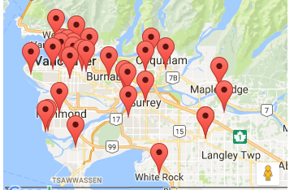
Farmers Markets. A farmer’s market is a marketplace in which farmers sell food directly to consumers. Farmers markets are present year round in metro Vancouver, and supply the local community with fresh local food products ranging from fruits and vegetables to meat and dairy products amongst even more. There are about 30 farmers’ market locations in Metro Vancouver. Figure 1 is a map of these locations. Farmers markets help give communities more food security and reduce environmental impacts of transport vehicles due to less transport time between producer and consumer.
Figure 1. Location of Farmers Markets in Metro Vancouver. From “BC Association of Farmers Markets”. (n.d), http://markets.bcfarmersmarket.org/market-search?region=7

Building and landscape Design
Green Rooftops. A green roof is a roof that is partially or fully covered with vegetation. Green roofs are sometimes are used for gardens and can help produce local food for citizens. Also, green roofs help lower the heat associated with urban heat island by absorbing and lower heat through evapotranspiration from plants (Green Roofs, n.d.) Green roofs are also good for people’s health as views of nature are associated with “boosting productivity and reducing absenteeism in offices and reducing the average length of stay among hospital patients” (Green Roofs, n.d.). The Young Women’s Christian Movement (YWCA) program center in downtown Vancouver is a model for green rooftop gardens and yields more than 1500 pounds of produce each year (“Sustainability”,n.d.). It produces fresh food for meal programs for its community members (“YWCA’s Rooftop”,n.d.). Unfortunately, there were no photographs of the garden to include in this paper.
Edible and Wall Landscaping. Edible landscaping is the practical integration of food plants into ornamental or decorative settings. People can do this in their own homes and have their gardens be dual functioning as food producers and decorative elements of their living area.
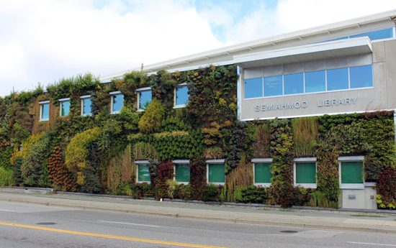
Metro Vancouver has seen a growth of green walls in the city in recent years (Whysall, 2008). This is when walls of buildings are turned into vertical gardens and add the ascetics of plant life to the normally dull exterior of buildings. They are not used for food gardening as much as horizontal gardens due to the difficulty of access to them. Figure 2 is an example of a green wall in Vancouver on the Semiahmoo Library.
Figure 1. Semiahoo Library in Vancouver. From “Semiahmoo Sky Garden by Green Over Grey Photo” by R. Weiss. (2016), http://www.insidevancouver.ca/2016/06/08/living-walls-vancouvers-vertical-gardens/
Urban Farms
Urban farming is farming done within urban areas. Urban farming is enabled in Metro Vancouver by the designation of lands as Agricultural Land Reserves by the provincial government of BC. On these lands agriculture is recognized as the priority. In 2014, Metro Vancouver had 60,893 ha of Agricultural Land Reserve which makes up 22% of the region’s land base (“Farming in Metro Vancouver”, 2014). Figure 3 is a map displaying Agricultural Land Reserves in Metro Vancouver.
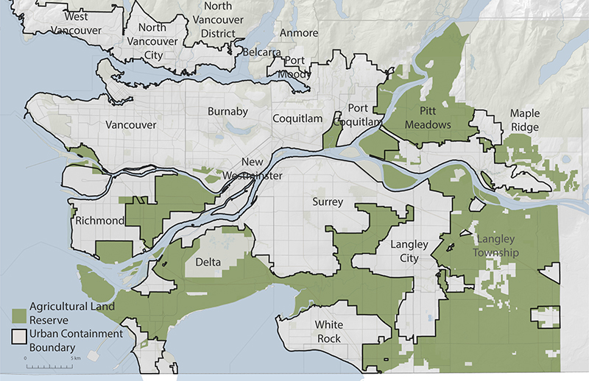
Figure 3. Agricultural Land Reserves in Metro Vancouver. From “About agriculture in the region”. (n.d), http://www.metrovancouver.org/services/regional-planning/agriculture/about/Pages/default.aspx

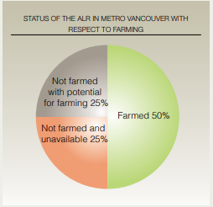
The 2016 Census of Agriculture found that there were 2,412 farms in the region (Saltman, 2018) The average farm size is small to medium at 20 ha (excluding the Vancouver urban farms) which is a common size for farms in urban areas (“Farming in Metro Vancouver”, 2014). Agriculture in the region makes a significant contribution to the BC economy. In the region, there were “over $789 million in gross annual farm receipts in 2010 (27% of the BC farm total) on only 1.5% of the province’s agricultural land” (“Farming in Metro Vancouver”, 2014). However, only 50% of Agricultural Land Reserves in the region are being farmed, as displayed in figure 4!
Figure 4. Amount of Agricultural Land Reserves being farmed in Metro Vancouver. From “Farming in Metro Vancouver”. (2014), http://www.metrovancouver.org/services/regional-planning/PlanningPublications/Farming_In_Metro_Vancouver_Oct_2014.pdf

Enhancement of Natural Capital
Urban agriculture in Metro Vancouver enhances the natural capital of the region by providing the area by fresh local food produce. Urban farms add many natural commodities to the local market :“The region’s farmers supply over 130 different farm commodities including a wide array of fruits, vegetables, dairy, poultry and other livestock products” (“Farming in Metro Vancouver”, 2014). This along with community and rooftop gardening increases the region’s food security. Also, green rooftops and walls provide cooling effect to the building and surrounding environment effectively becoming an ecosystem service that helps alleviate urban heat islands.

Enhancement of Social Capital
Urban agriculture in Metro Vancouver also greatly enhances social capital for the citizens. Social capital is the presence of social networks in an environment. Community gardening enhances social capital by providing an “outlet for physical activity, stress relief and creation of friendships through community involvement” (Community Gardens, n.d.). Urban farms create social capital in Metro Vancouver by directly employing around 8000 people in the area (“Farming in Metro Vancouver”, 2014).

Conclusion
Urban agriculture in Metro Vancouver comes in many forms. These include community activities such as community gardens and farmers markets. Building and landscape design can create gardens in the city from things such as green rooftops, edible landscaping, and green walls. Lastly, urban farms are the main source of local food for the region which has 2,412 farms. Metro Vancouver’s urban agriculture improves both the natural and social capital for the region. It enhances natural capital by producing local fresh food commodities sale to citizens or elsewhere. Gardens throughout the city also help reduce urban heat islands by providing cooling through evapotranspiration from plants, which acts as an ecosystem service. Social capital is enhanced by the creations of social connections within the community, centered on farming and gardening. Community gardens act as gathering and meeting place for people in the community, and urban farms provide employment for around 8000 people in the region directly. All this explains why urban agriculture is popular for a sustainability and green oriented region such as Metro Vancouver.
References
About Agriculture in the Region. (n.d.) Retrieved from http://www.metrovancouver.org/services/regional-planning/agriculture/about/Pages/default.aspx
BC Association of Farmers Markets. (n.d.) Retrieved from http://markets.bcfarmersmarket.org/market-search?region=7
Community Gardens. (n.d.). Retreived from http://www.metrovancouver.org/services/housing/tenants/community-gardens/Pages/default.aspx
Farming in Metro Vancouver. (2014 October). Retrieved from http://www.metrovancouver.org/services/regional-planning/PlanningPublications/Farming_In_Metro_Vancouver_Oct_2014.pdf
Green Roofs. (n.d.). Retrieved from http://www.thechallengeseries.ca/chapter-06/green-roofs/
Morris, V. & Tapp, C. (2008, December 18). Urban Agriculture Design Guidelines for the Private Realm. Retrieved from http://vancouver.ca/files/cov/urban-agriculture-guidelines.pdf
Saltman, J. (2018 January 7). Vancouver sees increase in farms despite downturn in region. Retrieved from http://vancouversun.com/news/local-news/vancouver-sees-increase-in-farms-despite-downturn-in-region
Sustainability. (n.d.) Retrieved from https://ywcavan.org/discover/sustainability
Weiss, J. (2016, June 8). LIVING WALLS – VANCOUVER’S VERTICAL GARDENS. Retrieved from http://www.insidevancouver.ca/2016/06/08/living-walls-vancouvers-vertical-gardens/
Whysall, S. (2011, June 15). Transforming ugly concrete walls into beautiful vertical gardens. Retrieved from http://www.vancouversun.com/homes/Transforming+ugly+concrete+walls+into+beautiful+vertical+gardens/5107779/story.html
YWCA's Rooftop Garden in Vancouver's Downtown Business District Feeds Families. (n.d.) Retrieved from https://planh.ca/news/ywcas-rooftop-garden-vancouvers-downtown-business-district-feeds-families

