Geography 352

T’Souke Solar Project
Oldways New Paths to Sustainable Development

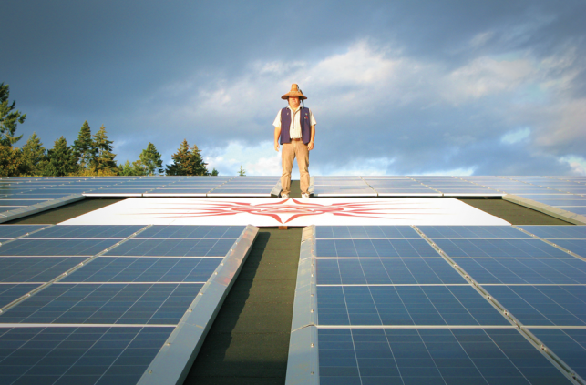

Alexander Kalmakov-Wellborn

Introduction
In 2008 the T’sou-Ke nations embarked on a journey to become the greenest community in Canada. The nation began this project with the goal to re-imagine the direction which it was taking on its path through the future and sought to reconnect with traditional ways of living. The nation sought a revival and return to traditional values through the redevelopment and conversion to sustainable energy. It sought to reverse 150 years of colonialism and continuation of 14,000 years of sustainable living in harmony with the environment. (T’souke sustainable toolkit 2012; Ozog,2012)
Background
The T’Sou-ke nation is on the southern end of Vancouver island and has a population of about 250 people. In 2008 it began the process of revisioning itself through the T’Sou-ke comprehensive community plan or CCP. Through this process a vision was identified with its core component being a need to transition to energy self-sufficiency. As Chief Gordon Planes declared, "Unless you have your own vision, you will always be a part of someone else's vision." [nicely put] Solar energy was chosen because it is the easiest for people and communities with little experience to understand. It also brought opportunities for learning and created local jobs for community members during the installation.
The Project
This new vision had several components which all worked together to support the nation’s development in becoming a leader for other first nations and small communities. The vision had several key tenets. These included energy self-sufficiency, food security, economic self- sufficiency, and building a stable economy. Through energy autonomy they sought to reduce the high costs of energy consumed by the community in the day-to-day operations of the nation. They also wanted to alleviate the problems of energy dependence.
Project goals were to 1) reduce the consumption of energy and bring down costs of hydro across the nation; 2) Demonstrate to all BC First nations how they too could progress towards renewable energy and particularly those in small off-grid communities isolated by geography; 3) Reduce greenhouse gas emissions (GHGs), and 4) Ensure First Nations’ resilience thorough building social capital. (Ozog 2012)
Project Funding

The Solar project was made available through a $400,000 capital grant from the provincial government for the capital funding. The T’sou-ke nation was able to leverage this funding to raise an addition $860,000 worth of funding from 16 additional sources. (Ozog 2012; Moore,Andrew interview [personal communication?] 2018)
The cost of the Conservation Program was $150,000; the cost of the Solar Hot Water Program was $300,000; and the cost of the Solar PV Demonstration Project was approximately $800,000.
The initial capital funding came through ICE, the Innovative Clean Energy fund of the provincial government. This fund is from a levy on certain energy products. Since 2008 a total of $97 million has been committed to supporting clean energy projects, alternative energy, research and development and energy efficiencies around the province. (BC Energy plan, 2012)
BC government established the Innovative Clean Energy (ICE) Fund in 2007; its purpose was to "support the development of clean power and energy efficiency technologies in the electricity, alternative energy, transportation and oil and gas sectors.” (BC Energy Plan website) To date a total of 1,250,000 has been allocated to the T’Sou-ke project. (Moore, interview 2018)
In 2009 an economic success and viability study was conducted which found that similar projects implemented could be even more efficient if implement in remote and off grid communities. (Bekker 2009) Many remote communities which are not connected to the grid are highly reliant on diesel fuel for electricity generation, which makes up a large part of their budgets. (Ozog 2012) Shipping costs of diesel are a major factor in the high price of electricity in remote communities.
Hydro Power in BC
BC Hydro has a 2 tiered system of hydro billing. The first system is based on an average energy usage system of 8c/KWH or Kilowatt hour; after a user has reached a certain threshold, the price bumps up to 12c/KWH.
At present the bi-monthly bill customer receive through their rate plan is the only feedback customers have to monitor their energy consumption. This represent a very loose feedback loop. What we need is tighter feedback loops by which to reduce our energy consumption and promote energy awareness.
The bold new steps that the T’Souke project was taking were not without their shortcoming. It was soon realized the most important component to success was a good energy conservation program. All the newly generated solar energy would disappear though the poorly insulated windows, unless more was done through insulation.
One of the elders explained:
“While conservation alone offers great savings, it is even better when it is combined with renewable power production. After all, electricity for a light bulb and running appliances still has to come from somewhere. When we noticed that our hard-won electricity was literally flying out a poorly insulated window or being wasted by lights left on in an empty room, we were even more motivated to conserve what we had.” Linda Bristol, Band member [was this a personal communication or a quotation in another article?]
The total capacity of the project is a considerable 75 kilowatts. It is the third largest photovoltaic (PV) connected grid project in BC. (Sinclair, 2010) [confusing sentence] Three different components, solar -thermal systems 40 systems are in place with plans to implement an additional 61 systems in the future. The 40 homes in the solar-thermal hot water system have managed to cut their power consumption bills by half! First Nations are among the leaders in renewable projects (Ozog, 2012); 123 out of 203 First Nations are involved in renewable energy projects.
Building Human, Social and Cultural capital
A major outcome of this project was the benefit and gains to human capital. Ten band members received training and certification on the installation of the solar-thermal hot water units. This meant new training for 5% of the population. The new skills were delivered to marginally employed and provided great skills training to band members by helping develop future leaders in sustainable development.
The project was so successful it caught the attention of the Haida nation. Councillor Barbara Stevens was excited about the idea. She knew that a similar project could help her community. [photo source?]
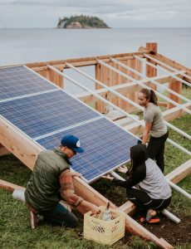
This is a picture of social capital being built by community members involved in the creation of the project. Social capital makes the greatest long lasting legacy of the project. [also human capital]
Haida Gwaii Project
Successful completion of Jiigawaay Naay Unguu Sun on Top of the House is a direct result of the innovation from the T’souke project. In August 2017 the cultural heritage centre in Skidegate was successfully outfitted with photovoltaic solar panels.
Installed on four south-facing roof tops are 385 photovoltaic (PV) solar panels capable of producing 100 kilowatts of energy, and, it’s the largest First Nation-owned community solar project in BC! [cool]
This marked the “First-nation to First-nation renewable energy partnership.” [how so? Were the T’souke the advisors on the project?]
The project timeline for Skidegate was much slower than for T’souke. On June 11, 2011, the application was successful and Skidegate was awarded the funds to develop their own solar demonstration project. The Haida project was funded through the ecoENERGY funds of INAC, formerly Indian and Northern Affairs Canada. Initially 15,000$ awarded to the skidegate Baseline project. Certain key elements were applied to the Skidegate project namely the solar-thermal heating system; however, due to the low levels of light in Skidegate [has it worked regardless?] and the government's reluctance to fund PV projects, the project was slow to get off the ground. (Ozog 2012) The project was completed in Skidegate in August 2017 and was celebrated by the whole nation. [is the next photo of the Haida project? Source?]

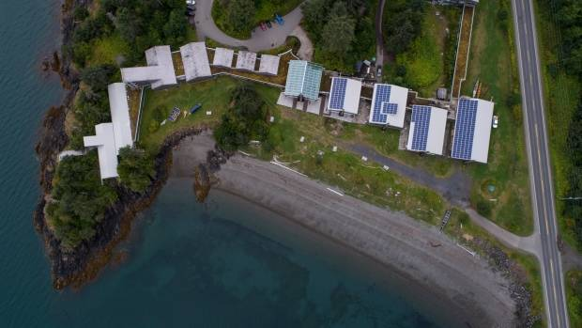

Conclusion
Lessons Learned from Sooke Project
“Don’t do what we did, do what we learned.” -Andrew Moore Project Director
These two projects successfully harnessed the natural capital of the sun and its rays as well as building social capital among their members. When I spoke with Andrew, he insisted that the most important part of the project, when looking back to the achievements of 2009-2010, that the lessons learned and the possible improvements are the most important part. Andrew stressed the importance of energy conservation ought to be the overriding priority above the generation of new electricity. He spoke about the importance of switching off the light when you leave the room can reduce the need for new electricity generation from solar and other sources. He also stressed the point of how converting to low flow shower-heads can have a major impact on hot-water generation and reduce the demand from solar hot water.
Another major point what has been learned was the progress through improvements and the reductions in costs for Photovoltaic panels. Since 2010, China has produced vast amounts of cheap and reliable solar panels. The price is now low enough for communities and individuals to invest the capital costs for long term gains.
One major reason this this project has been so successful and worthy of examination through this class is how it harnesses and feeds-in to so many forms of capital. It harnesses natural capital by harvesting the sun's rays and free energy. It builds human capital by training people how to transition to a green and sustainable future. It builds cultural capital by creating a role-model for other communities and individuals to emulate. It has been so successful in this end that it has been successfully recreated in Haida-Gwaii. [also: by saving fossil fuel energy and energy consumption in general, it indirectly is making a contribution to natural capital; it has also created physical capital – infrastructure which didn’t exist in either community before. You need to clean up the writing and referencing, but I would love to feature it on my VIU Blog of hopeful student case studies – see http://wordpress.viu.ca/alexanded/] [A-]

References
Bekker, Jessica , "Power Production, Emission and Financial Analysis for T'Sou-ke Nation's Photovoltaic Demonstration Project" (prepared paper, T'Sou-ke Nation, 2009)

Dauncey, Guy (Interview; telephone interview morning of February 20, 2018)

Moore, Andrew Power to the People: T'Sou-ke Nation's Community Energy Solutions
Communities (Louisa) 2013/12/01 161
Moore, Andrew (telephone interview March 22, 2018)

Ozog, Sarah THESIS SUBMITTED IN PARTIAL FULFILLMENT OF THE REQUIREMENT FOR THE DEGREE OF MASTER OF ARTS IN FIRST NATIONS STUDIES UNIVERSITY OF NORTHERN BRITISH COLUMBIA. UNBC Press April 2012

Sinclair, Jim. T’Souke Sets the Solar Standard The Sooke Mirror; Sooke, B.C. [Sooke, B.C]22 July 2008: 4
Sinclair, Jim. The Sooke Mirror; Sooke, B.C. [Sooke, B.C]05 June 2009: 1.

The BC Energy Plan: A Vision for Clean Energy Leadership," Province of BC, accessed February 6 2011, http://www.energyplan.gov.be.ca/bcep/default.aspx?hash=6.

T'Sou-ke Nation, "Renewable Energy Toolkit: T'Sou-Ke Solar Project," (unpublished report, T'Sou-ke Nation, 2010), 17

