Build with Nature for the Modern Era: Singapore the Green City

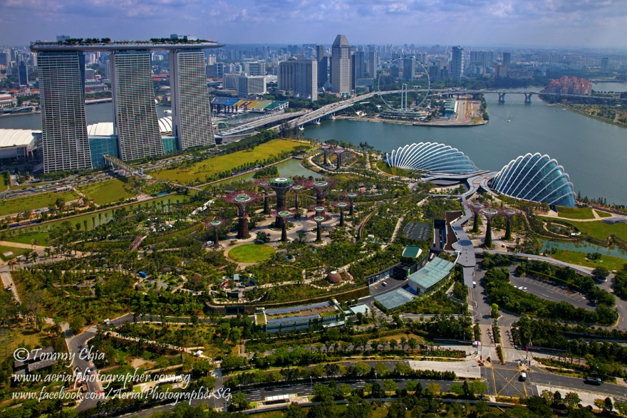

Carrie Robinson
GEOG 446 S18N01
Don Alexander
March 27, 2018
Build with Nature for the Modern Era: Singapore the Green City
Introduction
The magnificence of Angkor Wat’s captures the imagination, and because it was designed to harness nature it inspires planners, designers, and architects. Architect Rick Cook affirms he finds inspiration from the natural and built wonders of this historic Khmer city (Green, 2015). The complicated layout includes several satellite cities surrounding the main temple complex. This city motivates modern planners to replicate a livable city for today’s citizens. The issues that they face is how to reinvent or retrofit high density buildings that manage to capture the magic that Angkor Wat exudes. Singapore is a modern example that emulates a similar feeling; although, this was not always the case. The city of Singapore released their first official green plan in 1992. The process that converted a stark-hardscape metropolis into Asia’s greenest city deserves further analysis. The objective is to explore Richard Neutra’s “Building with Nature” concept by defining his approach, construing the method used to plan sustainable cities, and describing Singapore, the finest example of a modern city that models Neutra’s idea.
The Inspiration, Angkor Wat
Angkor Wat was just one capital city built by the Khmer empire during their rule between the 9th and 15th centuries. Angkor: the designated UNESCO protection area spans 400 square kilometers and contains other Khmer urban centres, parks, forested areas, and landscape modifications. The protected zone is still inhabited, and some of theses residents are descended from the Khmers, the builders of this metropolis. The complexity of this built environment showcases the level of sophistication that this civilization achieved. A major similarity between the historic city of Angkor Wat and the Modern city of Singapore is their similarities in climatic conditions, both are prone to dry seasons and monsoon storms. They are located in the same world region see figure 1. Angkor Wat was built using the five dimensions of place, centuries before the concept was developed. Ecological features such as maintaining the forest that surrounds the city for both human use and animal habitation was vital to the Khmers. The people were presented with a unique conundrum because the climate of Cambodia is one of a dry season followed by a torrential wet season. The society needed to find a solution to capture water during the monsoons and enough of it to maintain the community through the dry season. The solution was the east and west hand dug barays (water reservoirs), as well as a series of canals and dikes (UNESCO). The western baray still contains water and it is larger than Central Park in New York City (Green, 2015). The functional dimension includes features like food production in close proximity to the city and the causeways that connect this city to the rest of the empire. Describing the Aesthetic dimension is unable to convey the splendour of this metropolis see figure 2. The design features that make the city of Angkor Wat a green city include using the natural environment to control the climate within the city. The barays were not just for water storage, as the positioning of the buildings with their passages were aligned to maximize the wind currents. The breezes that are common in Cambodia flow over the water of the barays and through the passages creating natural air-conditioning within the structures. Khmer builders created spaces for the Civic Dimension by designating areas for informal gathering in the plazas and formal congregation in the Temples. The Social Justice dimension is achieved by this civilization because at its peak of power the Khmer society reached a million citizens. The historic people that inhabited the area in the 9th to 15th centuries would not have given up their rural lifestyles if it had not been advantageous to become urbanites. The built environment left by this civilization is the epitome of green builders.
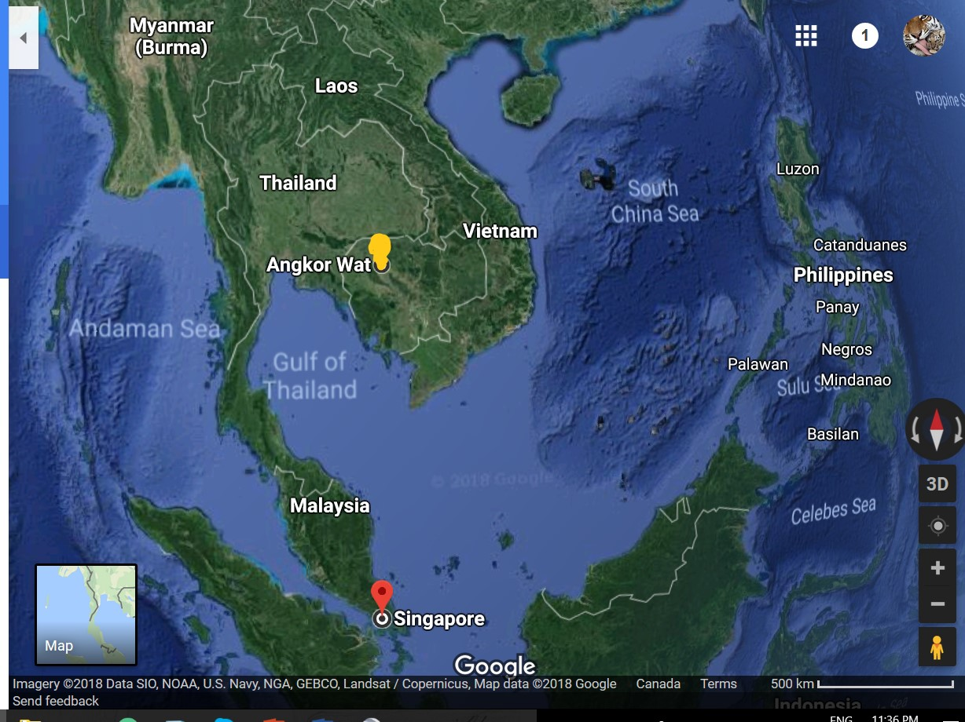
Figure 1 (Google maps, 2018). The distance from Angkor Wat to Singapore as the crow flies ≈ 700 km.
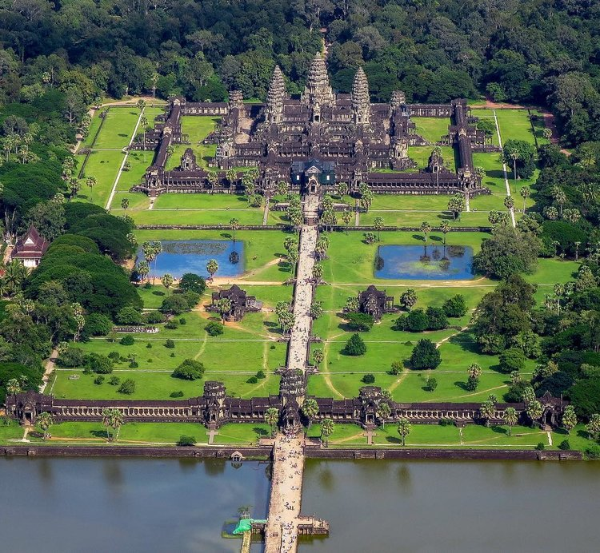
Figure 2, Cowie 2017. Angkor Wat featuring its causeways, barays, forests, and landscaping.

Build with Nature: Define the Concept
A man ahead of his time: Richard Neutra was born April 8, 1892 and raised in Vienna Austria (Encyclopedia Britannica, 1998). According to Los Angeles Conservatory (2016) he served in the Balkans from 1914 -1917 during WWI after which he returned to Vienna to complete a degree in Architecture. Studying revolutionaries, in the fields of architecture and town planning, fueled his childhood passion for and solidified his interest in a designing. The concept of linking landscapes with structures for the benefit of humans began to develop. He worked with Erich Mendelsohn in Europe before his other aspiration came to fruition when he moved to the United States in 1923. After working in New York city, Chicago, and Wisconsin with Frank Lloyd Wright he arrived in Los Angeles in 1925. He then worked with his fellow immigrant and countryman Rudolf Schindler until 1926 when he started his own company. By 1929 his first commission for Philip Lovell had been completed see figure 3. The house still stands today and is preserved because of its status as a “Historical Cultural Monument” (Prabook, 2018). The over all concept of Richard Neutra’s theory revolves around the idea that for humankind to be healthy in body and mind they need to be in nature. To create an environment where people can achieve harmony with the natural environment and that landscaping should be an extension of the structure. Modern City Planners, Architects and local governments will be required to work collectively as the world population continues to expand and the demand for healthy urban living becomes a priority for future generations.
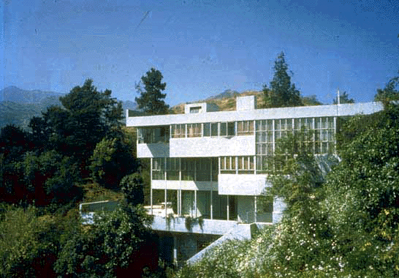Figure 3. Editors of Encyclopedia Britannica. Lovell House perched on the hills above Los Angeles, Ca.
Richard Neutra’s first commission.

Post-Colonization and Formulating the Plan
The island of Singapore has been inhabited by humans for more than a millennium (Kennard et al., 1999). It became a British colony after the island was purchased in 1824. Singapore became a self-governing state of the commonwealth in 1958, and Lee Kuan Yew was elected as the first Prime Minister by 1959. His reign as the country’s leader lasted for a lengthy period 1959 -1990 which created a stable political environment and allowed for many advancements to occur in the country. Prime Minister Yew was of Chinese descent and post-secondary schooled in Britain. He became a lawyer professionally and was also a master gardener. His two passions served him and his country well. In 1963, the country joined the Federation of Malaysia; he also started an annual tree planting program that he faithfully participated in every year until his death, in 2015. The country exited the Federation of Malaysia in 1965. This was due to pressure from Malaysian politicians because of tension between china and Malaysia. Singapore finally became a sovereign state, later that same year, after leaving the Federation. Another initiative that Prime Minister Yew oversaw was the mandatory savings fund that was initially implemented during colonial rule in 1955 (Kwong, 2012). Employed citizens are required to put on average 25 % of their income into the Central Provident Fund (CPF) which is matched by their employers. There are just two reasons that citizens may withdraw their entire savings: at age 55 or if they permanently leave Singapore. During Yew’s leadership the Housing & Development Board (HDB) began to purchase land and build public-housing. First and second time lower income citizens ready to buy and occupy a HDB apartment are allowed to ‘borrow’ from their CPF savings. Westerners might view Lee Kuan Yew’s leadership as a dictatorship because mandating that citizens are to save money into a government managed fund doesn’t give them a choice. Yet, the advantages might out weigh this loss of freedom, it is reported that 80% of the population live in these HDB apartments and over 90% of them are owners (The Economist, 2017). Singapore’s housing plan is relatively successful as the country boasts that their homeless rate is nearly non-existent. The disadvantages that have risen from this housing system include: buying difficulties for certain types of people. The LGBTQ, single people, and un-wed mothers are shunned when they attempt to purchase a HDB flat because preference is given to young married couples. There are some common complaints about the HDB complexes such as the oldest were built over 40 years ago and all of them lack aesthetic appeal. Overall Singapore does deserve credit for having the foresight to prepare for the future.
Prime Minister Lee Kuan Yew started the revolution to turn Singapore into a Garden City. Former Prime Minister Yew’s vision was modernized when Singapore’s Green Plan (SGP) was released in 1992. The main objective of the plan was to encourage economic growth while protecting the environment. An updated 10-year plan was released in 2002, with the intention to evaluate whether the targets were being met. A detailed report was released in 2012 that contained quantifiable goals focusing on “air and climate change, water, waste management, conserving nature, Public health, and international environment relations” (Chew, 2018). The highlights from this report include: air quality measuring in the ‘good’ range for 96 % of the days in 2008 and a continued measurable decrease of air pollutants. The city also reports installing more water treatment plants and water recapture systems in conjunction with overall reduction of water use. According to Chew (2018), waste-recycling increased from “40 percent in 2000 to 56 percent in 2008”. Greening the city comes in the form of annual tree planting day and ensuring new construction incorporates gardens. The result from the report states that the land “covered by greenery rose from 36 percent in 1986 to 47 percent in 2007”. The low percent of food related illnesses from 2006 – 2008 at 2.8 cases per 1000 outlets is an example of maintaining a high standard of health. To ensure that the city remains at the forefront of sustainability and share their knowledge, they continue to hold environmental summits. The city released the Singapore Green Plan 2012 to continue setting manageable targets and to ensure “sustainable development strategies” are in place “until 2030” (Chew, 2018). Singapore’s community plan showcases what can happen when clearly defined objectives are set out, and those goals are evaluated after a set time frame. When aims are quantified and justified governments are held accountable for successes and failures which allows for adjustments or corrections in the updated version of a city’s community plan.

Singapore: The Finest Example
The Island’s location was ideal to become a major deep-water shipping port. The country’s environment became degraded by colonial actions, and industrialization until the 1960s when Prime Minister Yew established his vision of a Garden City. The result from the affront to the environment and loss of habitat was the local extinction of the smooth coated otter and the endangerment to the Sunda pangolin (Scott, 2016). During colonization fortunes were made by a select few which caused increases in the disparity between the rich and poor. Many of the less privileged lived in deplorable housing. The Development & Housing Board started by British rule in the 1950s failed to address the issues, but the successful plan by Prime Minster Yew to combat the housing crisis keep his party in power and remains in power currently.
Sky Greens is a company headed by Jack Ng an engineer that wanted to create a more efficient way for Singaporeans to obtain food locally. The country imports over 80% of its food, and less than 1 % of its land mass is suitable for agriculture, as of 2014. Therefore, an innovative way to increase crop production became necessary. Jack Ng from Sky Greens invented a highly efficient greenhouse; by utilizing the vertical space it multiplies the productivity of the land by a factor of 10. The system runs on approximately the same amount of power as a 60-watt lightbulb and produces 2 tons of vegetables per day (Al Jazeera English, 2017). It uses a hydraulic system to rotate the planter box style shelving units. The plants receive sunlight at the top of the system and nutrients from the water at the bottom which is the same water that runs and is recycled through the hydraulic system. After three years of operation the water has never needed changed. If this wasn’t successful enough the entire green house floats on a pond that contains fish, and the trimmings from the vegetables and the bugs caught in the greenhouse pest management system both waste products are used to feed the fish. In turn the fish excrement in the pond water are the nutrients for the plants. This is an ingenious self-contained food producing organic ecosystem.
Prime Minister Yew’s and the subsequent government’s environmental protection and reclamation plans reversed some of the environmental degradation from the colonial aftermath. The success of the environment’s recovery has allowed the previously locally extinct smooth-coated otter to re-established itself in the waterways of Singapore. The pangolin is a symbol of the unique animal biodiversity in Singapore this creature is near and dear to Singaporeans. In 2006 the Natural Biodiversity Center was built and runs a captive breeding program focused on saving the pangolin and other threatened native species (Scott, 2016). The breeding program is credited with the birth of a fourth baby pangolin at its rehabilitation and educational centre see figure 4. The pangolin is the only scale covered mammal in the world. The 8-different species are native to both Asia and Africa, four in each region, and all are listed as endangered or vulnerable. These are just some of the many actions that Singapore is implementing to protect the extraordinary biodiversity, of their island. There are issues that continue to affect the human population. A common complaint about the housing structure, especially from young people, is that the HDB developments are equated to a gilded cage. Another criticism of the HDB apartments the buildings are not all that aesthetically pleasing. There are several benefits to living in HDB buildings: they have decent square footage, are considered safe, are multi-ethnic, and income diverse. Singapore’s greatest accomplishment is their ability to adapt and to integrate modern ideas while holding onto traditions.
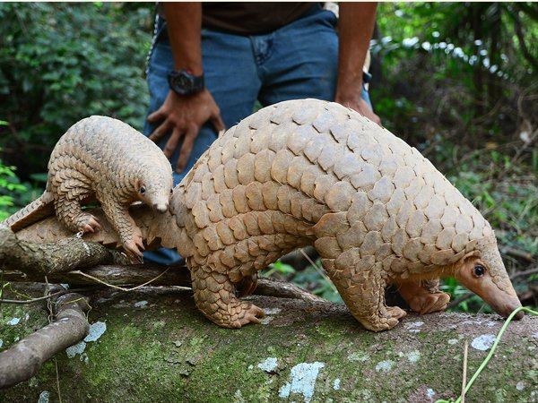
Figure 4. (Jufri, 2014). Mother and Baby pangolin just 1 of 400 baby animals born at wildlife centres in Singapore.
The future of the city rests in the hands of people that have a clear vision of what their city will become. An amazing feature that is relatively new is the concept of living skyrises. Since 2013, two incredible examples have been completed Park Royal Sky Gardens see figure 5 and Oasia Hotel downtown see figure 6. These structures are contributing to lowering the temperature and improving air quality, in the metropolis by literally greening the city. If the citizens of Singapore hold true to one poignant phrase quoted from Lee Kuan Yew they should follow this “Our beautiful island is a special place, we must take good care of it” (Soderstrom, 2006, p. 114). There are many parallels between Singapore and Vancouver Island. Thankfully, not the density issue yet, but this could be in our future as this fantastic and unique place where we live gains international attention.
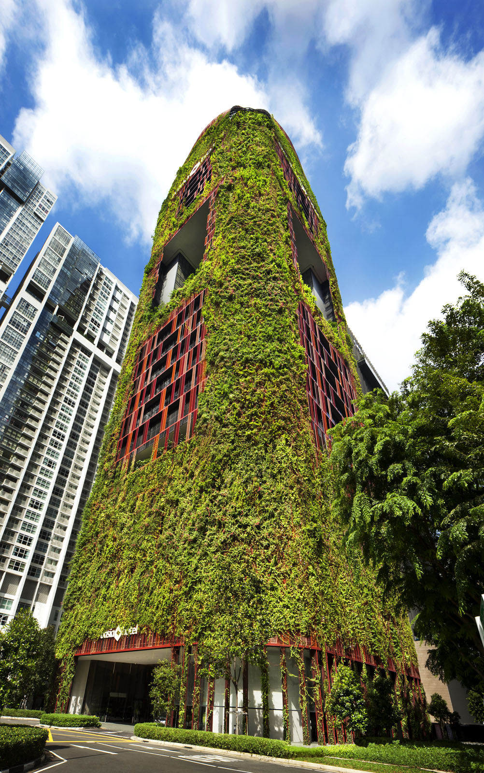
Figure 6 Council on Tall Buildings and Urban Habitat: Oasia Hotel Downtown (2018).
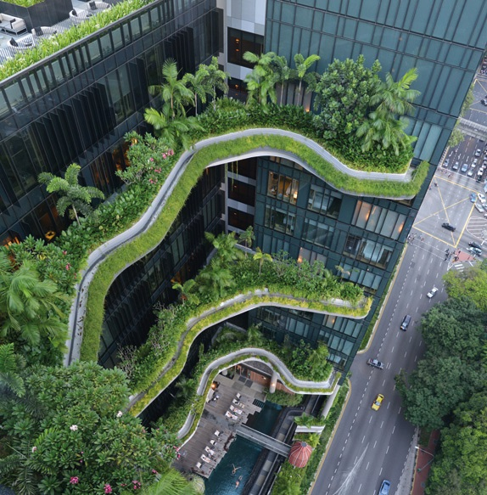
Figure 5 Council on Tall Buildings and Urban Habitat: Park Royal on Pickering (2018).
Conclusion
Angkor Wat and Singapore are each built with vastly different materials yet, they both create a similar response from humans. Their most similar attributes are that they are designed to be liveable, they incorporate nature in the built environment, and they harness the assets that the unpredictable climate offers. People with vision are integral to the implementation of any city plan. Without the innovative ideas of people like Richard Joseph Neutra or Lee Kuan Yew and their successors cities will be doomed to be stark, bland and uninviting places. Modern city planners will need to integrate concepts that encourage citizens to live, raise families, work and be happy, in urban environments.

References
Al Jazeera English. (2017, June 1). Earthrise – Singapore: Asia’s Greenest City. Youtube. Retrieved from https://www.youtube.com/watch?v=MjLo5RqAyzs&t=459s
Arch Daily. (2013, December 23). Cook + Fox Architects. Retrieved from https://www.archdaily.com/office/cook-fox-architects
Chew, V. (2018). Singapore Green Plan. National Library Board Singapore. Retrieved from http://eresources.nlb.gov.sg/infopedia/articles/SIP_1370_2008-11-22.html
Council on Tall Buildings and Urban Habitat. (2018). Oasia Hotel Downtown. The Skyscraper Centre. Retrieved from http://www.skyscrapercenter.com/building/oasia-hotel-downtown/14114
Council on Tall Buildings and Urban Habitat. (2018). ParkRoyal on Pickering. The Skyscraper Centre. Retrieved from http://www.skyscrapercenter.com/building/parkroyal-on-pickering/14115
Cowie, A. (2017, March 28). Cambodia’s exemplary centre of time and space [photograph, web log comment]. Retrieved from http://blog.world-mysteries.com/mystic-places/cambodias-exemplary-centre-time-space/
De Vriend, H.J. and Van Koningsveld, M. (2012). Building with Nature: Thinking, acting and interacting differently. EcoShape, Building with Nature, Dordrecht, the Netherlands. Retrieved from https://www.ecoshape.org/uploads/sites/2/2016/07/ECOSHAPE _BwN_WEB.pdf
Economist, The. (2017, July 6). The high life: Why 80% of Singaporeans live in government-built flats. Retrieved from https://www.economist.com/news/asia/21724856-subsidies-are-irresistiblebut-come-social-controls-why-80-singaporeans-live
Editors of Encyclopedia Britannica. (1998, July 20). Richard Joseph Neutra: Austrian-American Architect. Encyclopedia Britannica. Last modified October 15, 2013. Retrieved from https://www.britannica.com/biography/Richard-Joseph-Neutra
Kennard, A., Leinbach, R., Ho, R., and Winstedt, R. (1999, July 26). Singapore. Editors of Encyclopedia Britannica. Retrieved from https://www.britannica.com/place/Singapore
Kwong, Y. (2012, August 10). What you need to know about Singapore’s compulsory saving scheme. Singapore Business Review. Retrieved from https://sbr.com.sg/economy/commentary/what-you-need-know-about-singapores-compulsory-saving-scheme
Green, J. (2015). Designed for the future: 80 Practical ideas for a sustainable world. New York, NY: Princeton Architectural Press.
Jufri, Z. (2014, October 2). Rare pangolin baby among 400 animal babies born at WRS parks this year [photograph]. Retrieved from https://www.insing.com/feature/rare-pangolin-baby-among-400-animal/id-60503101/
Los Angeles Conservatory. (© 2016). Richard Neutra. Retrieved from https://www.laconservancy.org/architects/richard-neutra
Prabook. (2018). Richard Joseph Neutra [photograph]. World Biographical Encyclopedia, Inc. Retrieved from https://prabook.com/web/richard.neutra/731513
Scott, A. (Writer), & Clements C. (Director). (2016, May 21) “Hidden Wild”. In Little, J., & Chan, D. (Producers), Wild City: Singapore. The Knowledge Network.
Singapore Government. (2016, August 17). Singapore Green Plan. National Library Board Singapore. Retrieved from http://eresources.nlb.gov.sg/infopedia/articles/SIP_1370_2008-11-22.html
Soderstrom, M. (2006). Green City: People, Nature & Urban Places. Montréal, Québec, Canada: Véhicule Press.
Waterman, R. (2016, February). ‘Building with Nature’: principles and examples. Retrieved from http://ypcc.eu/wp-content/uploads/2016/02/III-3-3-1.pdf
UNESCO. (n.d.) Angkor. World Heritage List. Retrieved from https://whc.unesco.org/en/list/668

