5 Pointz Building Case Study
Spencer Croft
Vancouver Island University
GEOG 446
Professor Don Alexander
April 04, 2018

Introduction 1.0
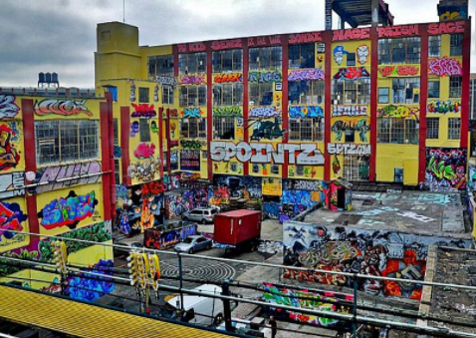
The 5Pointz building in Queens, New York was purchased by Jerry Wolkoff (Figure 1) in the early 1970s with initial plans for developing that were later abandoned to lease the space to companies (Gabbatt, 2017). In the early 1990s Wolkoff had begun renting the building as studio space at the request of local artists which unsurprisingly evoked the talented street artists of New York who began using the warehouses large bare walls as canvas’, it was later given the name The 5 Pointz Aerosol Arts Center (Figure 2), (5 Pointz, 2018). The preceding decades saw the outside of the building change and evolve constantly with new artworks replacing the old marked pieces while the inside, holding 200 studio spaces, was alive with artistic energy and creativity (5 Pointz, 2018). 5 Pointz was an artist’s haven in the borough of Queens, New York, often referred to as the ‘Graffiti Mecca,’ however in 2013 the dream came to a crashing halt, (Smith, 2016).
Figure 1 – Jerry Wolkoff, G&M Realty, 5 Pointz owner. Retrieved from: www.newsday.com
Figure 2 – 5 Pointz Aerosol Art Museum, Long Island City, Queens, New York. Retrieved from: www.5pointz.co.uk
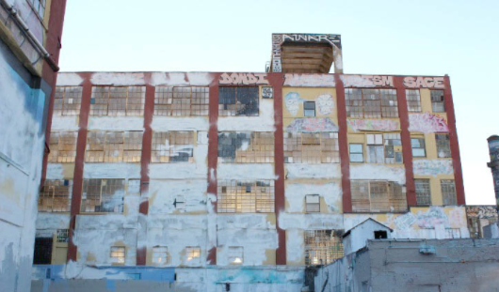
G&M Realty, the development firm owned by Jerry Wolkoff, the owner of the 5 Pointz building, had slated for its demolition in 2013 to replace the urban museum with two condominium towers scaling 41 and 48 stories in height, (Walker, 2018). The artists of New York awoke one morning to find the building had been white washed in the middle of the night destroying decades of the city’s art, history, and culture (Figure 3). Graffiti has its roots deep in the boroughs of New York and has acted as the written expression of the Hip Hop culture since its inception in the late 1970s when a kid named TAKI 183 began first writing his name, (Silver & Chalfant, 1983). The functional, aesthetic, and civic dimensions of place that were produced from the 5 Pointz building during its establishment as a legal art zone were part of what gave New York its sense of place giving local and visiting graffiti writers a place to freely collaborate in large productions of art, (Heathcott, 2015).
Figure 3 – 5 Pointz building after being whitewashed. Retrieved from: www.5pointz.co.uk
While Wolkoff had followed through with his planned demolition and replacement of two tower condominiums, with construction beginning in 2015, the artists of New York were not going to rest with their home being taken from them, (Walker 2018). In 2013 after the initial deletion of work and seizure of space, a group of 21 artists in New York filed a lawsuit in the Federal District Court in Brooklyn which concluded in late 2017. A jury ruled that under the Visual Artists Rights Act (VARA) Jerry Wolkoff had broken the law in destroying the building and decades of art and New York culture without giving the artists’ the appropriate amount of time in order to secure their work, (Gabbat, 2017). While the artists may have had the last laugh, their years of hard work, and dedication to their craft has been lost. The intent of this case study is therefore to look into the aforementioned dimensions of place produced by the 5 Pointz building and what was lost with its removal, as well as VARA and how it protects the rights of artists, especially those whose work may not be legal.
Dimensions of Place 2.0
Functional 2.1
The functional dimension of place refers to the built environment and its uses to the people who inhabit that environment. Functionality can be thought of as curb cuts, bike lanes, street lamps, or anything else that aids all people in the city. While 5 Pointz may look like a dilapidated run down old warehouse, prior to its demolition, the building had acted as an artist space for rent, housing 200 local artists since the early 1990s when Wolkoff had begun leasing it to artists who needed a place to express their creative views. Though it can be argued that the condominiums replacing the building are more functional to the city, as the proposed development offers housing to more people than the original warehouse, the added functionality of the building is hard to argue against.
5 Pointz acted as a legal graffiti zone for artists to take their time and create visually stunning acts of art all over the building without any sort of negative repercussion. As a graffiti artist is usually constantly looking over their shoulder while painting, worried about being caught by various people, at 5 Pointz that fear was able to be abandoned (Resko, 2013). While the developers have cited 1,115 new condos, 243 of which will be affordable split units, as well as 20 artists’ studios which may rationalize the demolition; the new development lacks the added utilities that were available to the residents of New York which cannot be replaced by expensive condos and studios, (Walker, 2018). However important housing and development in a mega city such as New York, demolishing a cultural landmark that offers so much in terms of cultural capital and purpose to the citizens is not the way to increase the function of a city.
Aesthetic 2.2
Aesthetics refers to a concern with the appreciation of beauty, whether given or designed to have a pleasing appearance. Aesthetics, especially in a city, can vary depending on the city and the people asked. Cities such as Singapore rely on biophilic design and greenery to achieve an aesthetic feel, while others rely on their beautifully built environment, or scrawling art to act as the attractiveness of the city. As New York City is arguably the home of modern graffiti it is appropriate that the urban art style takes precedents in the aesthetics of the city. City planning and art have rarely been incorporated with each other in the past, and it is quite evident in this case from the unrepentant way Wolkoff removed a piece of New York history for new development, (Haydock, 2018). Even though Wolkoffs initial act was ignorant of the artists of New York, the new condominium tower will pay tribute to the once great 5 Pointz building, (Figure 4).
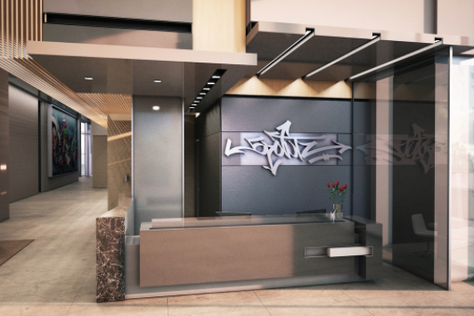
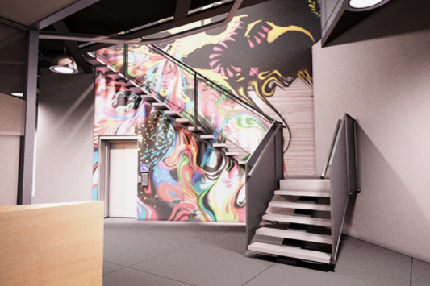
5 Pointz, as previously mentioned, acted as a legal graffiti zone in Queens. What this means is that artists are able to freely paint anywhere in or on the building without facing legal ramifications. For this reason talented artists from not just the city, but all over the world, were able to produce numerous vibrant thought provoking pieces of art. Without the fear of being caught, time constraints, and other factors that come into play with illegal graffiti, writers were able to produce remarkable pieces of art that would be on display to those walking or driving by, or the rail commuters. While the building may be looked at by some as nothing more than a place for deviance to run rampant, others rejoiced in the ever changing art that adorned the building until 2017 when it was covered and demolished without notice, (Walker, 2018).
Figure 4 – New condominiums incorporating graffiti elements in homage of old 5 Pointz building
Civic 2.3
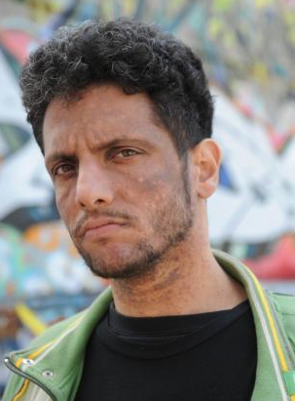
The Civic dimension relates to the amount of sociability there is within a community, the amount of responsibility that takes place between citizens and their built environment. The dimension also includes the notion of “third places” which refers to a pseudo-designated place that people congregate. 5 Pointz building, as noted, at any given time housed 200 artists giving them a place to work and live, as well hosted leagues of graffiti writers. Jonathan “Meres One” Cohen, (Figure 5), is a New York resident and had acted as curator who managed the building, the art, and artists inside and outside of it, (Smith, 2016). Graffiti is the glue that held the 5 Pointz community together, which was demonstrated by the amount of tumult created when it was demolished (Resker, 2013).
In the 2013 documentary: Don’t Bomb These Walls, the artist LED states that graffiti is a universal language in that you can open your black book and instantly have a connection to another writer despite not speaking the same language or sharing the same culture, and 5 Pointz was a celebration of that. The social and cultural capital that were built due to the nature of the 5 Pointz building are something that will not be easily replaced. Almost 30 years of New York and graffiti history were washed away when Wolkoff had ordered the building painted and demolished. From Wolkoffs development venture, 21 artists joined together and filed a class action lawsuit citing the Visual Artists Rights Act (VARA), against the building’s owner and too much surprise won. While the demolition in 2017 was unavoidable, the buildings legacy of bringing people together voluntarily for a larger endeavor had lived on through the artists that called 5 Pointz home.
Figure 5 – Jonathan “Meres One” Cohen. Retrieved from: news.artnet.com
Visual Artists Rights Act (VARA) 3.0
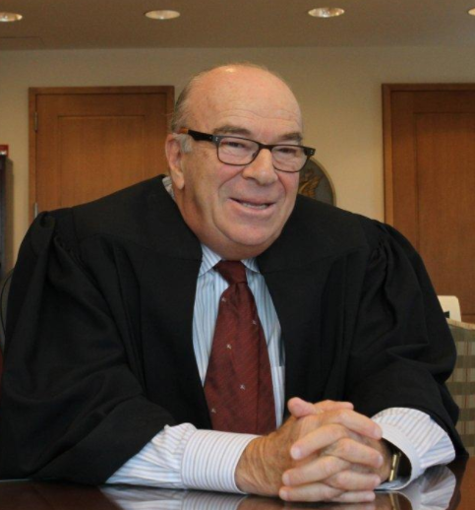
When an artists’ public works are faced with destruction due to development, the creators can challenge on the Visual Artists Rights Act (VARA) or state moral rights laws as an attempt to prevent the destruction of their public arts, or to receive a monetary compensation for their loss, (Haydock, 2018). While the 21 artists who challenged Wolkoff were unable to halt the demolition of the building, a ruling from Judge Block (Figure 6) awarded the artists $6.75 million in statutory damages from Wolkoff citing violations to the artists’ “right of integrity” under VARA, (Haydock, 2018).
Figure 6 – Brooklyn Federal Judge Frederic Block. Retrieved from: www.nydailynews.com
The Visual Artists Rights Act (VARA) is only granted to those artists whose public works have achieved a “recognized stature”. In order for an art piece to have stature it must be both: “viewed as meritorious,” and be recognized by art experts and others in the artistic community or by “some cross section of society,” (Haydock, 2018). In the case of 5 Pointz, Judge Block had determined that 45 of the 49 pieces of art in question had attained meritorious status and were recognized by an excess of art critics and societal member as being signified as significant art. Therefore, while Wolkoff was the owner of the building, he had not gone down the proper avenues in allowing the artists a fair opportunity to remove and preserve their works, or even the minimum required notice by law, (Haydock, 2013). For this reason, the artists’ were able to win their suit against Wolkoff and G&M Realty. The monetary amount came from the judges assessment of statutory damages through a six-factor test which included: i) the infringer’s state of mind; ii) the expenses saved, and profits earned, by the infringer; iii) the revenue lost by the copyright holder; iv) the deterrent effect on the infringer and third parties; v) the infringing material; vi) the conduct and attitude of the parties, (Haydock, 2018). Though Block stated that the second factor did not constitute as a VARA breach, “he found that Wolkoff indirectly profited by pushing the development project forward in the face of the VARA lawsuit – and directly profited by charging licensing fees to film at the site,” which caused this factor to weigh in the plaintiffs favour, (Haydock 2018).
Conclusion 4.0
To conclude, the 21 artists’ lawsuit against Jerry Wolkoff and G&M Realty spanning the past 5 years has been a monumental success for street artists in protecting their work from development. Since its establishment in the early 1970s, graffiti has always had to fight against modern society to be seen as true art. While it can be argued that a lot of it is nothing more than visual noise defiling a city, it has been able to create and maintain enough of a following in the past decades to cement itself in not just New York culture, but the culture of multiple generations. The 5 Pointz building acted as a graffiti artists Mecca and brought people from all walks of life to enjoy and marvel at the murals, with ten or so buses a day full of tourists wishing to catch and glimpse of this “must see spot of New York,” (Smith, 2016).
Since the destruction of 5 Pointz, the artists have moved on to creating a new Mecca for the local and visiting graffiti artists to paint, and for tourists to visit and marvel over. The decision made by Judge Block in allotting the artists such a large sum, $6.75 million, for their loss relates to his fourth factor noted above. Block stated that “without a significant statutory damages award, the preservative goals of VARA cannot be met. If potential infringers believe that they can violate VARA at will and escape liability because plaintiffs are not able to provide a reliable financial valuation for their works, VARA will have no teeth,” (Haydock, 2018). While graffiti may be an illegal act of vandalism, the removal of culturally significant works, in such a disrespected manor is arguably a larger offense. While the new tower being built will pay homage to the art that once adorned the walls of the old factory with graffiti art incorporated into the building and it’s design, without an open legal forum for artists to work, it is little more than good intent. Planners and developers may be the ones who design the city, but it is the artists and creative types who give it shape as “[c]ities are shaped by those who have a vision of what they might be, or those who see an opportunity,” (Sudjic, p. 97, 2017).
Works Cited
5 Pointz. (2018, January 24). In Wikipedia, The Free Encyclopedia. Retrieved 17:35, February 8, 2018, from https://en.wikipedia.org/w/index.php?title=5_Pointz&oldid=822048044
Gabbatt, A. (2017). New York graffiti artists triumph over developer who destroyed their work. [online] The Guardian. Available at: https://www.theguardian.com/artanddesign/2017/nov/09/new-york-graffiti-artist-win-lawsuit-5-pointz [Accessed 7 Feb. 2018].
Haydock, K. (2018). Aerosol Art | HHR Art Law. [online] HHR Art Law. Available at: https://www.hhrartlaw.com/tag/aerosol-art/ [Accessed 1 Apr. 2018].
Heathcott, J. (2015). “The bold and the bland: Art, redevelopment and the creative commons in post-industrial,” New York. City, 19(1), 79-101. 10.1080/13604813.2014.991171
Resko, R. [MrRyanResko]. (2013, December 3). Don’t Bomb These Walls (A 5 Pointz Documentary) [Video File]. Retrieved from https://www.youtube.com/watch?v=Qd73E21EjIw
Silver, T., & Chalfant, H. (Directors). (1983) Style Wars [Motion Picture]. United States: Public Arts Film, Inc.
Smith, C. (2016). Community rights to public art. St. John's Law Review, 90(2), 369.
Sudjic, D. (2017). The language of cities. London, UK: Penguin, p. 97.
Talen, E., & Ellis, C. (2004). Cities as art: Exploring the possibility of an aesthetic dimension in planning. Planning Theory & Practice, 5(1), 11-32. 10.1080/1464935042000185044
Walker, A. (2018). First look inside the 5 Pointz-replacing rentals in Long Island City. [online] Curbed NY. Available at: https://ny.curbed.com/2017/5/25/15689938/long-island-city-5pointz-rental-buildings-interior-renderings [Accessed 30 Mar. 2018].

