New Urbanism: A Canadian Perspective
Graham Louwers
Vancouver Island University
December 3rd, 2018

Authors Note
This paper was prepared for Geography 342 instructed by Alexander Don
Abstract

With the sustainability of traditional suburban development becoming frequently questioned, the principles of New Urbanism are becoming increasingly popular in the theory and practice of planners all over the world. This paper examines the topic of New Urbanism form a Canadian perspective, looking at its history as well as the extent and effectiveness of its current projects. After having reviewed the current literature on the subject, it is evident that, despite the popularity of the movement, New Urbanism has been relatively unsuccessful in altering conventional land development practices within Canada, thus far. Though the literature tends to focus on the many shortcomings of New Urbanism, it does so in a constructive manner and typically has a positive outlook on the movement as a whole. New Urbanism in Canada is something that planners and scholars what to see succeed, and similar to alternative forms of energy, a slow transition is likely required before it can do so.

Introduction

New Urbanism is a movement that focuses on the development of compact, mixed-use communities that are resilient and environmentally friendly. New Urbanism is an important aspect of community planning, as it is a growing alternative to conventional land development practices which create sprawled out, automobile dependent communities. This type of development began to grow rapidly after World War II and cities were soon focused around the needs of automobiles instead of the needs of actual people. New Urbanism looks to bring back design principles that were prominent before the rise of automobiles, where communities were walkable and had a greater sense of place.
Though New Urbanism originated in the United States, it has a very large geographic scope, with nations all over the world adopting its principles. Canada was very receptive towards the movement and was one of the first nations to successfully develop New Urbanism communities. Though this movement has certainly had an influence over the ideals and theory of Canadian planners, the true impact of New Urbanism in Canada is relatively unknown. This paper looks to examine the extent and effectiveness of New Urbanism in Canada, focusing on its history, current projects and the barriers it faces. Will New Urbanism really change the way we develop our communities? Or is it just a passing trend?

Literature Review

The principles of New Urbanism have a long history, dating back decades before the movement itself was even recognized. Modernist planning techniques, which typically centered around low density, automobile dependant neighbourhoods, have faced criticism since the early 1960’s. Jane Jacobs (1961) was one of the first people to bring to light the many problems associated with the modern design of cities. Jacobs described the modern, orthodox style of city planning as being unsuccessful in halting the decay of city neighbourhoods or eliminating slums, and blamed not only the planners, but also the theorists and educators. Jacobs disagreed entirely with the principles and aims of the modern, orthodox style of planning, and instead, put forward new principles that were completely different, and in some cases even opposite from what was currently being taught in schools of architecture and planning. Jacobs argued the importance of diversity (districts having more than one primary function), walkability and high density within cities, principles that would all eventually become important aspects of the New Urbanism movement.
Though these new principles had been present since the 1960’s, an organized movement to implement them did not begin until decades later. The Congress for the New Urbanism (CNU) was founded in 1993 and acted as the organizing body for New Urbanism. It described New Urbanism as having grown from design ideas which oppose the sprawling, anti-urban practices that prevailed in the latter half of the 20th Century (CNU, n.d.). Two of the CNU founds, Duany & Plater-Zyberk (1992), were at the forefront of the New Urbanism movement. They called for a return of the traditional American town and viewed the classic suburb as being "less a community than an agglomeration of houses, shops, and offices connected to one another by cars, not by the fabric of human life" (p. 21). Duany and Plater-Zyberk played a key role in designing some of the first communities based off New Urbanism principles, such as Seaside, Florida. Seaside, which was the first New Urbanism town, became internationally famous even before it was completed, proving that developments that functioned like traditional towns could be quite successful in the postmodern era (Steuteville, 2004).
When it comes to New Urbanism in Canada, it has quite a long history. Similar to the United States, the principles of New Urbanism have been present within Canada for decades prior to New Urbanism being recognized as a movement. As early as the 1970’s, Canadian cities actively promoted principles linked to New Urbanism such as infill development, mixed use and residential intensification (Grant & Bohdanow, 2008). Urban intensification was especially prominent in the province of British Columbia, where agricultural land reserves acted as “de facto urban growth boundaries” which contained urban growth and promoted intensification (Smith & Haid, 2004, p. 36). With the success of New Urbanism projects, such as Seaside, and the abundant media attention it was getting on both sides of the border, Canadian planners, designers and politicians grew increasingly interested in the growing movement. Throughout the 1990’s commitment to New Urbanism began to grow in Canada, with many cities revising their community plans in order to incorporate its principles (Grant, 2006).
In a study by Grant & Bohdanow (2008), the extent of New Urbanism projects in Canada were documented. The study identified 42 New Urbanism communities with the majority of them being located in Ontario and British Columbia (Figure 1). In terms of success, the study suggested that the New Urbanism approach was best suited in particular locations. Major urban centres such as Vancouver, Toronto and Calgary have a large demand for high-density housing as well as diverse populations which create a demand New Urbanism projects. High growth suburban fringe areas such as Markham and Surrey face pressure for intensification which results in the government having to turn to New Urbanism principles to guide growth. Retirement and resort destinations, such as Kelowna, have created niche markets for New Urbanism projects where traditional architecture styles may attract older households looking to purchase. It was also noted that historic villages were especially fond of New Urbanism, as it was viewed as being the best way to protect their local character. Overall, the study states that in order for a New Urbanism developments to be successfully constructed according to its principles, a number of factors such as municipal policy, political will and particular market pressures must establish a context that supports density, connectivity and walkability.
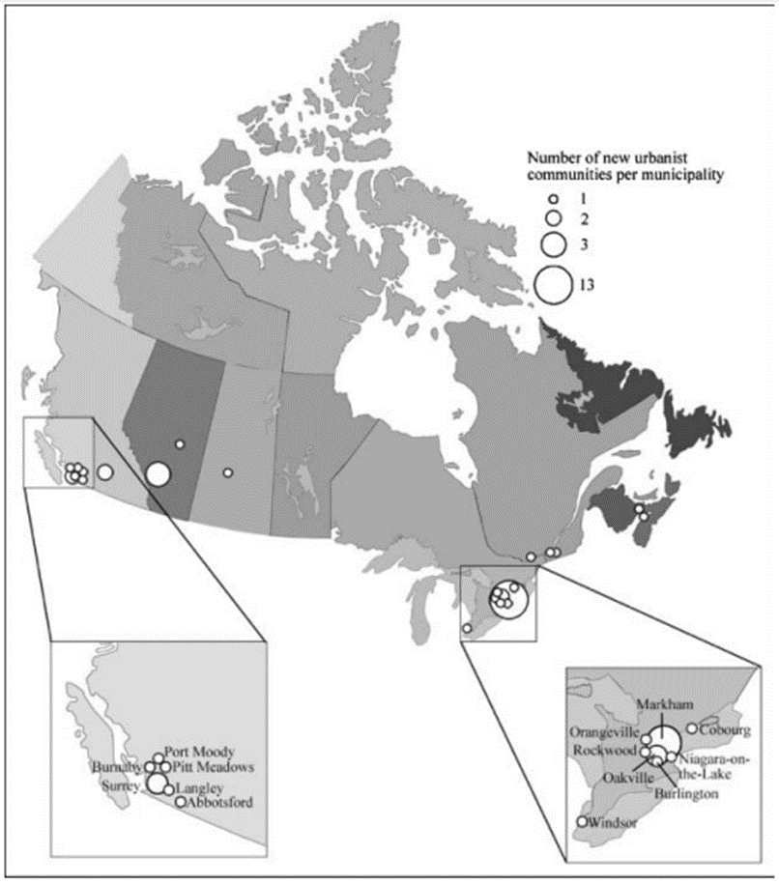
Figure 1. Map of New Urbanism communities in Canada. Reprinted from Journal of Urbanism, 2008, retrieved from http://dd6db2vc8s.scholar.serialssolutions.com/?sid=google&auinit=JL&aulast=Grant&atitle=New+urbanism+developments+in+Canada:+a+survey&id=doi:10.1080/17549170802221435&title=Journal+of+urbanism&volume=1&issue=2&date=2008&spage=109&issn=1754-9175

Though the principles of New Urbanism are generally supported by Canadian planning policy (Filion, 2001), the same study by Grant & Bohdanow (2008) found that there was a large gap between the ideology of Canadian planners and the actual implementation of these principles. Though many New Urbanism communities have been completed in Canada, this study found that these projects often changed during development and became more traditional in style. Some features proved particularly difficult to implement and the developments that did follow through with the full-fledged New Urbanism style often did not live up to people's expectations. Although the projects did typically include a range of housing types, they were often segregated into different streets or project phases as opposed to being mixed within individual blocks. Opportunities for commercial uses were often provided, however, it was found that retailers struggled in many of these projects. Having a retail centre designed within walking distance of all homes was described as being not economically viable in today's landscape of big box retail and outlet malls. It was also noted by Skaburskis (2006) that the density increase of these communities was not as large as expected from New Urbanism, and the desire for large lots with detached housing remains strong even among the residents of New Urbanism communities.
Despite the growing popularity of the movement, developments that stay true to the New Urbanism style are still quite rare within Canada and are proving to be difficult to successfully implement (Grant & Bohdanow, 2008). Different barriers that contribute to this difficulty were outlined in Grant’s (2009) study. Four types of barriers (institutional, political, economic and socio-cultural) hindering the development of New Urbanism communities in Canada were identified. Institutional barriers included things such as a lack of support or tools given to planners from council, poorly organized structure of planning staff, land development pressures and developer interests. Political barriers, which include things such as an overall lack of political commitment, were often present, as it was found that many councillors have had previous experience working in the development industry, and vice versa. With this in mind, the development industry has a considerable influence over municipal politics and the direction of urban growth, which often favours whatever produces the greatest profit. Economic barriers, which were centered around the consumer, often provided a significant challenge in the implementation of new planning principles. The market was described as having its own logic that shapes whether planning ideas were adopted or not. Consumer preferences also tended to favour a more traditional community design (lots of parking, privacy and space) and were difficult to persuade. Finally, it was found that the local character of place and its regional context had a large influence over a planner’s ability to implement New Urbanist principles. If the project did not fit the context of the community it tended to face a greater amount of resistance prior to development.
Probably the greatest barrier in the development of New Urbanism communities is that conventional development practices are still embedded in zoning bylaws, infrastructure standards and building codes (Farris, 2001). If a developer did want to construct a New Urbanist community, there would be a far greater amount of time and cost associated with building it. There is often little incentive for a developer to build a New Urbanism community compared to a more traditional one.

Analysis

After having reviewed the literature addressing New Urbanism in Canada, there appears to be a trend within many of the studies. Though they are often focused around the flaws and shortcomings of New Urbanism, they typically view the movement as being something that is positive and a better alternative to conventional suburban development. This is interesting, as the New Urbanism movement is regarded as being highly controversial. Though controversy is certainly present within much of the American literature, Canadian studies seem to view the topic in a more positive manner. There is a good chance that this is simple due to there being a smaller amount of Canadian literature on the subject. However, this also suggests that despite New Urbanism being relatively unsuccessful within Canada, it is still supported, and something that scholars want to see succeed. This is likely true for planners and architects as well, as it is difficult to find one who doesn’t believe in mixed use, compact development and transit-oriented design. Where New Urbanism likely faces the greatest barrier is at the public level. The issue is not necessarily that the public doesn’t support its principles, but rather, that the public won’t actually be willing to give up its current style of living.
Conventional suburban development is the fossil fuels of our energy. Our society is so use to it, that we have become reliant on it. Single-family housing on large lots is what the majority of people have been brought up on and what society has grown accustomed to. Though these styles of communities are effective at comfortably housing people, they create many problems. Large amounts of land are being consumed by sprawl and the great distances between residential and commercial areas, along with the general lack of walkability, is creating a society dependant on automobiles. This type of society not only discourages social interaction and exercise, but also has a negative effect on the environment, increasing the rate of global warming and taking away large portions of land that plant and animal species depend on. Overall, our reliance on conventional suburbs, just like our reliance on fossil fuels, is not only leading to a decrease in the health of people, but also a decrease in the health of our planet.
The main point of this analogy is not to emphasize the impact of conventional suburban development, but instead, to suggest that a transition is slowly taking place. Similar to fossil fuels, conventional suburban development has an alternative, one that fixes and avoids many of its negative effects. New Urbanism is that alternative, and just like renewable forms of energy, it is being implemented more and more within Canada. Though New Urbanism may appear to have been unsuccessful within Canada, it is still a relatively new concept and cannot be expected to replace conventional suburbs as our main form of development all of a sudden. A transition is required, one that will likely take decades to complete.
However, what this analogy misses out on, and where New Urbanism differs from renewable energy, is awareness. In order for people to want to move into these compact, mixed use communities, they need to understand why they are important. Without awareness, New Urbanism will continue to face the many barriers described above and conventional suburbs will continue to dominate.

Conclusion

Though the principles of New Urbanism are becoming increasingly accepted among Canadian planners, the movement as a whole has been relatively unsuccessful in altering development practices within Canada. Despite its sustainability being highly questionable, conventional suburban development still dominates, while New Urbanism projects often fail to stay true to their principles. It was found that New Urbanism projects tended to change during development, becoming more tradition on style, while the ones that did follow through with the movement’s principles, often did not live up to expectations. There are many institutional, political, economic and socio-cultural barriers that New Urbanism faces, all of which contribute to the large gap between the theory and practice of Canadian planners.
However, despite the lack of success New Urbanism has had within Canada so far, there is still a great deal of support towards it. Those who are aware of the movement seem to view it in a positive manner and want it to succeed. Though the topic of New Urbanism is regarded as being highly controversial, this controversy appears to be largely absent within much of the literature regarding New Urbanism in Canada. Just like our energy, we are beginning to move away from unsustainable forms of development, and transition towards more sustainable communities that are based around the principles of New Urbanism.

Bibliography

CNU. (n.d.). CNU History. Retrieved from: https://www.cnu.org/movement/cnu-history
Duany, A., & Plater-Zyberk, E. (1992). The second coming of the American small town. Wilson Quarterly, 16(1), 3-51.
Farris, J. T. (2001). The barriers to using urban infill development to achieve smart growth.
Filion, P. (2001). The urban policy-making and development dimension of Fordism and post-Fordism: A Toronto case study. Space and Polity, 5(2), 85-111.
Grant, J. (2006). Planning the Good Community. London: Routledge.
Grant, J. L. (2009). Theory and practice in planning the suburbs: Challenges to implementing new urbanism, smart growth, and sustainability principles. Planning Theory & Practice, 10(1), 11-33.
Grant, J. L., & Bohdanow, S. (2008). New urbanism developments in Canada: a survey. Journal of Urbanism, 1(2), 109-127.
Jane, J. (1961). The death and life of great American cities. New-York, NY: Vintage.
Skaburskis, A. (2006). New urbanism and sprawl: a Toronto case study. Journal of Planning Education and Research, 25(3), 233-248.
Smith, B. E., & Haid, S. (2004). The rural-urban connection: Growing together in Greater Vancouver. Plan Canada, 44(1), 36-39.

