Triple Bottom Line: Grand Rapids Michigan

Carrie Robinson
GEOG 352 S18N01
Don Alexander
March 29, 2018

Triple Bottom Line: Grand Rapids Michigan
Introduction
The modern version of the environmental protection movement began in the 1960s. This was spurred by Rachel Carson’s book Silent Spring; where she exposed the dangerous side-effects of DDT. The next few decades brought discord and clashes between environmentalist groups and businesses. In the 1990s, John Elkington struggled to bring balance to economic prosperity and environmental protection. He concluded that social credit was a neglected factor in the equation. When he coined the phrase, “Triple Bottom Line” (TBL) in his 1994 article it took a few years, but by the late 1990s the idea caught on. The accounting sector for businesses could now quantify environmental conservation and Human well being. The result was to create the TBL index. The focus will be on how the index is used and can result in a viable Triple Bottom Line. Grand Rapids, Michigan like many other Rust Belt cities was plagued with environmental degradation and economic collapse. In the last two decades the city reversed their misfortunes by introducing a TBL strategy and has become a model of success.
The Triple Bottom Line History and Theory
John Elkington is a world renown advocate for environmental protection and social justice practices. While sill in school in 1961, he had already begun his advocacy for wildlife and habit protection, as he asked an assembly of his fellow students to donate their two weeks of pocket money to World Wildlife Fund (Elkington, About, 2018). After, he obtained a Masters Degree from the Environmental Studies Program at UCL in London, he “focused on the psychological, sociological and economic links that people forge with their built environments” (Elkington, About, 2018). He has been working with the business community since the 1970s to encourage companies to change their view as to what a green business looks like (Elkington, About, 2018). He co-founded the SustainAbility think-tank, in 1987: a collaboration of professionals and experts from varying fields that work to address environmental and worker equality issues in businesses while maintaining economic viability (SustainAbility, 2018). The 1992 United Nations Conference on Environment and development held in Rio De Janeiro Brazil was the catalyst that spurred the need to develop the Triple Bottom Line. During the conference hundreds of companies signed the Business Charter for Sustainable Development. The realization that many of these business leaders believed that “greening business meant efficiency and cost cutting (). The Triple Bottom Line (TBL) was coined in 1994 by John Elkington; the phrase was developed to simplify the theory that the future of free market companies would include the need to factor in environmental and social justice solutions into companies’ financial bottom lines. The issue he faced was backlash from environmentalists. The practicality of calculating the TBL was another matter as environmentalist would argue how to place a monetary value on nature. What is the price of a marsh or ecosystem; how valuable is water quality, air quality, or livability. Elkington developed the TBL Index as an accounting tool that is used to quantify environmental and Social Justice responsibility.
The Triple Bottom Line enables accountants and businesses to formulate an accounting method that allows for the ecological and human components into a company’s financial report. An index to quantify the TBL is featured by Brendle Group (2014), in table 1.

Table 1 (Brindle Group, 2014). Quantifying the Environment and Social Justice with Triple Bottom Line Index.
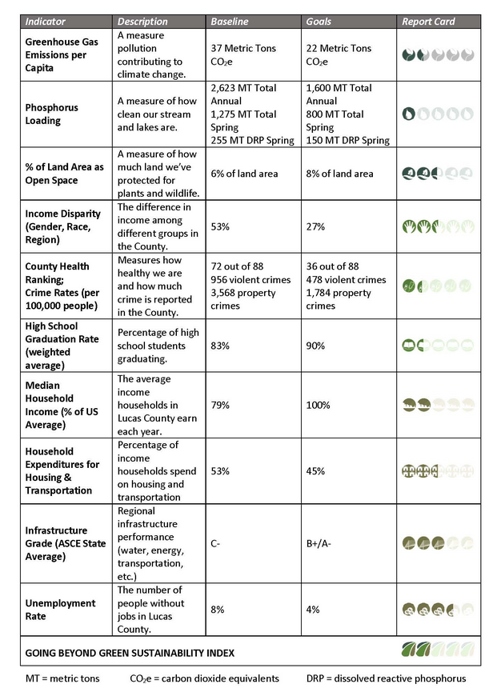
The three factors in the TBL are also known as the 3Ps, Profit, People, and Planet:
- Profit - The textbook definition: Earnings minus costs equals net profit. The mandate for all companies is to generate revenue including those that use the TBL method.
- People – This equates to a companies’ historical, current, and future social responsibility. How is social responsibility defined: corporations have an obligation to ensure that workers have a safe environment in which to carry out their duties. This would include both a place free from physical or psychological damage. An issue that arose during the 1980s was the use of sweatshops and child labour by manufacturers that supplied major corporations. Some being Nike, Adidas, Walmart and clothing lines for Kathy Lee Gifford and Disney. Clothing manufacturing under deplorable conditions still exists in many of the same countries as those from the 80s. The manufacturing of electronics has added an entirely new demand for cheap products and likely multiplied the number of people working in unsafe conditions. In fact, Foxconn a producer of parts for apple products are reported to be one of the worst companies in the world with regards to workers conditions and rights See Figure 1. These are all examples that would negatively affect a company’s Triple Bottom Line.
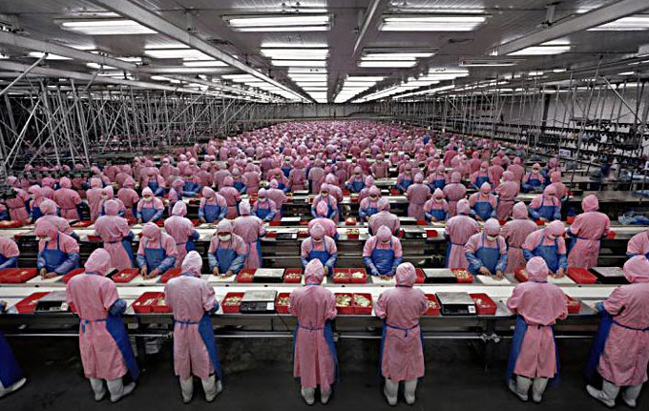
Figure 1 (D’Arcy, 2014). Foxconn factory workers in China.
- Planet – To factor the Earth into the TBL, this would require that companies become “environmentally conscious” (Elkington, 1997). This environmental consciousness would include that companies refrain from international resource extraction (Elkington 2004). An example of what not to do is AngloGold Ashanti in South Africa the depth of this gold mine ranges between 2.4km to 3.9km (Radio Free South Africa, 2018) see figure 2. This open pit mine will remain a scar upon the earth for an undetermined but lengthy period.
The positive gains for companies would come from changing practices like cutting out Styrofoam packaging, performing the reclamation of polluted water, and reducing or eliminating chemical use.
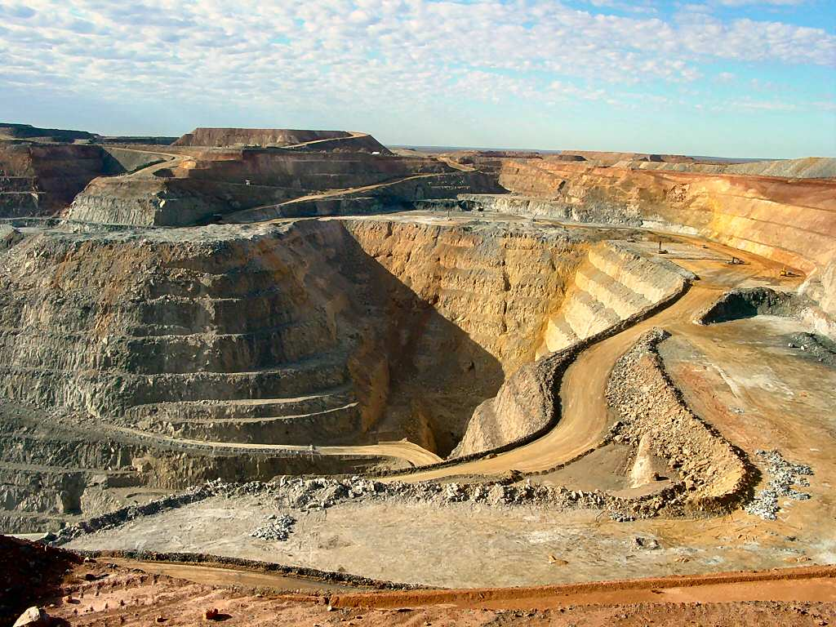
Figure 2 (Radio Free South Africa, 2018). AngloGold Ashanti gold mine located south-west of Johannesburg S. Africa.
There is only one Earth and humans are causing the degradation of it beyond a level that would allow the planet to recuperate. The Triple Bottom Line is just one tool to encourage companies to become environmentally conscious and socially responsible.
A strength of the TBL index is that it is adaptable to meet specific requirements depending on the cities location or unique issues. Also, the TBL is scalable in such that a small owner operator business to the largest corporations can implement the factors that make up the TBL. This theory also known as the 3Ps: people, planet, profit can create sustainable communities when used by governments.
Grand Rapids, Michigan: The Primary and Secondary Based Economy
The first European settlement was established in 1926, and it expanded to become the city of Grand Rapids by 1950. The features of this region supported a bustling natural resource industry, and because of the proximity of the forests a booming furniture industry had already rooted itself into the fabric of the city. With 44 furniture manufacturers at the height of the boom, the industry became ingrained into the community, and it came to be known as “the Furniture Capital of the World” (Compton, K, 2013). The Grand river made for the perfect transportation hub to bring in natural resource products such as logs and export out value added products like furniture. The river also provided the source to power the city’s industrial revolution; therefore, the manufacturing district flanked the banks of the river (Grand Rapids Historical Society, n.d.). The regulations for industrial waste disposal was non-existent in the early days which resulted in the river becoming polluted.
The environmental pollution legacy from the Industrial era led to hidden dangers in the city’s Grand River. The State of Michigan is a series of interconnected waterways see figure 3. The city of Grand Rapids as well as many other cities in the state are part of America’s rust belt and the combined industrial activities of the State polluted water sources throughout the region. In 1968 West Michigan Environmental Action Council (WMEAC) was formed to combat the degradation of the fresh water resources; the council is a collaboration between “churches, parent teacher groups, businesses, men’s clubs, student groups, women’s groups, labor associations and conservation organizations (History, 2012). According to 309(d) of the Clean Water Act as reported by WMEAC, the Grand River in Grand Rapids contained such extreme levels of toxins that the river was unsafe to swim in, fish from, let alone drink. Under the regulations of the act the toxicity levels in the river report that the water contains high levels of E. coli, mercury and PCBs which all pose the risk of illness to the human population (WMEAC, 2012). The cleaning of the waterways is one of the highest priorities for the region because of the interconnectedness of all the fresh water resources. WMEAC was one of the first environmental and water protection groups in the region and it continues to be a vital resource to combat further degradation of the natural resources. The council and all levels of government work in conjunction with the city of Grand Rapids and their Triple Bottom Line Initiative.
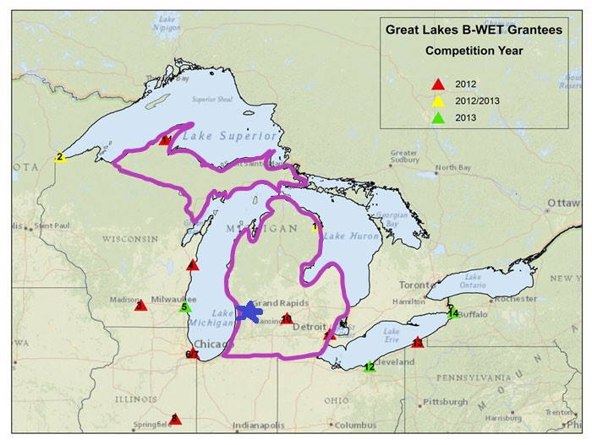
Figure 3 (National Oceanic & Atmospheric Administration, 2013). The State is blessed with 100s of km of fresh water coast lines highlighted here in purple. An essential resource that needs protection.
Grand Rapids Municipal Triple Bottom Line Action Plan
Environmental damage from the industrial era in Grand Rapids Michigan reached alarming rates by the mid 20th century. During the new era of environmental awareness in the 1960s the Rust belt city of Grand Rapids began to formulate an alternate direction. The community’s plan included environmental awareness and protection, addressing social justice issues, and re-evaluating the economic viability, in this region. The municipal government incorporated the first Triple Bottom Line initiative into the Community Plan in the early 2000s. The city released an accountability report in 2008 which led to adjustments in the Community Plan (Portney, 2008). The most current sustainability report was presented to the community in November of 2017 (City of Grand Rapids, 2017), as this updated report was released just at this paper was completed it will require future evaluation. The 2008 report will be evaluated and assessed for Successes, failures, and modifications.
The City of Grand Rapids incorporated John Elkington’s Triple Bottom Line Theory into their community plan a few years earlier, but in 2008 the first TBL Indicator report was released. Portney states (2008), that a list of “34 various measurements” were used to evaluate the community’s commitment to sustainability. The city’s 2008 plan was divided into 3 categories that correspond to the 3Ps: Planet was translated to the “Environment Quality Category”; Profit was translated to the “Economic Prosperity Category”; and People was translated to “Social Capital and Equity Categories” (Portney, p 5-34). Each category was further broken down into sub-categories just the highlights will be discussed and will be taken directly from the report by Portney (2008):
Successes and Failures:
- Environment Quality Category
- Waste – Refuse was reduced between 2002 – 2007 from 0.44 – 0.38 tons per household.
- Energy – Changing traffic lights to LED, equiptment to Energy star, replacing motorized vehicles and equipment to high efficiency, all combined to save the city $350,000.
- Water – spent $350 million on reducing sewer contamination which resulted in 99% reduction of sewer discharge in to the Grand River. The per capita usage has been reduced from 123 gal/capita/day in 2002 to 114 gal/capita/day.
- Air Quality - the report did not contain data for reducing toxic air pollutants in Grand Rapids.
- Land Use and Natural Habitat – By July of 2007 the city contained 18 LEED Certified Projects that were completed and 73 more registered to be built. According to the Tree Canopy Assessment Map there was 34.6 percent of the city’s total area covered by tree canopy.
- Transportation – Both public transit ridership and DASH ridership increased from 2002 to 2007. DASH is a park and ride system from the outskirts to Downtown.

- Economic Prosperity Category
- Personal Income - The per capita income rose above $20,000 in 2001 and plateaued to 2004 then it fell to nearly 2000 levels by 2006.
- Unemployment – The unemployment rate fluctuates but is consistently higher in Grand Rapids than at the state level. Except for in 2006 when it matches the states level.
- Brownfield Redevelopment – Between 2003 and 2007, there were 197 redevelopment projects which created 9,354 new jobs/residents. The investment totaled $1,143,074,225 which generated $4,473,486 in taxes.
- Knowledge Competitiveness – The city dropped from 9th to 13th on the “World Knowledge Competitive Index. Although it is the only metropolis in the state to rank at all.

- Social Capital and Equity Categories
- Safety and Security – Crime statistics indicate that major crime offenses rose slightly between 2002 to 2007 from just under 12,000 to just above 12,000. The less serious offenses decreased during the same period from 15,000 to 11,000.
- Education Attainment – The percent of high school graduates dropped from 88 in 2004 to 81 2005. During the study period 2002 – 2007 the college graduates rose slightly from 25% to 29%.
- Health and Wellness – Infant mortality from 2002 to 2006 the total percent increased slightly. For Caucasian it dropped from7.2% to 4.9%, African American it dropped from 28.0% to 21,8%, yet for ethnic Hispanic it rose significantly from 11.1% to 20.0%. Elevated blood lead levels decreased during the study period 2002 to 2007.
- Quality of Life – Homeownership rose from 72.3% to 76.3% between 2002 to 2006. Poverty rates increased during a five-year period 2000-2005. The percent of students that received reduced price and free lunch increased by 12% between 2000 to 2008.
- Community Capital – Annual 211 calls increased from 20,000 in 2001 to 31,000 to 2007. Voter turn-out decreased between 2000 to 2006. The population grew 2.5% between 1990 and 2007.
(Portney, p. 5-34).

The city of Grand Rapids, Michigan has made great strides to improve its commitment to sustainable practices by implementing the TBL into its Sustainable Community Plan. The city has received several awards for being a Green city leader (Latocki, 2014). Overall the sustainable practices have improved water quality and protected the environment from further degradation. Unfortunately, the city either failed to address the air quality issue or to collect data which is a major issue, as a green city can not have poor air quality. A green city at the very least should know what their air quality is because it can negatively impact the health of its citizens.
Modifications and Future Targets
- Environment Quality Category
- Waste – The program to reduce waste was successful and the new target released is to increase residential recycling rate another 10% by 2010.
- Energy – The new target is to reduce global warming air pollutants a minimum of 7% by 2012, switch to 100% renewable energy by 2020, and replace fleet vehicles with alternative fueled vehicles by 2015
- Water - eliminate sewer discharge into the Grand River by 2019. Reduce water consumption 15% of year 2000 use levels by 2015.
- Air Quality – The new target 7 % of year 2000 levels reduction of Greenhouse gas emissions by 2012.
- Land Use and Natural Habitat – increase the square footage of building stock. Promote LEED and Energy Star building practices. Increase the city’s urban tree canopy to 40% by 2015. Develop a new Parks Master Plan.
- Transportation – The new target is to build a rapid transit system by 2015. Asses the viability of installing a light rail system to be completed by 2020.

- Economic Prosperity Category
- Personal Income – The target is to increase personal incomes to match the state levels, approximately $25,000, by 2020.
- Unemployment – There are no quantifiable targets set to reduce the unemployment rates.
- Brownfield Redevelopment – The new target creates walkable community development zones.
- Knowledge Competitiveness – The new target grows the knowledge economy to place Grand Rapids in the top 5. Recently the site for a new medical school was released.

- Social Capital and Equity Categories
- Safety and Security – The target “Continue to work with City Neighborhood Associations, the Police Department, the Community Relations Commission and others to reduce crime and violence within the community” (Portney 2008).
- Education Attainment – The target is to raise graduation rates by 2015.
- Health and Wellness – The target provide new medical and prenatal services for all sectors. Develop sustainable purchasing program of non-toxic materials throughout the city.
- Quality of Life – The targets Create sustainable neighborhoods based on collaborative dialogue. Create employment to increase incomes. Reduce percent of students receiving lunch assistance by 10%.
- Community Capital – The targets to encourage the use of “211 system”, evaluate unmeet needs, and define the gaps. Increase publicity to encourage voter turn-out and improve convenience of voting sites.
Grand Rapids, Michigan made improvements by including a 3P approach to city development. They lacked quantifiable future objectives in several categories such as job creation specifics or the raising education attainment rates without clear goals there is no accountability. Water and air quality improvements are based on the levels in 2000 which would calculate to a lower percentage improvement than if they were based on reducing the current levels by the same percent. The key to the success of creating sustainable communities is the continuation of the collaboration between the regional government, municipality, economic sector, public sector, and local NGOs. The most important factor to achieve the community’s goals is to ensure there are measurable gains or losses that focus on accountability. The future for communities require obtainable targets and these are determined by past successes and failures.
Conclusion
Grand Rapids, Michigan the recipient of multiple sustainability awards sets an example of the positive effects of incorporating John Elkington’s Trible Bottom Line action plan into their master community plan. Although, the TBL alone is not able to reverse the Global effects caused by the runaway capitalist society, it can be used to form an environmental and social conscious for Corporate Capitalism. The city continues its commitment to build sustainable communities and the release pf the 2017 report is the next step in its development. The municipality, citizens, and economic sector of Grand Rapids, Michigan will need to continue their combined efforts to achieve the vision of the city that they want to enjoy living and working in.

References
Ashton, J. (2012, May 21). How Green is My Occupy? Looking ahead to Rio+20. Occupy blog, article from Huff post. Retrieved from https://www.occupy.com/article/how-green-my-occupy-looking-ahead-rio20#sthash.gfGof2xf.dpbs
Brendle Group. (2014, May 5). The Sustainability Index – A Different Way to Quantify the Triple Bottom Line [blog]. Retrieved from https://brendlegroup.com/blog/2014/05/05/the-sustainability-index-a-different-way-to-quantify-the-triple-bottom-line/
Cascade Engineering. (2015). Triple Bottom Line Report. Retrieved from http://www.cascadeng.com/sites/default/files/cascade-engineering-tbl-report-2015.pdf
City of Grand Rapids. (2017, November 21). “City of Grand Rapids Sustainability and Transformation Plan: Progress and Potential” In Sustainability Plan Progress Report Presentation: Our Government: Sustainability. Retrieved from Reports and Documents in https://www.grandrapidsmi.gov/Government/Sustainability
Compton, K. (2013, October/November). Grand Rapids, Mich.: Resurgence on the River. Earth Mother News. Retrieved from https://www.motherearthnews.com/nature-and-environment/sustainable-communities/grand-rapids-mich-zm0z13onzcom
D’Arcy, S. (2014, November 24). An Exploited, Dominated, and Oppressed Class? [photograph]. The Public Autonomy Project. Retrieved from https://publicautonomy.org/2014/11/24/exploitation-domination-oppression/
The Economist. (2009, November 17). Triple Bottom Line. Retrieved from https://www.economist.com/node/14301663
Elkington, J. (2018, April 21). About, In SustainAbility: Our People John Elkington – Education [Weblog]. Retrieved from http://johnelkington.com/about/personal/education/
Elkington, J. (2004, August 17). Enter the triple bottom line. Retrieved from http://www.johnelkington.com/archive/TBL-elkington-chapter.pdf
Environmental Movement." Dictionary of American History. Encyclopedia.com. Retrieved from http://www.encyclopedia.com/history/dictionaries-thesauruses-pictures-and-press-releases/environmental-movement
Experience Grand Rapids. (n.d.). History of Grand Rapids. Retrieved from https://www.experiencegr.com/about-grand-rapids/history/
Grand Rapids Historical Society. (n.d.). History of Grand Rapids. Retrieved from http://www.grhistory.org/history_of_grand_rapids
Latocki, B. (2014, July 22). Michigan is Most Improved State for Business 2014 [photograph]. Production Realty. Retrieved from http://productionrealty.com/michigan-is-most-improved-state-for-business-2014/
National Oceanic & Atmospheric Administration. (2013). Great Lakes B-WET Grantees Competition Years [map]. Retrieved from https://thunderbay.noaa.gov/B-WET/
Portney, K. (2008, September 30). Community Triple Bottom Line Report 2008, City of Grand Rapids, In Our Government: Sustainability. Retrieved from Reports and Documents in https://www.grandrapidsmi.gov/Government/Sustainability
Radio Free South Africa. (2018, February 1). SA has only 39 years worth of gold left [photograph]. Retrieved from http://www.radiofreesouthafrica.com/sa-39-years-worth-gold-left/
SustainAbility. (2018). John Elkington Co-founder & Honorary Chairman, In Who We Are: Our People. Retrieved from http://sustainability.com/who-we-are/our-people/john-elkington/
WMEAC. (2012, April 18). History. West Michigan Environmental Action Council. Retrieved from https://wmeac.org/wmeac-history/
WMEAC. (2012, April 18). Polluted Rivers in Grand Rapids. West Michigan Environmental Action Council. Retrieved from https://wmeac.org/water-pollution-in-grand-rapids/2012/

