Forward-Looking Vauban:
A Case Study in Exemplary Sustainable Neighbourhood Development

“In the beginning, it was only militant, ecological people.
So, a lot of ideas, not so much money.
And now, it’s business [as usual].”
–Jurgen Hartwig, Freiburg Tour Guide (Bloomberg, 2009)

Kyle Wardstrom
November 30, 2016
Professor Don Alexander
Vancouver Island University
Table of Contents
Vauban At-A-Glance 3
Geographical and Historical Context 4
Key Features of Sustainable Urban Development 7
Parks and Open Space 7
Buildings 7
Transport 9
Waste 10
Water 11
Energy 11
Governance 12
Lessons from Vauban and Transferability 13
Conclusion 14
References 16

Forward-Looking Vauban:
A Case Study in Exemplary Sustainable Neighbourhood Development
Vauban is a neighbourhood in Germany considered by many sustainability researchers to be a model of how neighbourhoods should develop in the future. Its development has carefully considered different elements of the environment and how urban residents can live more in tune with the natural realm. Delegates from around the world have visited and studied Vauban for its important lessons in applying ecological principles into their own master plans.
The district is well-known for its network of green and open spaces, its energy efficient buildings, its transportation network encouraging active transportation methods, its use of renewable energies, and its focus on cooperative living.

Vauban At-A-Glance
Area: 41 hectares (0.41 km²)
Number of households: 2,472
Population: ~5,500
Population density: ~134 persons / ha
Average age: 28.7 years
Figure 1. Vauban neighbourhood. Retrieved from http://www.freiburg.de/pb/site/Freiburg/get/params_E-1604864046/647919/Infotafeln_Vauban_en.pdf

Geographical and Historical Context
The new neighbourhood of Vauban is situated in the southwestern German city of Freiburg im Breisgau in the state of Baden Württemberg. Freiburg lies just twenty kilometers east of the French border and about fifty kilometers north of the Swiss border. Its location on the Upper Rhine River Plain adjacent to the famous Black Forest region has firmly established Freiburg as a hub for regional tourism (Freiburg im Breisgau, 2006).
The city benefits from an extremely diversified economy, part of which focuses on environmental technologies and renewable energies, especially solar power technology (Freiburg Wirtschaft Touristik und Messe, 2016). Germany may not seem the ideal location to take advantage of solar energy. And it is true that even the sunniest locations in Germany receive roughly the same amount of sunshine as southern Vancouver Island. However, southwest Germany obtains somewhat more sunshine (based on mean monthly sunshine hours) than more northerly German cities (Freiburg receives roughly 200 more hours each year of sun than Berlin.) Freiburg is also known for its relatively warm climate and can experience summer heat waves with temperatures hovering in the mid-30s Celsius.
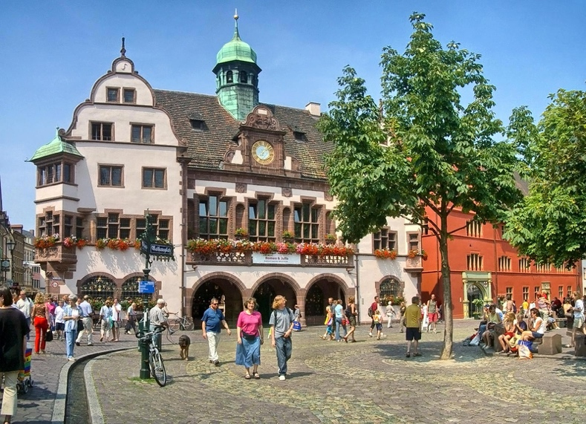
Freiburg has a long, varied, and sometimes dark history. In its nearly nine hundred years, the city was conquered multiple times (Freiburg im Breisgau, 2006), suffered a devastating plague (Durant & Durant, 1961), and fell victim to Allied forces during World War II when much of the city centre was flattened in air raids (Zabecki, 2014). Following the devastation of World War II, the city chose to rebuild its downtown on the medieval pattern (fig. 2, next page), which became a “benchmark in public space quality both for other cities and for new districts in Freiburg proper” (Scheurer & Newman, 2009, p. 3). The narrow streets of the newly rebuilt city centre were intended primarily for pedestrian traffic and, according to Scheurer and Newman (2009), Freiburg began a pedestrian- and tram-priority program in the early 1970s, which was to eventually influence the development of new districts in the area, including Vauban.
Figure 2. Freiburg city centre. Retrieved from http://www.hotel-barbara.de/images/background/start-4.jpg
Freiburg City Council today is dominated by the Greens, and the mayor since 2002, Dieter Salomon, is also a member of the Greens. However, the state of Baden Württemberg has a history of political conservatism dating to the early 1950s. Scheurer and Newman (2009) estimate that Freiburg’s progressive attitudes stem from its role as a node of grassroots activism in a state defined by conservatism. In a similar way, we could view Austin as a bastion of liberalism in the middle of the overwhelmingly conservative American state of Texas. No doubt, there are similarities in Freiburg’s and Austin’s regional roles as postsecondary education centres.
The University of Freiburg has garnered much acclaim for its research and teaching. The higher education centre has been chosen as one of Germany’s elite (Der Spiegel, 2007). The university has resulted in many internationally renowned organizations and research facilities devoted to environmental causes (Scheurer & Newman, 2009). For instance, the city hosts ICLEI – Local Governments for Sustainability’s European Secretariat, the International Solar Energy Society (ISES), the Öko Institut (researching sustainable development), and the Fraunhofer Institute for Solar Energy (ISE), to name a few.
Freiburg became Germany’s ‘ecological capital’ in a short period of time. The environmental movement in the city can be traced to one flashpoint event in the 1970s when a nuclear power plant was slated for development nearby, but halted by a successful protest against it (Scheurer & Newman, 2009; Gregory, 2011). This event combined with the city’s large academic presence and progressive values to create the ecologically-minded region that exists today.
Before Vauban’s development, the Freiburg city government held a master planning competition to create a new ‘ecodistrict.’ This district, Rieselfed, was designed as a dense, mixed use neighbourhood, with easy access to public transit, traffic calmed streets, onsite jobs, and energy efficient buildings (Field, 2011).
Following WWII, Vauban was occupied by the French military, which held a continuous presence there until the early 1990s, when the land was returned to the city government (Scheurer & Newman, 2009). In seeking to replicate the success of Rieselfeld, the city sought to develop the former barracks site into a new district. However, in a quintessentially bottom-up approach, a number of environmental campaigners banded together to form an organization called Forum Vauban, which approached the city with its own master plan for Vauban that was to include radical social and ecological elements that Forum Vauban thought was lacking in Rieselfeld (Field, 2011). More discussion on Forum Vauban continues below.

Key Features of Sustainable Urban Development

Parks and Open Space
Vauban was designed to incorporate green spaces throughout the district and to connect a comprehensive open space network in the city. At the regional scale, Vauban’s green spaces link the neighbourhood with agricultural areas, regional nature reserves, and the nearby foothills of the Black Forest. At the local scale, public, private, and cooperative open spaces envelop buildings and streets (Scheurer & Newman, 2009). Freiburg has a robust land conservation program with a focus on preserving biodiversity, water quality, soil quality, and serving as the city’s “green lungs” (Gregory, 2011, n.p.). Residents were intimately involved in the design of Vauban’s green areas, and sought to emphasize soft surfaces, restore the locale’s natural water features, and make use of native vegetation to enhance biodiversity (Scheurer & Newman, 2009). Residents use a number of green spaces for small-scale agriculture and recreation. The green space network also works to reduce the urban heat island effect (Field, 2011).

Buildings
Most buildings were constructed between three and five storeys and residential density stands around 95 units per hectare (Scheurer & Newman, 2009; Field, 2011). This density not only allows for a maximum amount of residents, but also includes plentiful green spaces that would be scarce if accommodating a similar number of people in single-family housing. Many land plots were established to allow potential residents to design their own homes next to professional developers. The result is “an architecturally diverse and colorful district with a strong sense of community” (Field, 2011, p. 2). Furthermore, during the second and third phases of development, many small cooperatives (Baugruppen) bought individual blocks and designed and built buildings according to their specialized needs (Scheurer & Newman, 2009). This further added to the variety of housing types and diversity of architectural styles found within the district.
All buildings are very energy efficient. They meet, or in some cases even exceed, the ‘Freiburg Low Energy Standard,’ a local code that originated during Freiburg’s development of the Rieselfeld neighbourhood and was subsequently adopted at the national level in 2001 (Scheurer & Newman, 2009). This standard limits the allowed heating energy needs of buildings at 65kWh/m²/year.
Some buildings are even more efficient; requiring less than 15kWh/m²/year. These homes—at least 100, in all—achieve either the passivhaus standard, where building design ensures that almost all heating energy (except in extreme weather conditions) comes from the Sun, or the PlusEnergy standard, whereby homes create more energy than they use (Delleske, 2013). Fifty-nine PlusEnergy homes in Vauban are located in architect Rolf Disch’s Solar Settlement. Since these homes usually create more energy than residents use, the excess energy may be sold back to the power companies for a profit (Ellen MacArthur Foundation, 2010).
Cohousing projects in Vauban took a fantastic approach to building with the future in mind. Buildings were constructed in such a way that interior walls could be removed or reconfigured without affecting the integrity of the exterior shell of the building (Scheurer & Newman, 2009). This level of thought that went into construction means that, should the use of the building change in the future, the building can change with it, translating to savings in materials.

Transport
The transportation concept in Vauban is revolutionary. Not only does the local transport company, Freiburger Verkehrs AG (VAG), operate a tram and buses within an easy walk of all homes, but Vauban is also a car-reduced community.
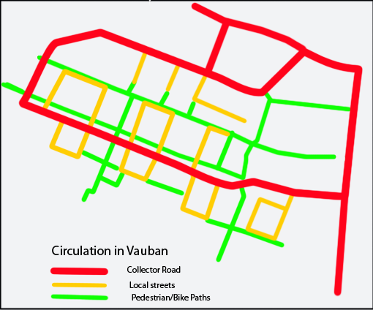
During the planning and development of the district, Forum Vauban sought explicitly to deter car use by restricting parking and to provide safe streets for children to play. Nevertheless, planners were bound by Baden Württemberg’s Land Law requiring each home to have access to a parking space (Field, 2011). Forum Vauban then negotiated an agreement which resulted in 0.5 parking spaces for each unit, with most of the spaces located in nearby parkades. Furthermore, Forum Vauban created a unique street layout that incorporated the concept of filtered permeabiity (fig. 3), which seeks to maximize access for pedestrians and cyclists, yet limits motor vehicle access by blocking off linkages by bollards and other devices. Pedestrians and cyclists can find easy connections to any destination in the district and to adjacent districts, yet car drivers will find it more difficult and time consuming.
Figure 3. Filtered permeability in Vauban by Fgrammen - Own work, Public Domain, https://commons.wikimedia.org/w/index.php? curid=10112211
A few main thoroughfares allow curbside, metered car parking. However, most homes are located on side streets with no parking. Instead, these routes are strictly for picking up / dropping off and for emergency services. Accessing the homes for transporting large loads is thus simple, yet to park one’s car for an extended period requires more work and a sizeable cost. Residents have two options: either declare themselves car-free by signing a legal contract with the Car-free Living Association (Verein für autofreies Wohnen) or purchase a parking space in one of Vauban’s parking garages located around the periphery of the district (Field, 2011). Should the resident take the option of declaring themselves car-free, they must renew their declaration on an annual basis. The alternative option—purchasing a parking space—costs roughly €20,000 followed by a monthly maintenance fee of €70 (Field, 2011). It is easy to see why many residents chose the car-free option. In fact, there are just 160 cars/1,000 residents (16% of the district population owns cars) (Field, 2011).
Since car-owning seems like a bad decision because of the inconvenience and cost, many residents belong to the local carshare company, Stadtmobil Südbaden. However, far more forgo cars completely. The transportation modal split in Vauban is telling: 16% of trips is by car; 19% by public transit (this figure is from before the tram was extended to Vauban in 2006); and 64% by bicycling and walking (Scheurer & Newman, 2009; Field, 2011).

Waste
Vauban incorporates an interesting and innovative approach to waste. Organic household waste is sent to an anærobic digester to ferment. In a pilot project of the Baugruppen collective group, vacuum toilets send human feces to the digester to ferment with the household waste. The fermentation process produces biogas, which is then captured and used for cooking gas in the district. The remaining greywater is filtered through a system of biofilms and returned to the hydrologic cycle (Delleske, 2013).

Water
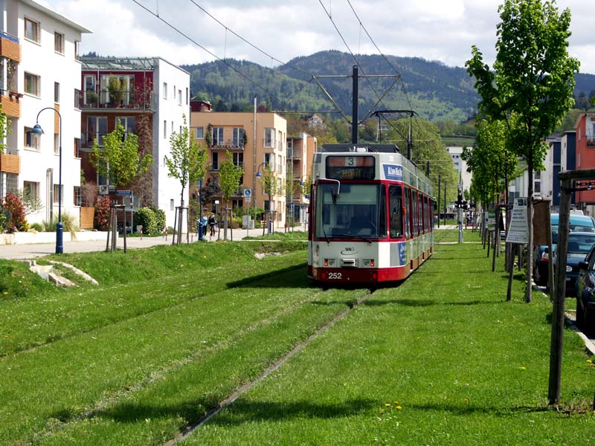
To encourage residents to maintain permeable ground surfaces, Freiburg established a stormwater fee which charges owners based on the percentage of land that is permeable (International Making Cities Livable LLC, 2016). Going further, Vauban makes it mandatory for flat roofs in the district to be green roofs to allow for rainwater infiltration and many homes capture rainwater for use in the home (Delleske, 2013). Also, newer tram lines, including the Vauban line, have laid tracks on soil and grass (fig. 4) for two reasons: to reduce tram-related noise and to improve rainwater permeability (Loux, 2009).
Figure 4. Tram line in Vauban features sod surface to reduce noise and enhance permeability. Retrieved from http://www.tramtom.de/tram/freiburg/ttm_tram_freiburg.html

Energy
Freiburg is a leader in sustainable energy technology. The city’s storied university, with its respected research facilities, has translated to a population eager to put ecological and sustainable principles into practice (International Making Cities Livable LLC, 2016). So, in new districts, like Vauban, it just makes sense that they sought to take advantage of renewable energy technology.
Vauban uses its sunny and mild climate to its advantage. Solar power has been in use in the area since the 1970s. Gregory (2011) noted that Freiburg now contains more than 150,000m2 of photovoltaic cells, which together produce upwards of 10,000,000 kWh/year. In Vauban, most homes contain solar cells and some, including the passivhausen and PlusEnergy homes, contain solar panels along the entirety of their roofs.
Cogeneration, also called combined heat and power (CHP), also has a firm reach in the region. Freiburg’s share of electricity generation from CHP was just 3% in 1993, but now forms 50% (Gregory, 2011). CHP has also reduced the city’s reliance on nuclear power from a high of 60% to just 30% today. CHP in Vauban takes wood pellets, a waste product of the forestry industry in the Black Forest, and burns them to create power. However, the waste heat that would normally be lost to the atmosphere is captured, turned into steam, and sent through a network of pipes to heat homes throughout the district.

Governance
Freiburg has taken a very participatory approach to governance since the late 20th century, and has done so especially since the early development of Vauban. Scheurer and Newman (2009) described Freiburg’s “governance system with its emphasis on community engagement and a commitment to the public good of the area” (p. 3) as central to the successful development of the neighbourhood.
Forum Vauban, a community organization comprised of neighbourhood and environmental activists and campaigners, was given a central role in the community engagement process. Freiburg outsourced their work to Forum Vauban, which acted as an intermediary between the planning authorities and prospective residents (Scheurer & Newman, 2009). A master plan was then created by Forum Vauban that included innovative ecological principles into the design, such as: diverse, mixed use, medium density development; priority of access for pedestrians, cyclists, and public transit users; low energy buildings; and, solid social infrastructure. Central to the planning process from the outset was a concept of ‘planning that learns.’ Forum Vauban’s public participation went far beyond the mandatory consultation process and sought to continually reassess and improve itself throughout the planning and implementation phases. For these reasons and more, Vauban today profits from a strong sense of community.

Lessons from Vauban and Transferability
From the outset, Vauban has been an exemplary model of sustainability at the neighbourhood scale. The area boasts very high rates of water and waste recycling, low energy buildings utilizing renewable energies, a transportation network and system which actively discourages private automobile ownership and use, an open space network that is “the envy of most new suburbs” (Scheurer & Newman, 2009, p. 10), and a forward-thinking system of governance with a focus on strong public participation.
Fortunately for Vauban residents, most approaches work extremely well. However, there are a couple items that have not fared as well. Social housing was originally slated for around one quarter of the residential units. Yet, during Vauban’s development the state of Baden Württemberg’s social housing program suffered from cutbacks (Scheurer & Newman, 2009), resulting in a much lower amount of social housing units – less than 10% (Loux, 2009).
Although there are fewer social housing units than originally desired, Vauban does contain a couple cooperative housing associations with about 150 housing units (Delleske, 2013). Additionally, a University student’s association contains nearly 600 affordable dormitory rooms.
The energy technologies in Vauban including CHP (cogeneration) and solar power are highly transferable to most areas of the world. Biomass can be obtained in many areas of the world to be used as fuel for CHP plants and solar power can be utilized nearly anywhere, but is most suited to latitudes between the Arctic and Antarctic Circles. If a neighbourhood were looking to Vauban for inspiration, they should have an excellent system of public transportation nearby that can be extended into the neighbourhood. Although Vauban’s transportation system worked quite well even before the tram extension was completed in 2006, other areas may want to ensure that thorough public transportation is in place prior to development. Furthermore, the density of the neighbourhood works well in a European or Asian context, but may be too dense for many North Americans, unless the prospective neighbourhood is located in an already urbanized area.
It is highly unlikely that all sustainable urban development elements could culminate into such a smoothly operating neighbourhood as it does in Vauban, but taken individually, a community could institute similar models quite effectively.

Conclusion
Vauban is viewed by many as an exceptional example of how to incorporate sustainable practices at the neighbourhood scale. Freiburg’s experiment has paid off and many international delegates arrive in Vauban each week in their own bids to replicate the success of the district.
Vauban integrates many key elements of sustainable development. The area boasts very high rates of waste and water recycling; district-wide combined heat and power; solar power technology on most buildings; an efficient transportation system that has successfully reduced car usage; plentiful gardens, parks areas, and public spaces; mixed-use medium density buildings requiring little energy compared to standard buildings; and, high rates of public engagement.
While the individual elements of sustainable urban development in Vauban are highly transferable, it would be difficult to duplicate Vauban’s particular success in total. However, going further into the future, it will not only be wise, but necessary for other areas to integrate Vauban’s pioneering ideas into their own plans.

References
Bloomberg. (2009, August 14). Special Report - Eco-friendly Freiburg - Bloomberg. Retrieved from Youtube: https://www.youtube.com/watch?v=6iqADeY-LfU&list=PL39CF94B977E1C5D1&index=2
Delleske, A. (2013). An Introduction to Vauban District. Retrieved from Vauban˚de: https://www.vauban.de/en/topics/history/276-an-introduction-to-vauban-district
Der Spiegel. (2007). Crème de la Crème: Six More German Universities Anointed for 'Elite' Funding. Der Spiegel online.
Durant, W., & Durant, A. (1961). The age of reason begins: a history of European civilization in the period of Shakespeare, Bacon, Montaigne, Rembrandt, Galileo, and Descartes: 1558-1648. Simon and Schuster.
Ellen MacArthur Foundation. (2010, August). Vauban: a pioneering community in Germany. Retrieved from News: https://www.ellenmacarthurfoundation.org/news/vauban-a-pioneering-community-in-germany
Field, S. (2011). Vauban, Freiburg, Germany. Europe's Vibrant New Low Car(bon) Communities, 96-106.
Freiburg im Breisgau. (2006, May 3). Encyclopaedia Brittanica online.
Freiburg Wirtschaft Touristik und Messe. (2016). Economy. Retrieved from Welcome Center: http://www.welcomecenter-freiburg-oberrhein.de/en/region/economy
Gregory, R. (2011, January). Germany - Freiburg - green city. Retrieved from The Ecotipping Points Project: http://www.ecotippingpoints.org/our-stories/indepth/germany-freiburg-sustainability-transportation-energy-green-economy.html
International Making Cities Livable LLC. (2016). Freiburg: City of Vision. Retrieved from International Making Cities Livable: http://www.livablecities.org/articles/freiburg-city-vision
Loux, J. (2009, August). Comparison of Rieselfeld and Vauban. Retrieved from Sustainable Design (web log): http://ucdesustainability.blogspot.ca/2009/08/comparison-of-rieselfeld-and-vauban.html
Scheurer, J., & Newman, P. (2009). Vauban: a European model bridging the green and brown agendas. Case study prepared for the Global Report on Human Settlements 2009. Retrieved from https://www.researchgate.net/publication/228970605_Vauban_A_European_Model_Bridging_the_Green_and_Brown_Agendas.
Zabecki, D. T. (Ed.). (2014). Germany at War: 400 Years of Military History. ABC-CLIO.

