The Issue in the Classroom

The students (and I!) struggled to connect with a 60 slide long ‘legal terms and principles’ lecture (zzzzz). Each slide was densely packed with interconnected legal principles and it was difficult to make connections between topic areas. Students were confused with the terminology and concepts and didn’t understand how to apply the theory to the real world.
PowerPoint Slide Example – How Not to Present Legal Terms
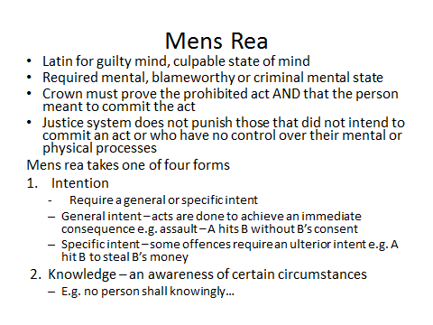
The Fix

Deconstruct the Power Point Slide Show and Create a Visually Appealing Hand Out, Questions and Discussion
Restructure the material so the students learn by doing

- De-construct the slide show | - Sort and chunk up the information | - Create at-a-glance visually appealing handouts | - Group similar concepts together
- Walk the students through the hand out | - Assign questions (individuals try to answer the questions) | - Group Work | - Group discussion

