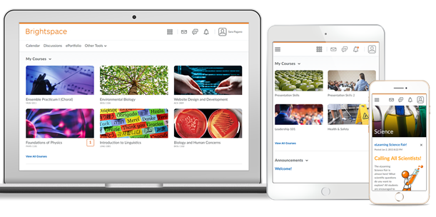
Daylight has Come and Gone Vancouver Island University’s Experience Moving to the New Responsive Design Interface

Vancouver Island University (VIU) is a mid-sized university on Vancouver Island. We have 3 campuses and approximately 17,000 students. Roughly half of our 750 faculty use our Learning Management System in some capacity. In 2017, 39% of course sections created through our registration system were activated in D2L. This is an increase from 34% in 2016, and 27% in 2015.

How Did We Manage the Change to Daylight?
We began communicating with our campus community in November 2016 for a planned April 2017 rollout of Daylight. Over 6 months we held 20 public awareness sessions, reaching approximately 100 faculty.
In addition to public awareness sessions, we used our existing communications platforms to keep our community up to date. This included blog posts, updates to our custom Faculty News widget in Brightspace and announcements embedded in sessions we ran for faculty between November 2016 and April 2017.
We did not message students directly about the change or run Student-focused public awareness sessions, but we put an announcement in a custom widget in Brightspace and updated our student resources to the new interface

How Are We Doing Six Months After Daylight?
Overall, our transition to Daylight was very smooth. Faculty and students embraced the new mobile-responsive design and most feedback has been positive.
We have seen a significant increase in mobile and tablet access to the system this fall over the previous two years for which we have analytics.
Our passive resource update project is still ongoing, but we have recut and posted 72 faculty and student support videos since April 2017.

More Information Available on Our Blog

Daylight Is Coming! VIULearn Upgrades to a Modern Responsive Design April 30
February 7, 2017: This blog post focuses on raising awareness of change to institution. It includes links to the slideshow and handout shown at our Public Awareness Sessions
http://goo.gl/hpFJbi

Enhancements to VIULearn: My Home, Course Home and Nav Bar
April 19, 2017: This post focuses on the institution-specific changes we made to the navigation and home pages within Brightspace.
https://goo.gl/dfhZ8f

‘Daylight’ Has Come and Gone: VIU’s Experience Moving to D2L’s New Responsive Design Interface July 16, 2017: This post summarizes VIU’s move to Daylight as well as our experience sharing our story with other institutions at D2L Fusion 2017.
https://goo.gl/GNTibk

VIULearn Looks Different! Updated to a Modern Responsive Design!
August 4, 2017: This post highlights the key changes for our campus community leading up to Fall 2017 semester start-up.
https://goo.gl/A24ooo

Contact Us
If you have any questions, we would be happy to hear from you.

The Centre for Innovation and Excellence in Learning
http://ciel.viu.ca
LearnSupport@viu.ca
250.740.6179

Jacqueline Kirkham
Learning Technologies Support Specialist
Jacqueline.Kirkham@viu.ca

Stephanie Boychuk
Learning Technologies Support Specialist
Stephanie.Boychuk@viu.ca

Liesel Knaack
Director
Liesel.Knaack@viu.ca

