Word Activity
Left tab at 2 inches
Right tab at 5 inches
Movies & Food
Name | Favourite Movie | Favourite Food
Mary | Bill & Ted’s Excellent Adventure | Popcorn
Bill | Top Gun | Peas
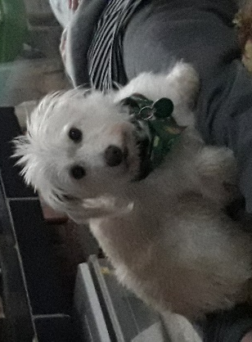
Monty
I’m typing some stuff.

